New Retail Store Creation and Maintenance

**Group -2**

Design Specification

# Introduction

Scalability and profitability are the two factors that determine the growth of any business. In retail industry, it is very common that a new store gets established very often. This immediately creates the need for the new store to have the necessary software to manage its day to day tasks.

It is a hectic task to create a new web application and provide separate access to each new sub branch that is set up that includes maintenance of its data to track the business related operations.

To overcome this problem, we have come up with a solution that gave us base for developing our project “New Retail Store Creation and Maintenance”. Our main objective behind developing this project is to avoid the redundancy and re-organization of the existing data whenever a new store is created from the existing parent store.

## Project Overview and Statement of Proposal

Our project "New Retail Store Creation and Maintenance" aims to quickly provide software services required to run a new store.

**Statement of Proposal:**

We propose to automate the task of providing a web application service to the newly created store from an existing parent store with just a single click by the new Store Head. When an existing parent store establishes a new sub store irrespective of the location, the system would enable the client to provide all the required services corresponding to the new store. This is an automated process, in which client configures required data and the store is created automatically.

The application allows creation of new stores and defines the departments present in the store. Inventory of various items sold in the stores is maintained and updated accordingly. Store customer will be issued a store credit card upon request. Points are added to the customer credit card based on the purchases made. The system generates bill for the items that have been sold. The application allows special deals to be configured on items sold in the store.

## Scope and Objectives

The various objectives that are in the scope of the project can be broadly classified as follows:

### Creation of New Stores

The application allows creation of new store, configure the store with details such as the various departments the store has and assign department heads to each department. The task of creation of a new store is carried out by Store Head.

### Inventory Management

The inventory keeps track of various items that a store sells. Sales, promotions, customer rewards are interlinked with the inventory. Store head can manipulate items of any department. Department head can manipulate items in his/her department. Sales, returns, promotions, customer rewards also trigger changes/ updates to inventory.

### Promotions and Clearances

It is common for stores to provide special discounts on products during sales. Promotion and Clearances allow such special discounts to be set up on various items sold by a store. Store head can create promotions and clearances over items of any department. The department head can create promotions and clearances over items of his/her department.

### Customer Points System

The application allows customers with the store credit card eligible to earn points upon purchases. These points are linked with the store credit card. Points need to be added upon purchase and deducted accordingly upon returns. Upon accumulation of certain points, the points can be used to claim an extra discount offered by the store.

### Point of Sales

All the activities that happen at a point of sale need to be tracked. Activities include generation of bills, handling returns, updating inventory accordingly, updating reward points if the customer owns a store credit card.

**Out of Scope:**

1. The application does not support interaction with barcode scanners and card readers required for credit or debit cards while billing items.
2. The application does not provide the required analytics to help decide the special deals and promotions to be put on items
3. The application does not support multiple currencies or any kind of international transactions. All transactions are in US Dollars.
4. Departments that a new store can have must be selected from a set pre defined values by the parent store
5. The application is limited in handling store credit cards. The application does not validate whether or not a customer is eligible to be granted a store credit card. Everyone who applies for a store credit card gets it.
6. Currently promotions or clearances or any kind discounts offered need to be in the form of percentage discounts. Other kinds of special deals are not supported.

**Future Enhancements:**

1. Adding support for hardware such as card readers and bar code scanners.
2. Adding support for data analytics to help make managerial decisions such as discounts on items and identifying items that need to be put special promotions.
3. Adding support to multiple currency transactions.
4. Expanding the application's support to store credit cards by help deciding the customers eligible for allocating store credit.
5. Adding support to different types of store credit cards like platinum, gold and silver store credit cards based on the frequency and amount of purchases.
6. Adding support to buy one get one offers apart from discounts on price.

# Non-Functional Requirements

## Security Requirements

### **Authentication requirements**

Department Head, Store Head, POS Executive, Service Desk Operator should be authenticated before they can access the application.

**2.1.2 Authorization requirements**

The role and therefore the functions that a user can access must be determined and restricted to those functions only once authenticated.

## Product Requirements

**2.2.1 Portability requirements**

The application should be able to run on Windows, Linux and Mac OS.

## Organizational Requirements

**2.3.1 Delivery Requirements**

All the functionalities must be completely incorporated before 12/03/2014

**2.3.2 Implementation Requirements**

The server technology architecture required by the application consists of:

- JDK 1.7

- MySQL Community Edition 5.6

- The server machine must have at least 4GB RAM dedicated to the application

- The server machine must have at least 50GB space on Hard disk

The client machines require:

- Web Browsers - Mozilla Firefox, Google Chrome or Internet Explorer

**2.3.4 Standards requirements**

The application code must use intuitive names, camel case convention for variables including comments.

# Functional Requirements

**Actor Description**:

1. **Employee(abstract):** All the actors in the system are a specialization of the Employee actor. Employees actoris any actor employed in a store.
2. **Store Head:** Store Head is a specialized Employee who sets up a new store providing the details of the Department such as Department Name and Department Head. He maintains the records of the Employees of the new store. He can apply promotions/Clearances on the item and apply discount percentages to the promotional items.
3. **Department Head:** Department head is a specialized Employee whose actions affect a department in a store.He is the one who adds, deletes and updates all the items in a particular department.
4. **Service Desk Operator:** He is a specialized employee who checks the points present in customer credit card and provides certain discount on the purchase made by redeeming the points availed, if applicable.
5. **Point of Sales Executive:** He is the person who adds/remove the items for billing and he also issues store credit card to the customers upon the request existing in the system and he also generates receipt.

## Creation of New Store:

**Architecture View:**

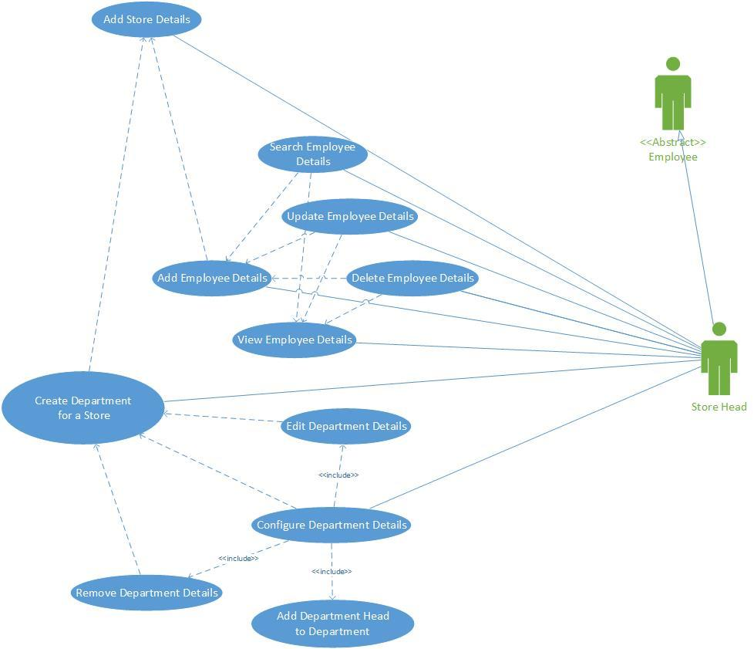

**Use case Description:**

* **Use Case Name:** Creation of a new store
* **Participating actors:** Head of the store
* **Objectives of the use case:**

Objective of this use case is to create a new store in which Store Head adds departments to the new store and manages the details of the employees of the new store. He configures details of the department which includes assigning a head to each department. Also configuring Department Details includes editing department and removing Department from the store.

* **Pre-conditions:** Store head should be able login to the application by authenticating his/her credentials
* **Post-conditions:** There should be a new store configured with the department and employee details.
* **Primary Flow of events:**

Store head logs in into the application. He adds Employee Details. After adding the employee details, he can search for the Employee Details to either update or delete the details of the Employee. He also adds the New Store Details. After the store is created and employee details are added, she/he adds Department Name and assigns Department Head to the new store. After Adding Department details, he/she can configure the department details. While configuring the Department details, he/she can either add new Department to the new store and assign department head or edit or remove the already added department details from the store.

* **Formal model:**

**Activity Diagram**

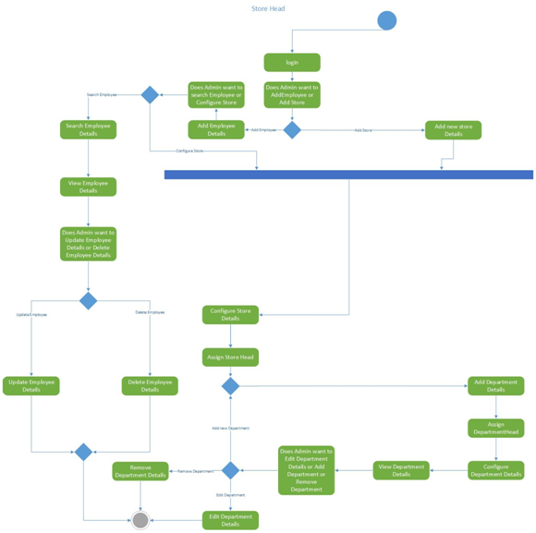

**3.2. Inventory Management:**

**Inventory Management Use case model:**

**Use case diagram:**

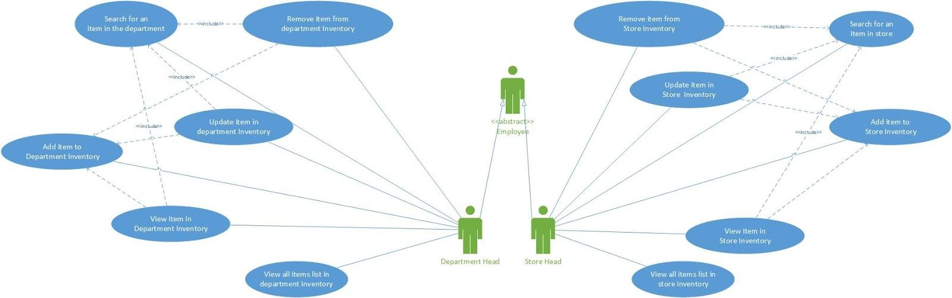

**Use case Description:**

1. **Use case name:** Inventory Management
2. **Participating Actors:** Store Head, Department Head both of which are specializations of Employee
3. **Goals of the use case:** Store head must be able to manipulate items in store inventory. Department Head should be able to manipulate items in store inventory that belong to his/ her department
4. **Pre-Conditions and Post-Conditions:**
   1. **Pre-Conditions:** The Store Head must be logged in to exercise any of his use cases. The Department Head must be logged in to exercise any of his use cases.
   2. **Post-Conditions:** Changes are made to store inventory based on the actions of the Store head or Department Head
5. **Primary and Alternative Flow of Events:** The Store Head can add an item to the store inventory. The Store Head can search an item in the store inventory. The Store Head can search and view an item in the store inventory. The Store Head can search and update an item in the store inventory. The Store Head can search and remove an item in the store inventory. The Store Head can view a list of all items in the inventory. The Department Head can add an item to his department inventory. The Department Head can search an item in his department. The Department Head can search and view an item in his department. The Department Head can search and update an item in his department. The Department Head can search and remove an item in his department. The Department Head can view a list all items in his department.
6. **Formal Model:**

**Activity Diagram:**

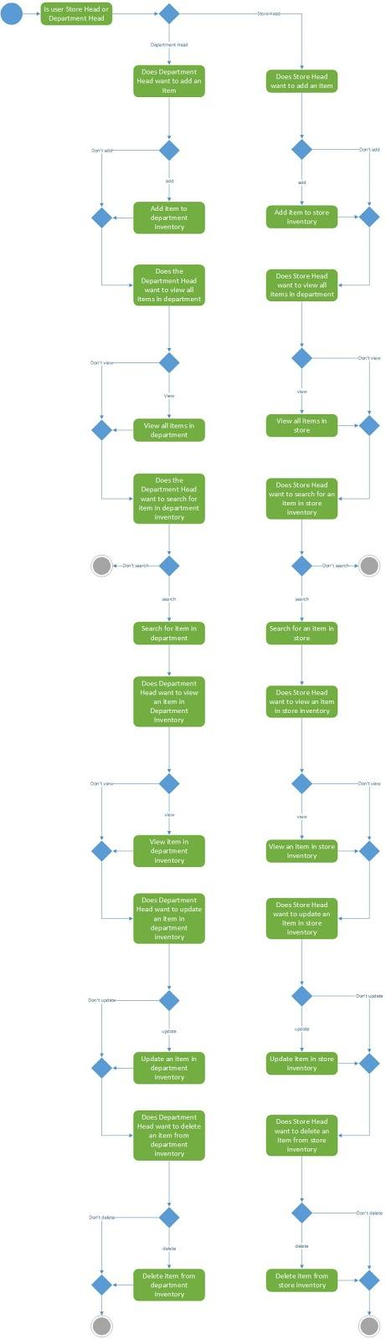

**3.3**. **Promotions and Clearance**:

**Architecture View:**

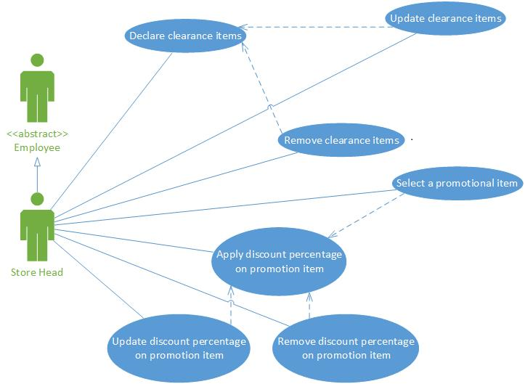

**Use Case description:**

1. **Use Case Name:** Promotion and Clearances.
2. **Participating actors:** Store Head .
3. **Objective of the use case:** The main objective of this use case is to provide store head to apply discount percentage on promotional items and also to declare clearance items.
4. **Pre-conditions:** The store head should be able to login to the application
5. **Post-conditions:** Store head should be able to successfully update discount percentages and clearance details on items.
6. **Primary & Alternative Flow of events:**

Store head logins to the New Retail Store creation and maintenance application and chooses to add items under promotions or clearances. After selecting promotions or clearances store head can declare new promotions and clearances or modify the existing items that have already been declared. Store head can declare new promotional or clearance item after logging in to the application.If he selects an already existing promotional item he can add discount to the item or update or remove the promotional item. If he selects an already existing Clearance item he can update or remove the clearance item.

1. **Formal model:**

**Activity Diagram**

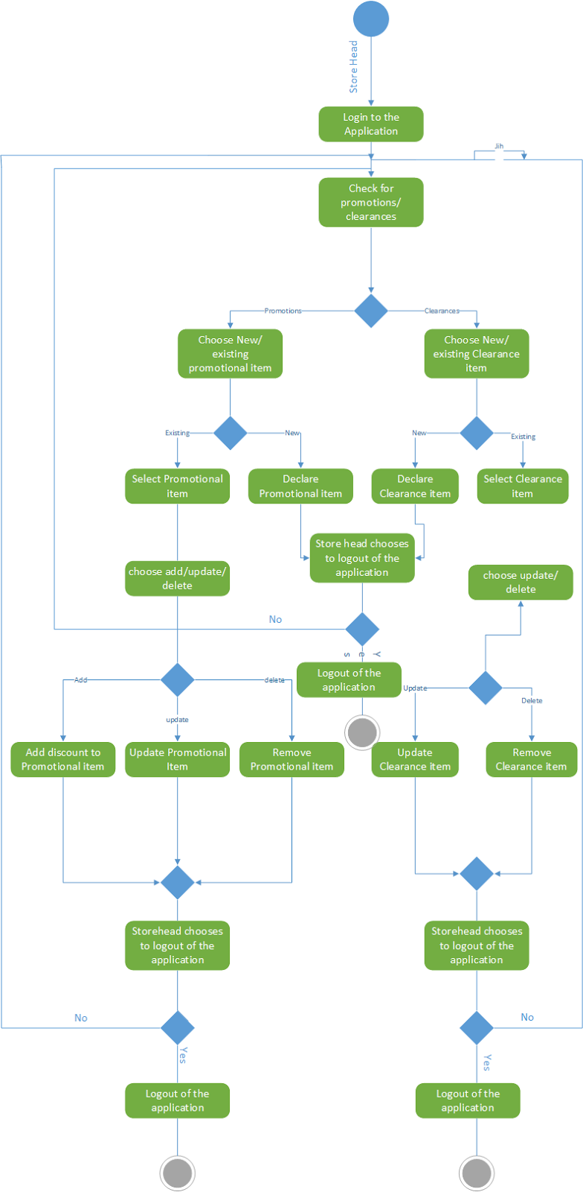

## Customer Point System:

**Architecture View:**

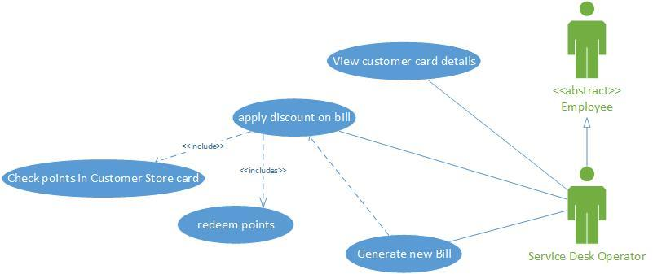

**Use Case description:**

1. **Use Case Name:** Customer Point System.
2. **Participating actors:** Service desk operator.
3. **Objective of the use case:** The objective of this use case is to make frequent customers avail the Customer points system where the service desk operator checks the points present in customer’s store credit card, provide discount on the purchase of the customer if eligible, and generates a new bill receipt.
4. **Pre-conditions:** Customer requesting a store credit card and receiving a card from POS executive and purchasing using the store credit card. Also, service desk operator should be logged into the application.
5. **Post-conditions:** Customer should obtain discount on the billing if satisfactory points are present and points to be redeemed accordingly.
6. **Primary & Alternative Flow of events:**

When a customer visits the service desk, the service desk operator views the customer card details and the points present in the card on the request of customer. If the customer does not request for viewing points, The service desk operator moves to applying discount. If the customer does not request for discount on the billing, the process terminates. If the customer requests for discount, he checks for the points present in the card. Then, If the customer does not have sufficient points to avail discount, the process terminates. If the customer has required points, in parallel the service desk operator reduces the bill amount and points are redeemed in the customer card. After the reduction of both bill amount and the points, he generates a new bill. Then the function of service desk operator terminates.

1. **Formal model:**

**Activity Diagram**

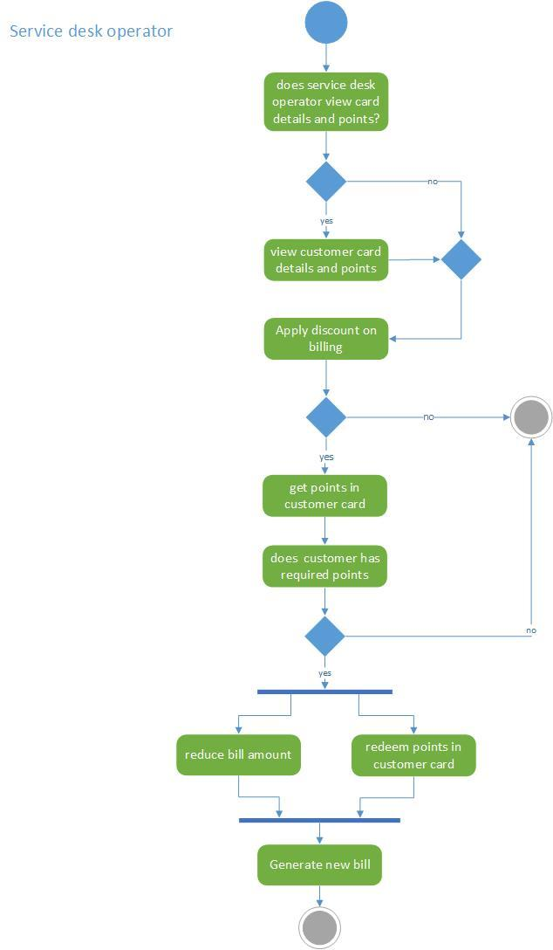

* 1. **POINT OF SALES**

**Architecture View:**

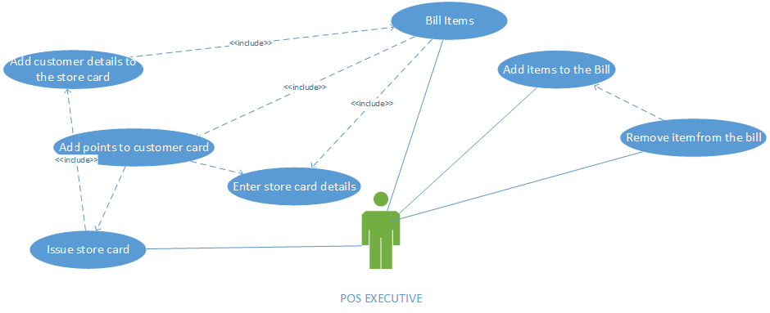

**Use Case description:**

1. **Use Case Name:** Point of Sales.
2. **Participating actors:** Point of Sales Executive
3. **Objective of the use case:** The primary objective of this use case is to enable the POS executive to Bill the items,as a part of it he can add items and he can also remove items for billing and he also adds points to the customer credit cards,if the customer holds the store’s credit card.If the customer do not have any card and he would make decision based upon the existence of request for card in the system,pos executive would issue card and then the points would be added to the card based on the billing amount and generate the reciept.In case, if there is no request for card he would directly generate the reciept
4. **Pre-conditions:** POS Executive should have access to the application.
5. **Post-conditions:** POS Executive should successfully add item and remove items for billing.The store credit card should be issued based on the existence of the request in the system.Post billing, the points will be added to the customer card based on the billing amount.Finally the recieptshould be generated.
6. **Primary & Alternative Flow of events:**POS executive is the person who bills the items.In order to bill the items,he adds the items to the bill,he can edit the shopping list to remove items for billing.After billing those items,he checks for the existence of store credit card.If card exists,then he card details to the system and the points are added to the card and generates the receipt. lf there is no existence of card,he then checks for the existence of credit card request.If the request exists,he then adds customer details to the card and issues the card.After which he enters the card details in the system the points are added to the card and generates the receipt,if there is no card request,he directly generates the receipt.
7. **Formal model:**

**Activity Diagram**

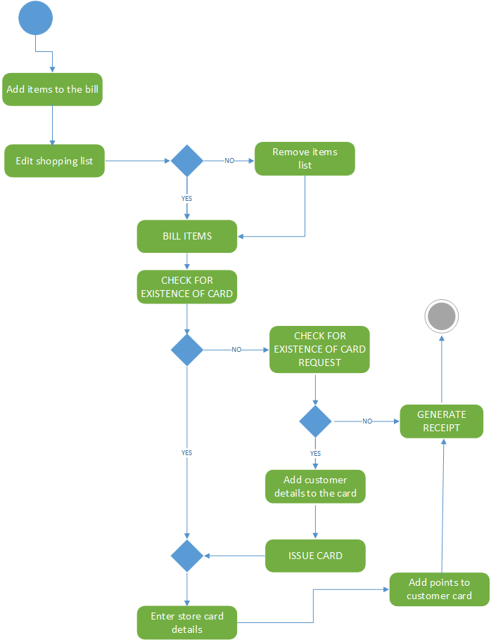

# Architectural Design

## 4.1 Subsystem Architecture

Briefly overview your architectural design. Discuss alternatives examined. Indicate why the architecture discussed in section 4.1 & 4.2 was chosen and why the alternatives were eliminated.

The following is the subsystem architecture design for New Retail Creation and Maintenance:

The application’s GUI is exposed as a REST service(NRSCMGUIService) and Business logic is exposed as a SOAP service(NRSCMService). The NRSCMGUIService is client to NRSCMService. These are in the application specific layer. The application generic layer has the database subsystem which is composed of database tables used by the application specific layer. The NRSCMGUIService and NRSCMService is subdivided into subsystem for each functional module.

The middleware layer has the HTML, Javascript/ jQuery, JSP and REST subsystems used by application GUI service. The GUI interface is accessed from web browser. The web browser and server (Wildfly) exchange HTTP messages. NRSCMService depends on SOAP, and MySQL subsystems in the middleware layer. JSP, JDBC, REST and SOAP subsystems are all Java API. The GUI and business service run on Wildfly server

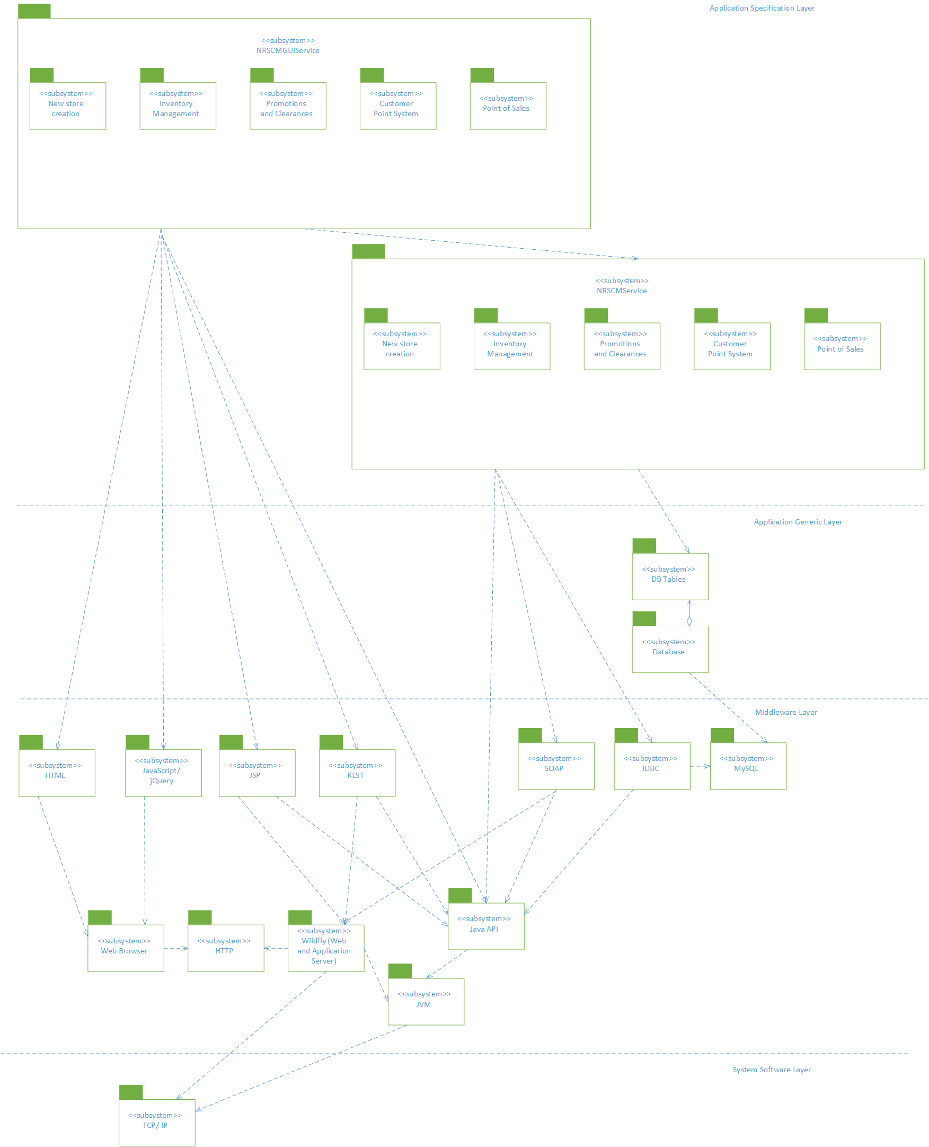

**Alternatives considered:**

This is another alternative design considered, without proper separation of GUI logic from business logic. This architecture design does not use any web service implementation.

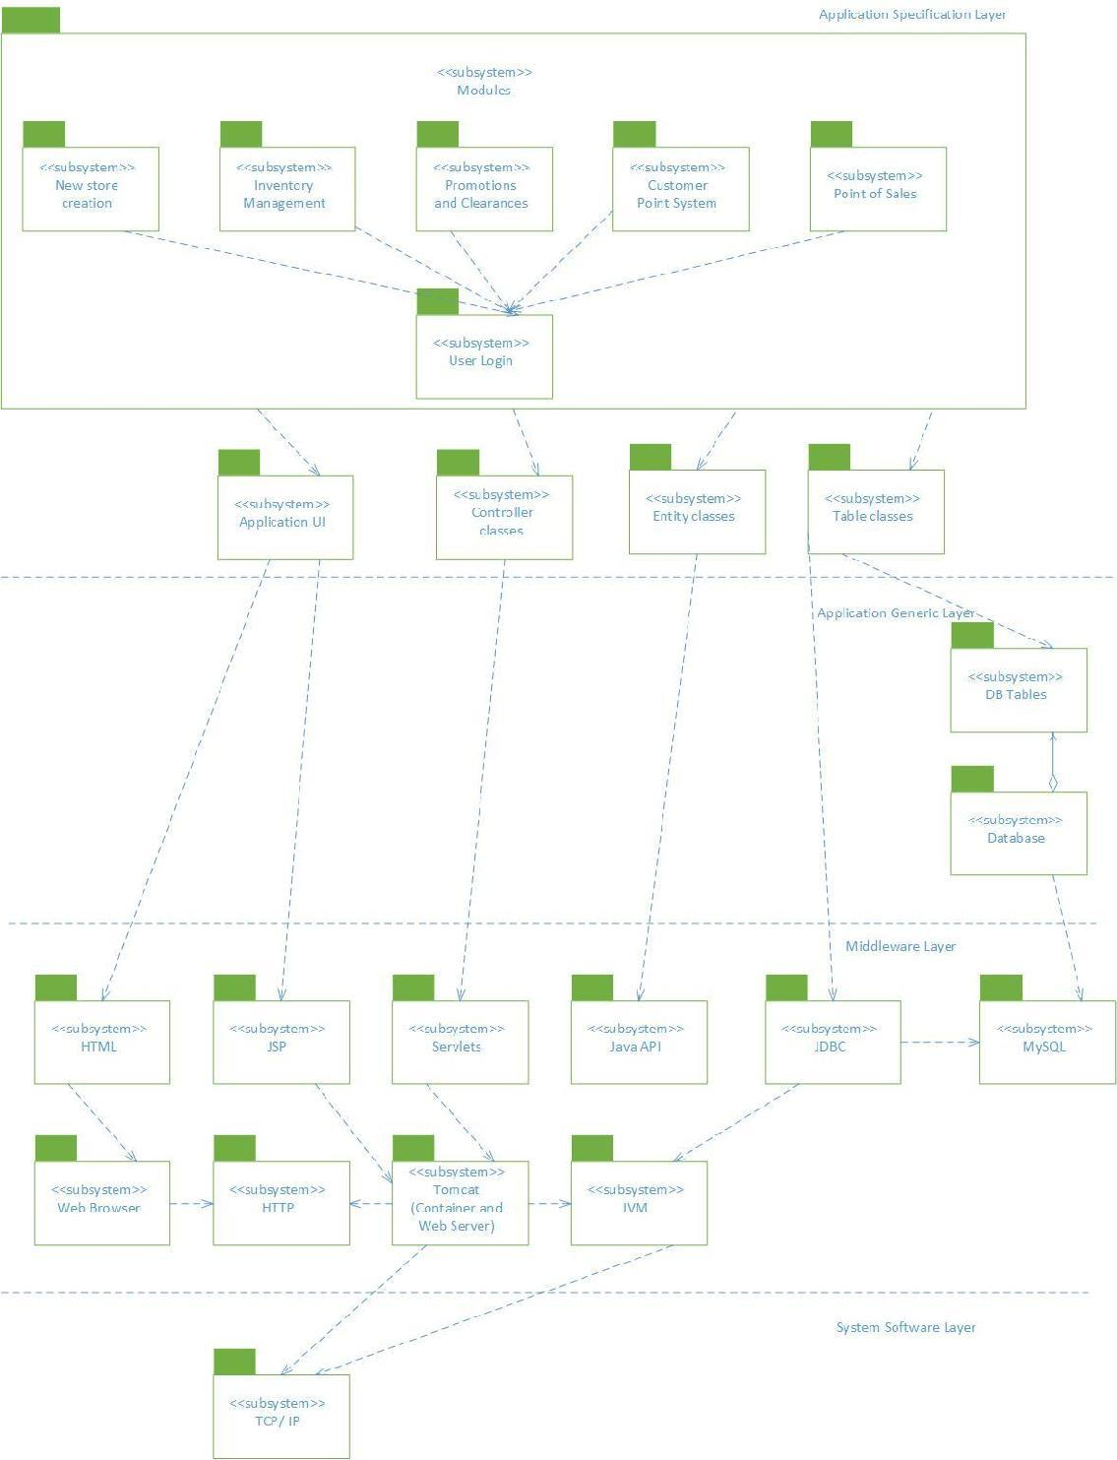

## 4.2 Deployment Model

The GUI service NRSCMGUIService is exposed as REST service is deployed on Wildfly server. The business logic service NRSCMService is exposed as SOAP service is also deployed on Wildfly application server. The GUI is accessed from Web Browser. The application GUI in browser communicates with GUI service using HTTP messages exchanges data in JSON format. The GUI service and business services communicate using SOAP XML messages. The business service uses JDBC api to communication with MySQL database server.

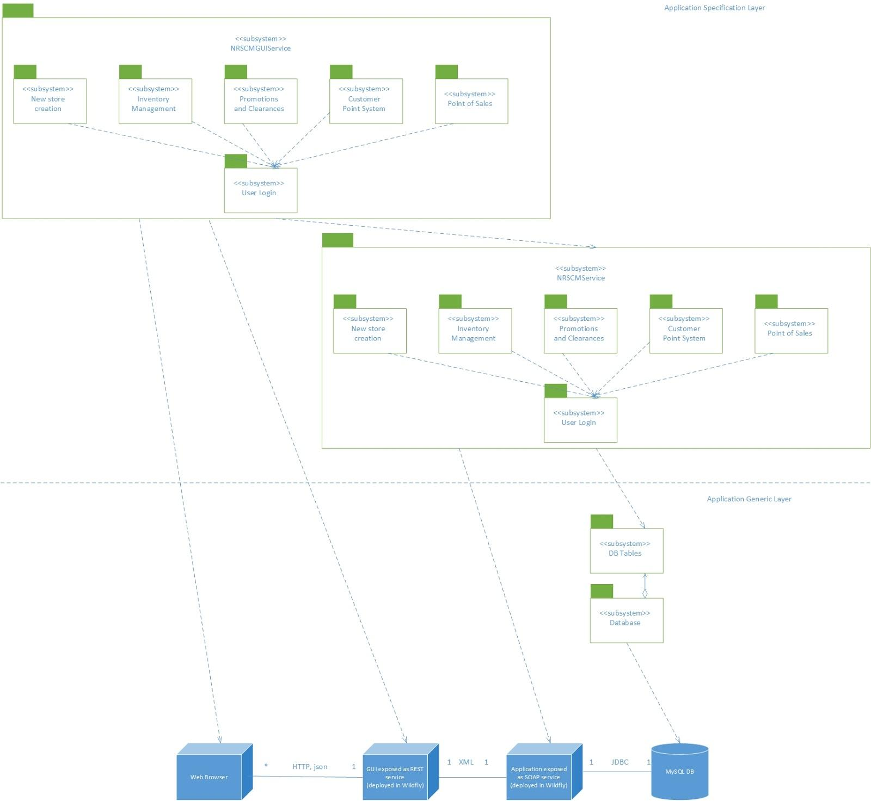

# Use Case Realization Design

**5.1 Creation of new store:**

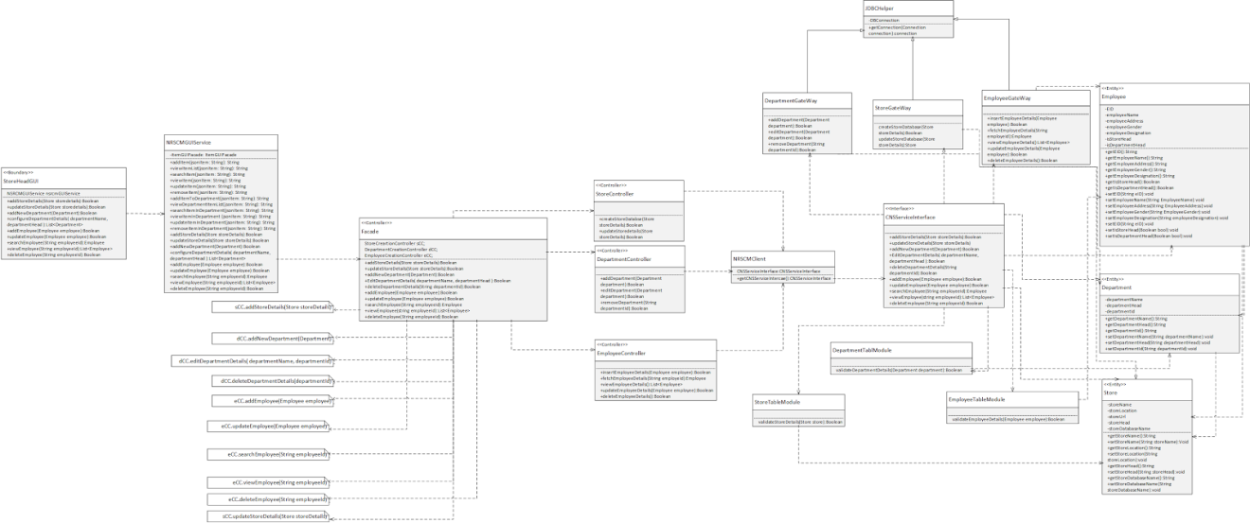

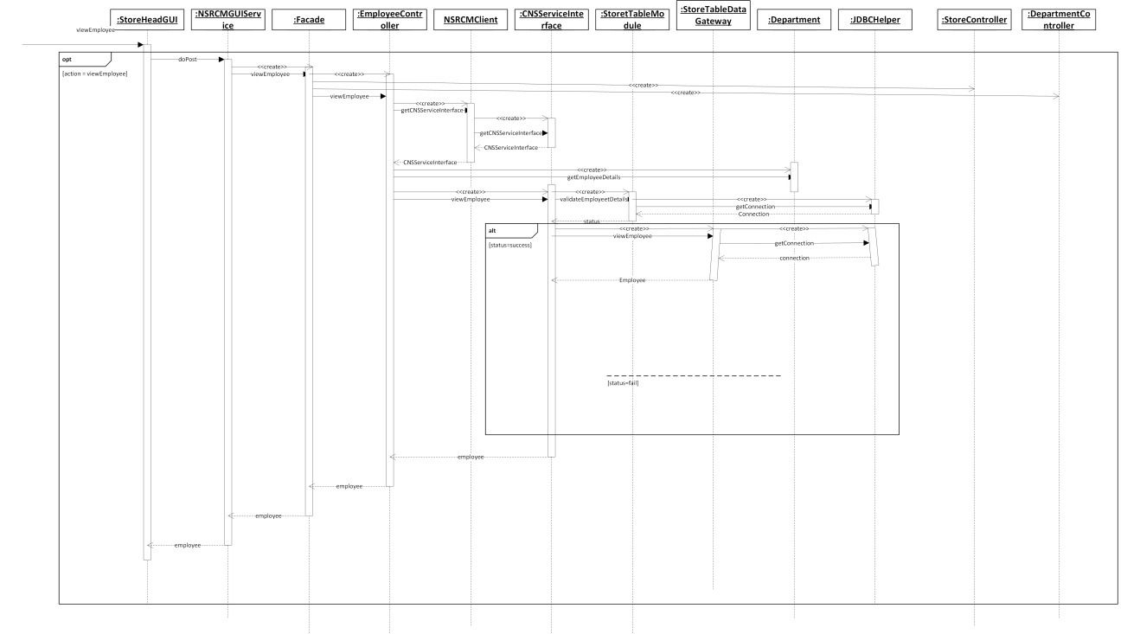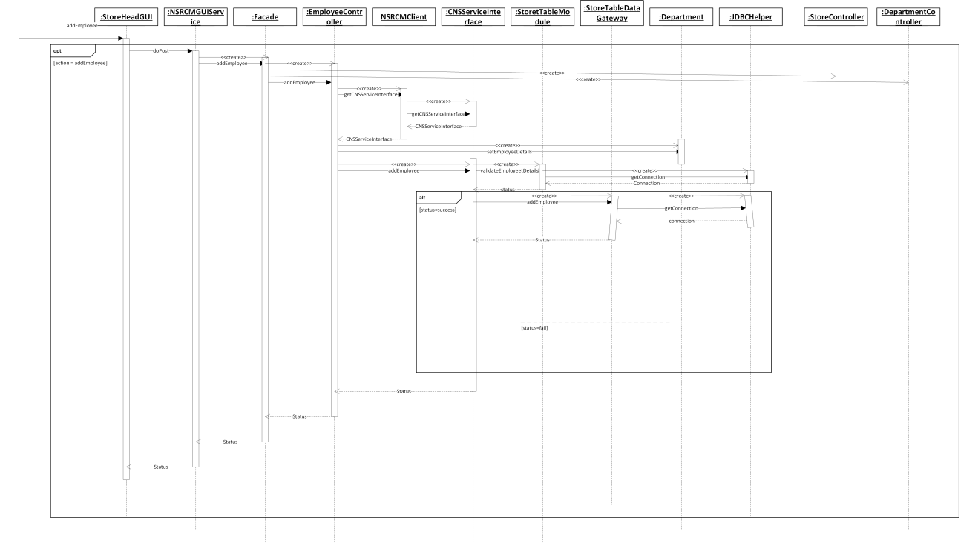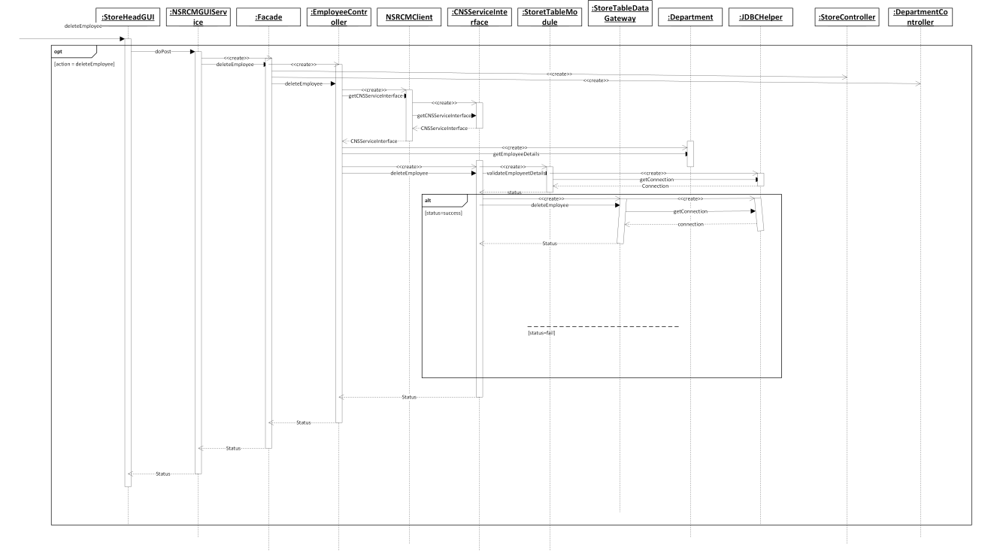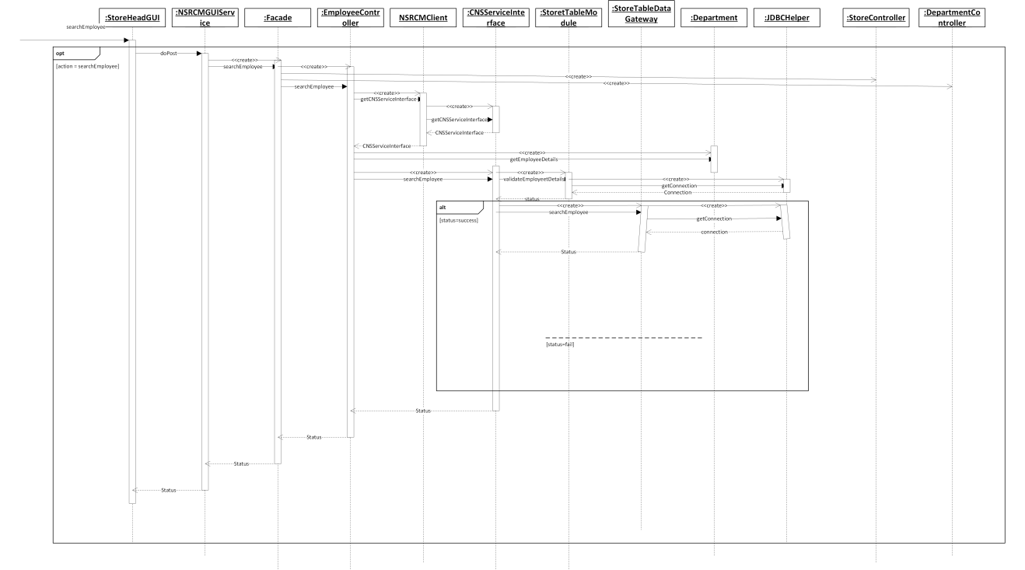

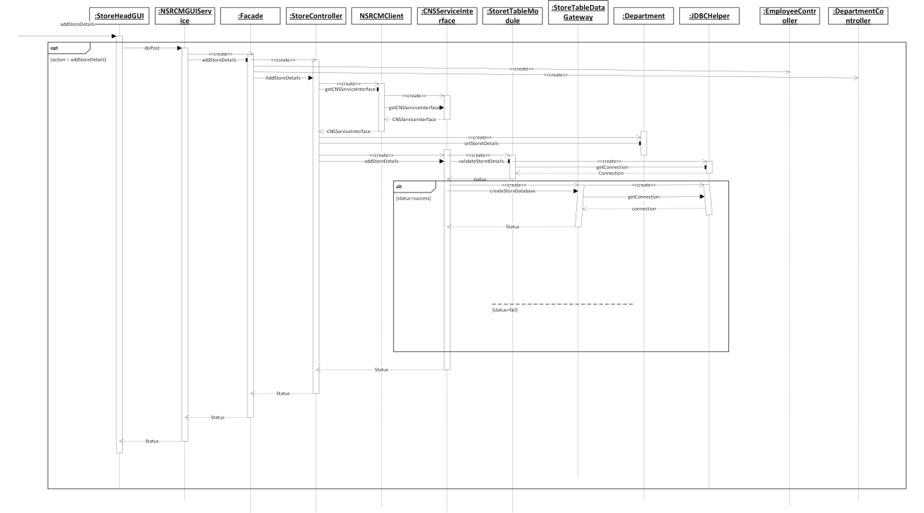

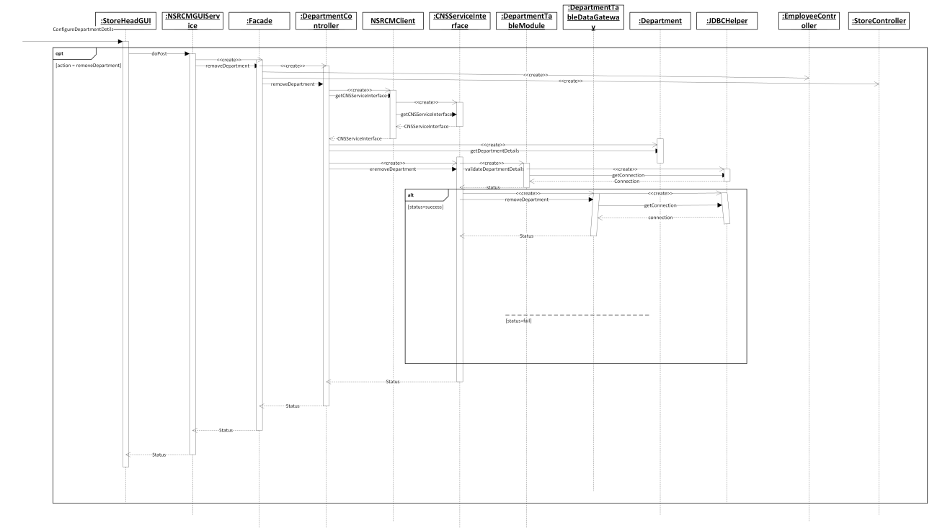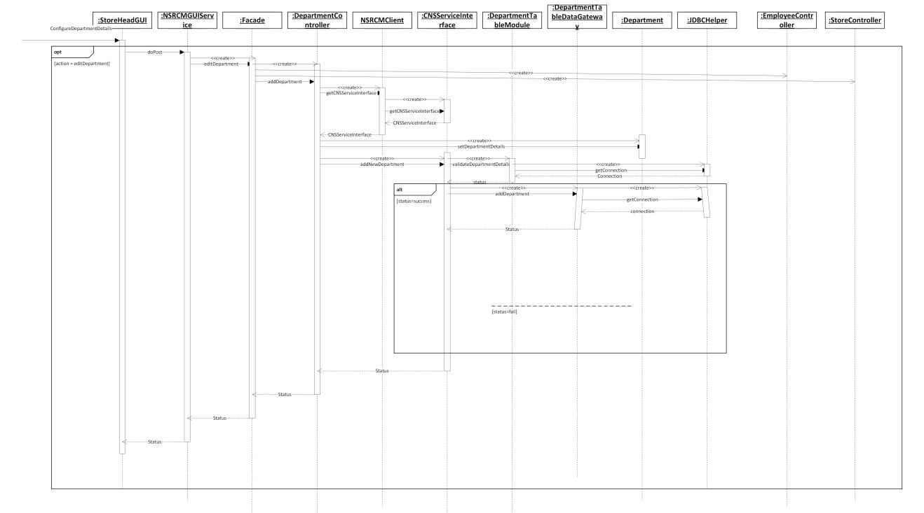**5.2 Inventory management**

**5.2.1 Class Diagram**

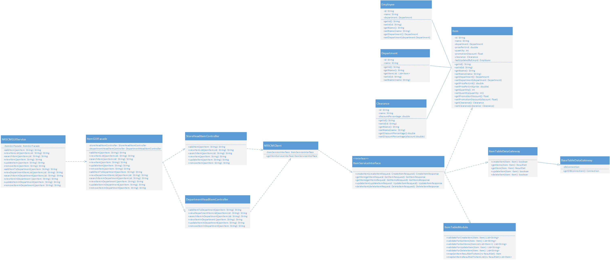

**5.2.2 Sequence Diagram**

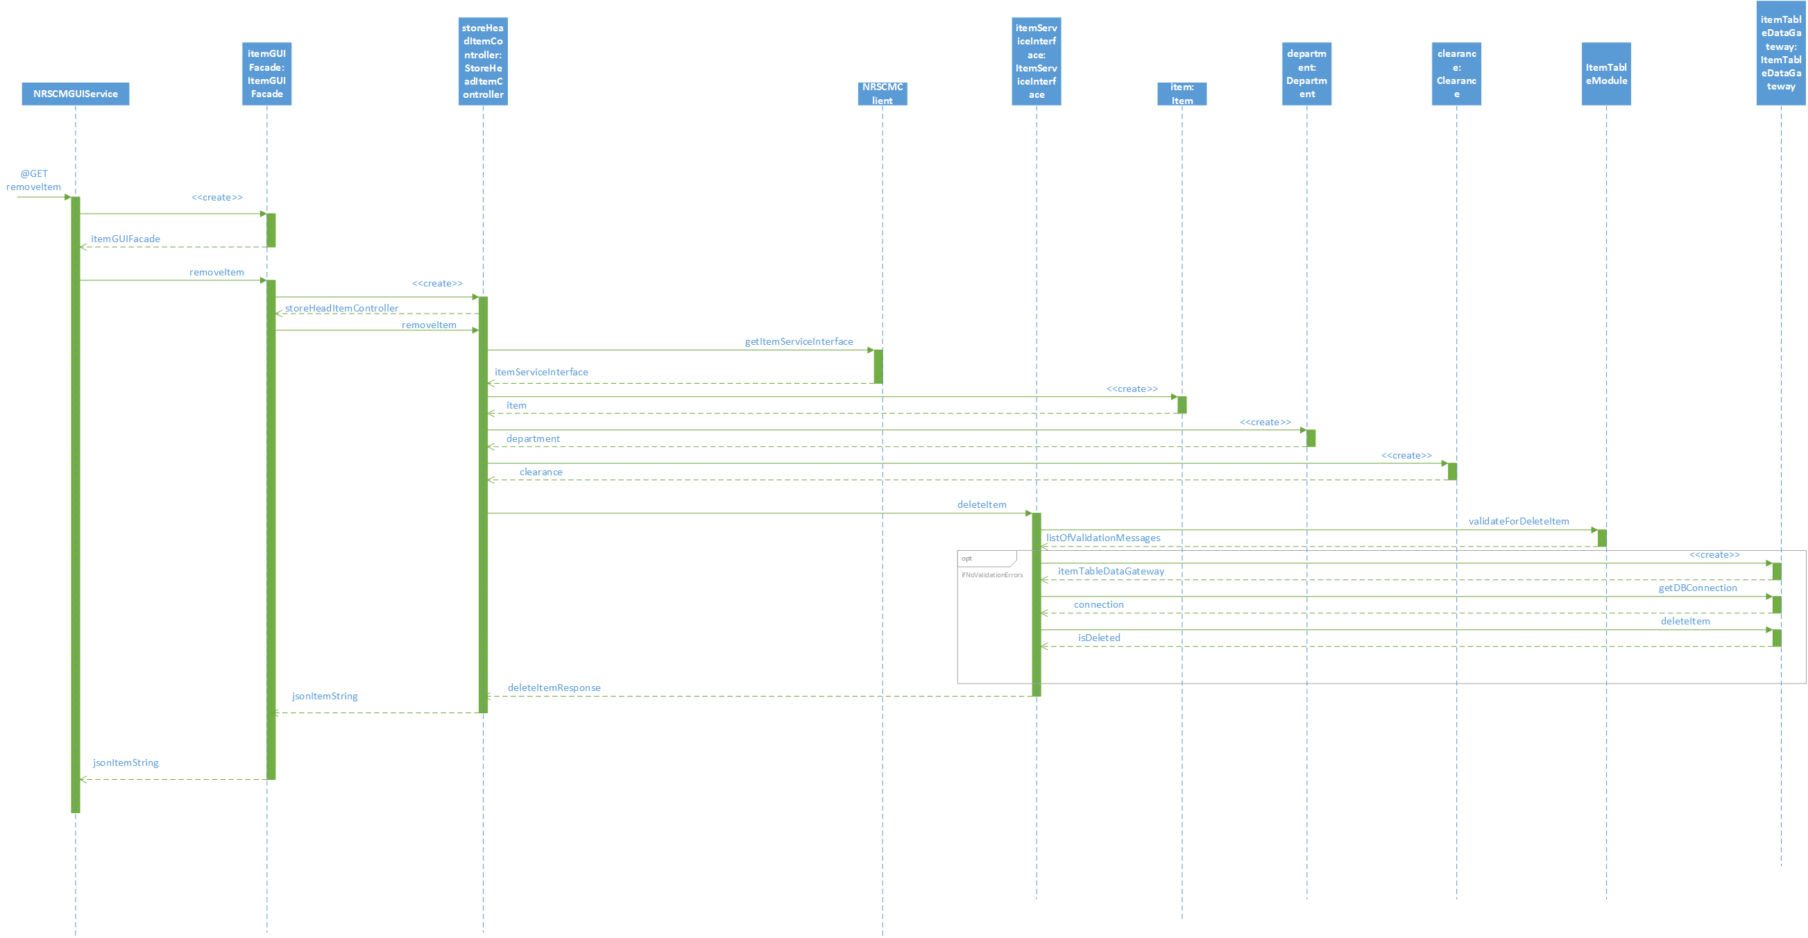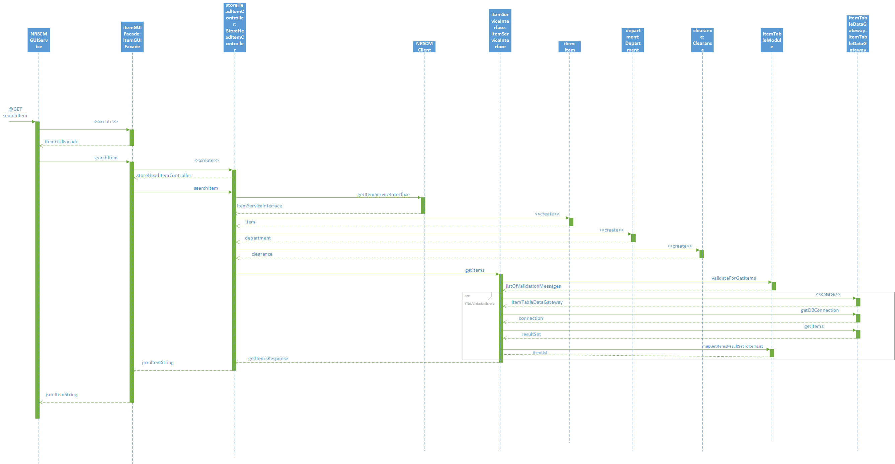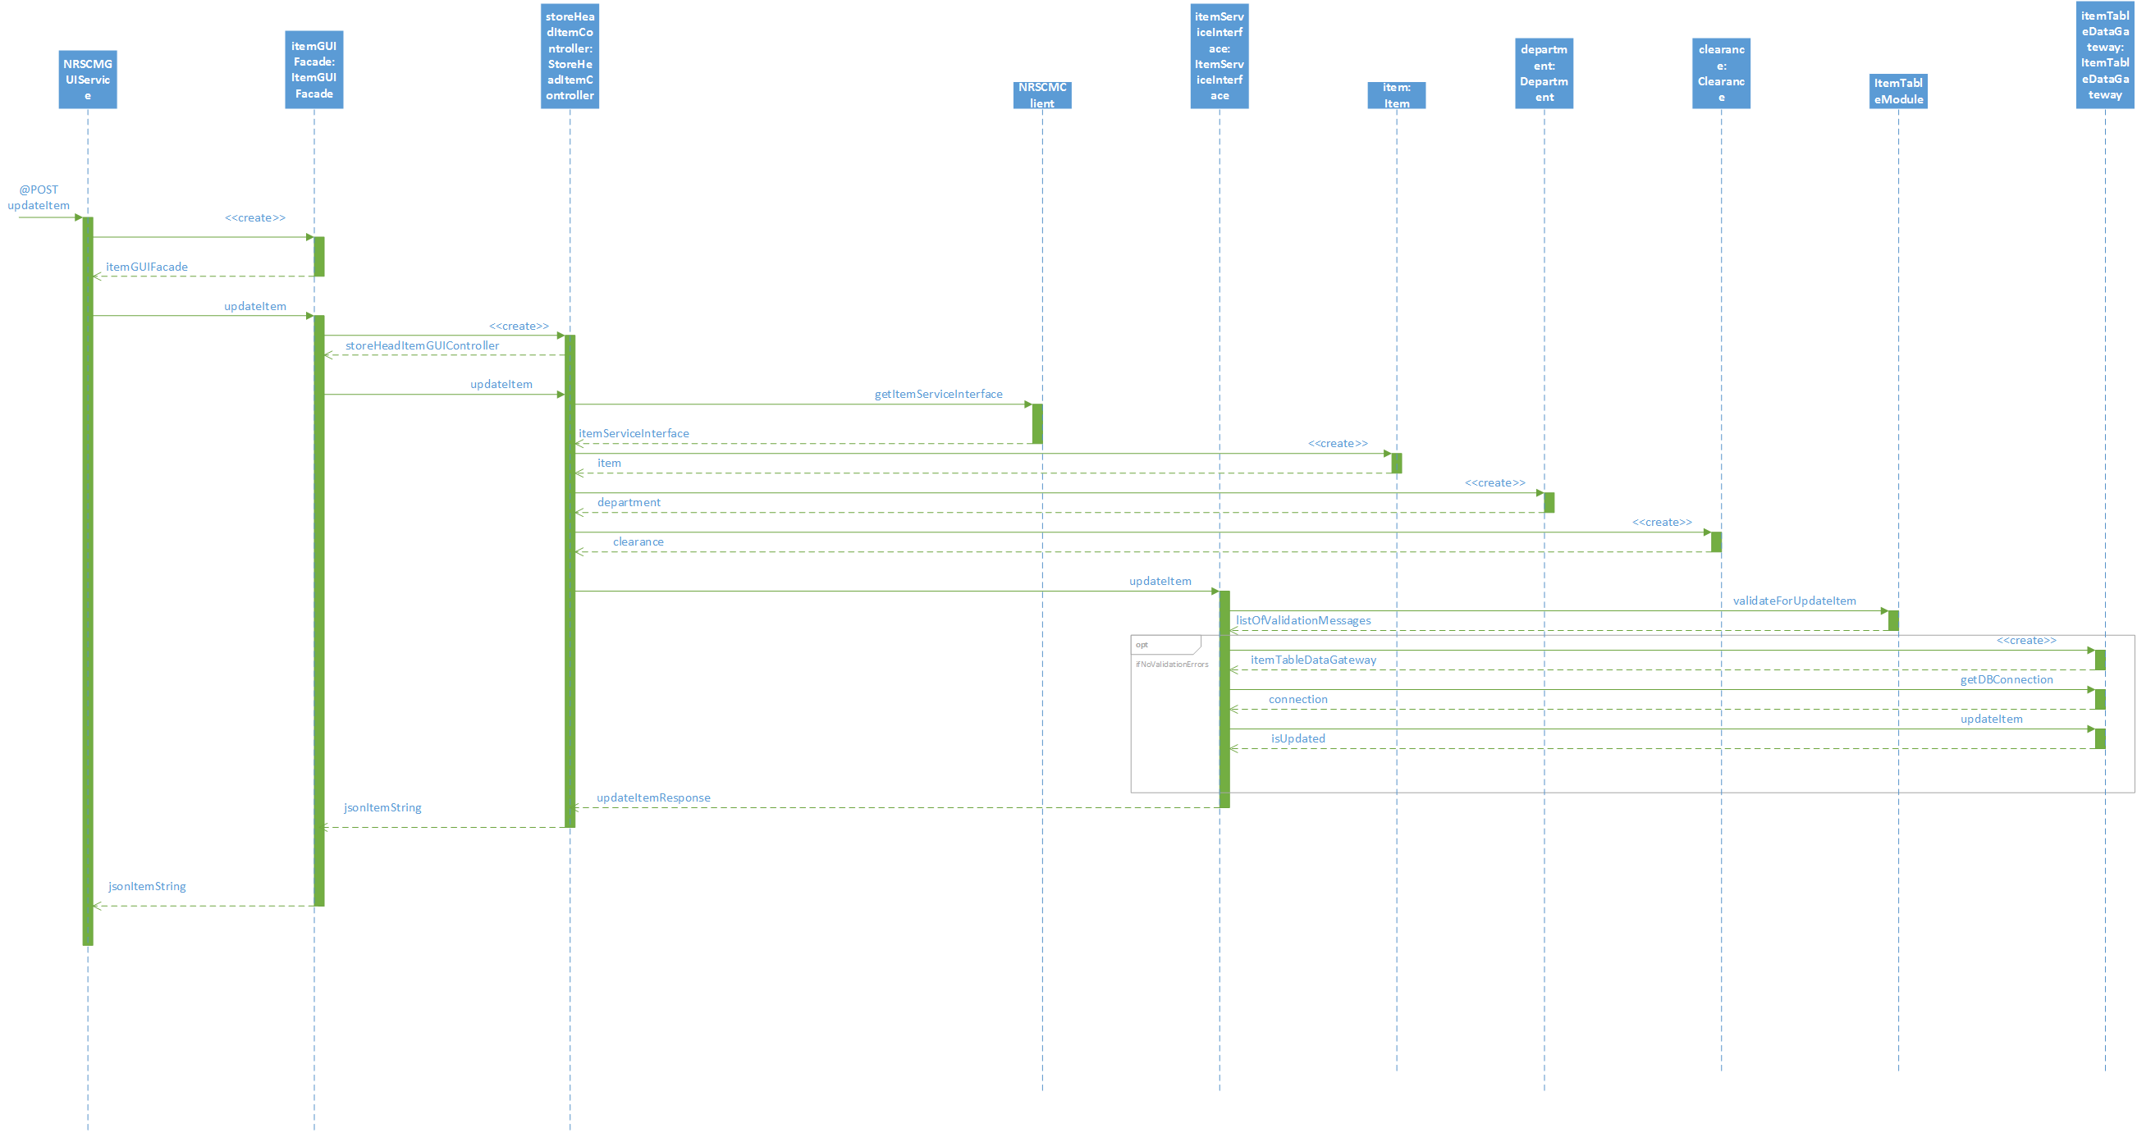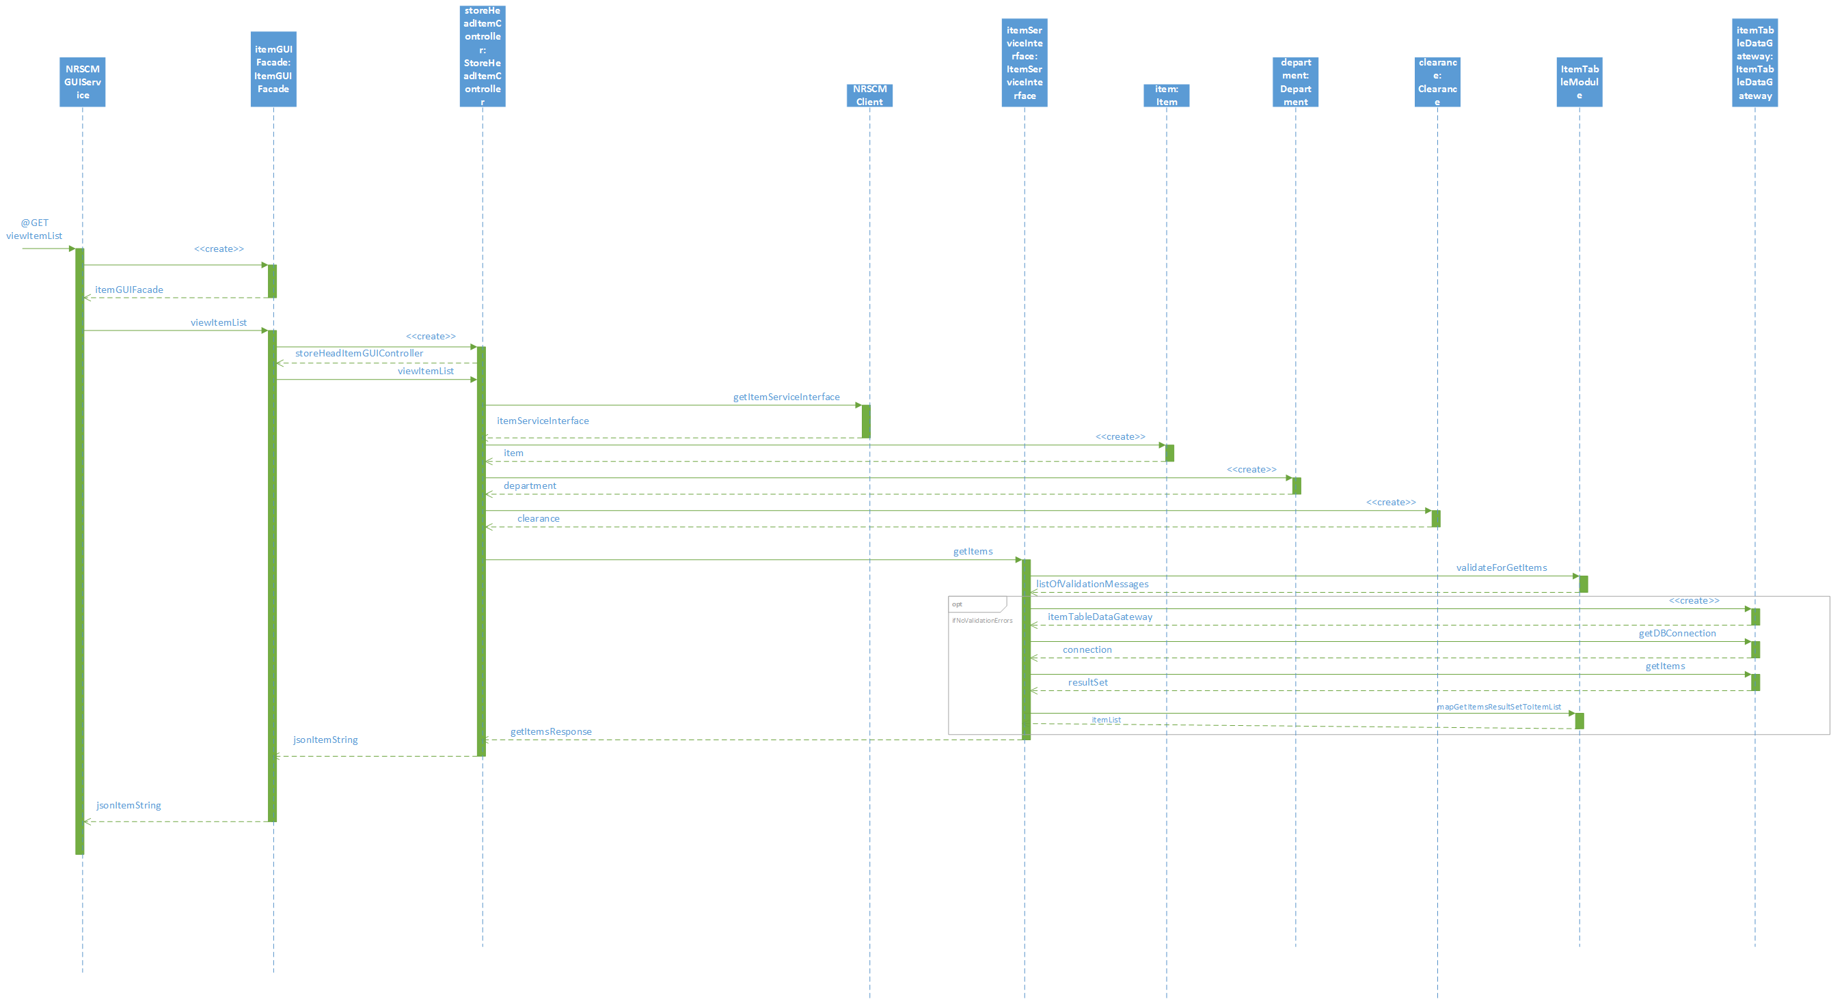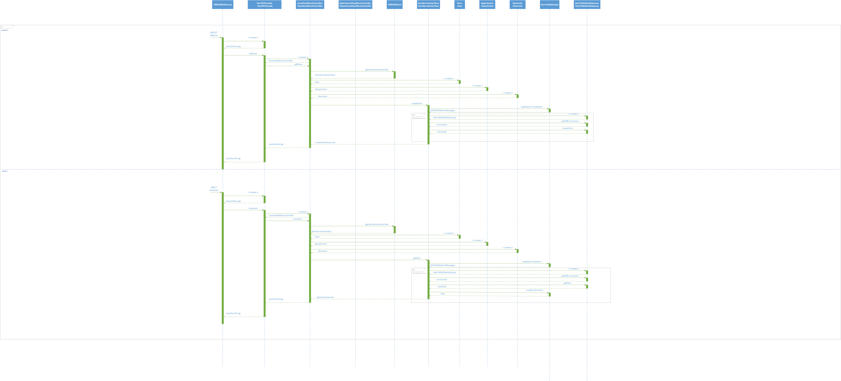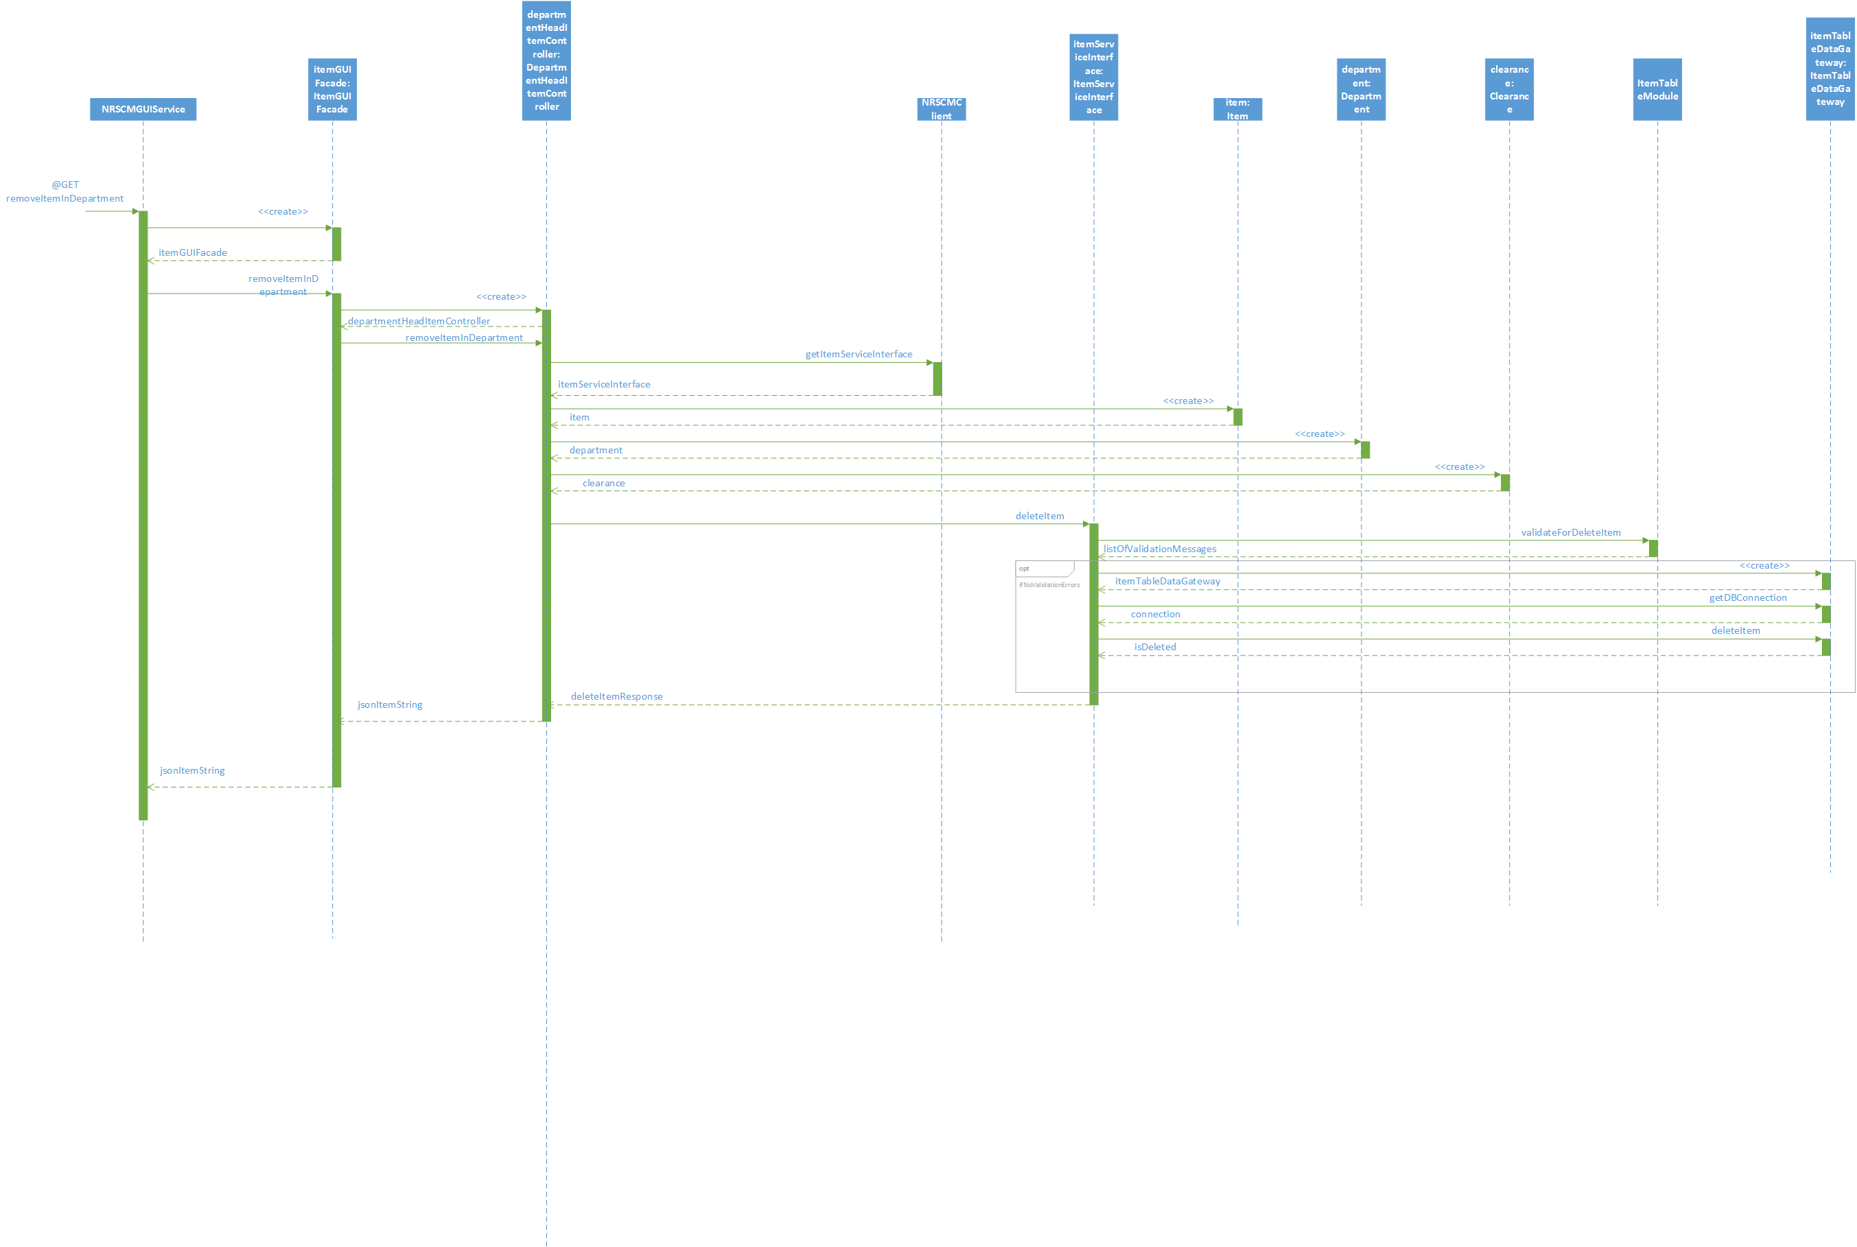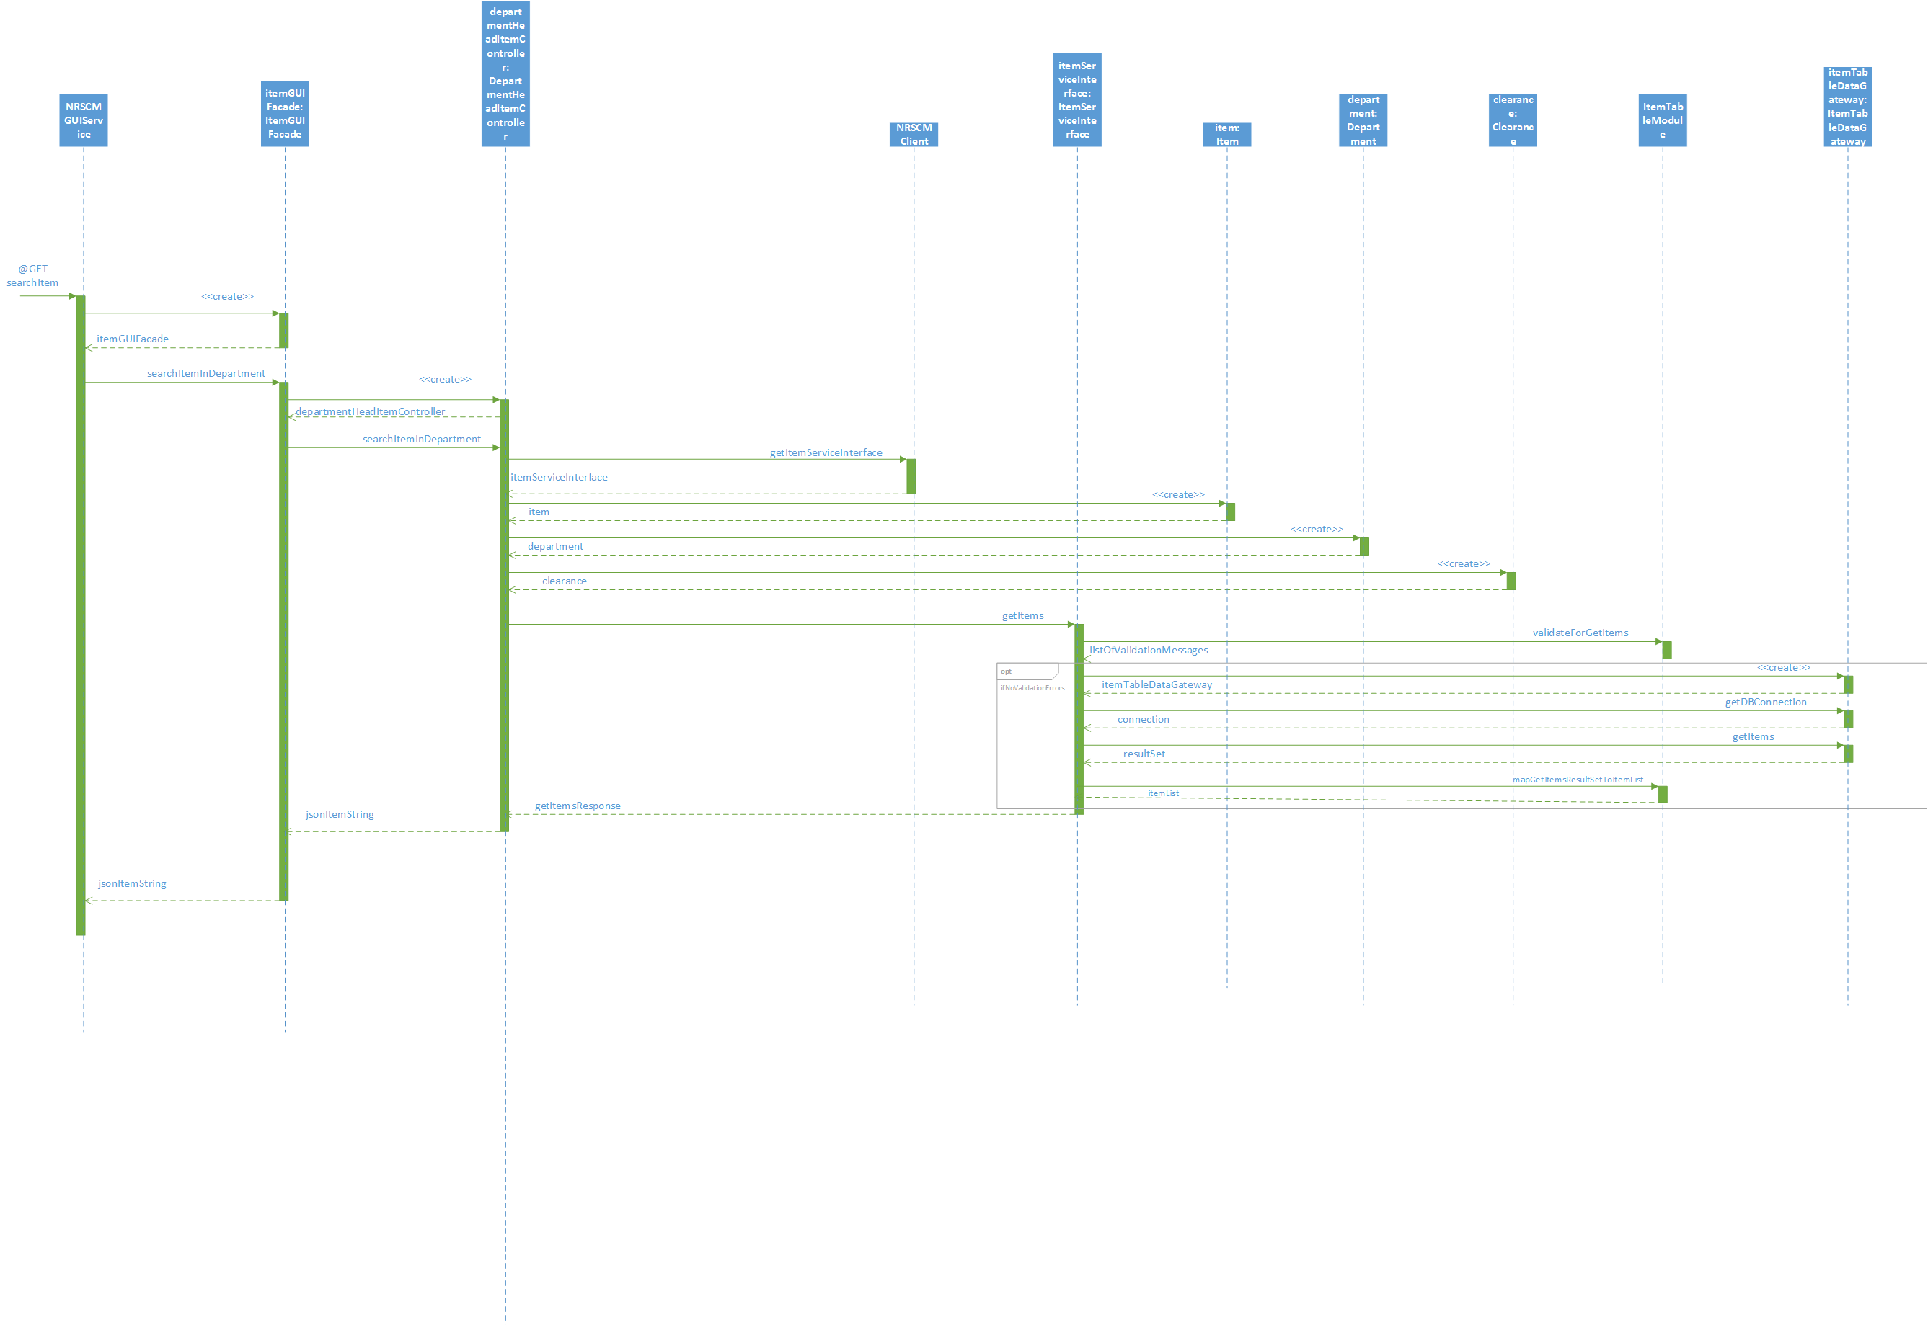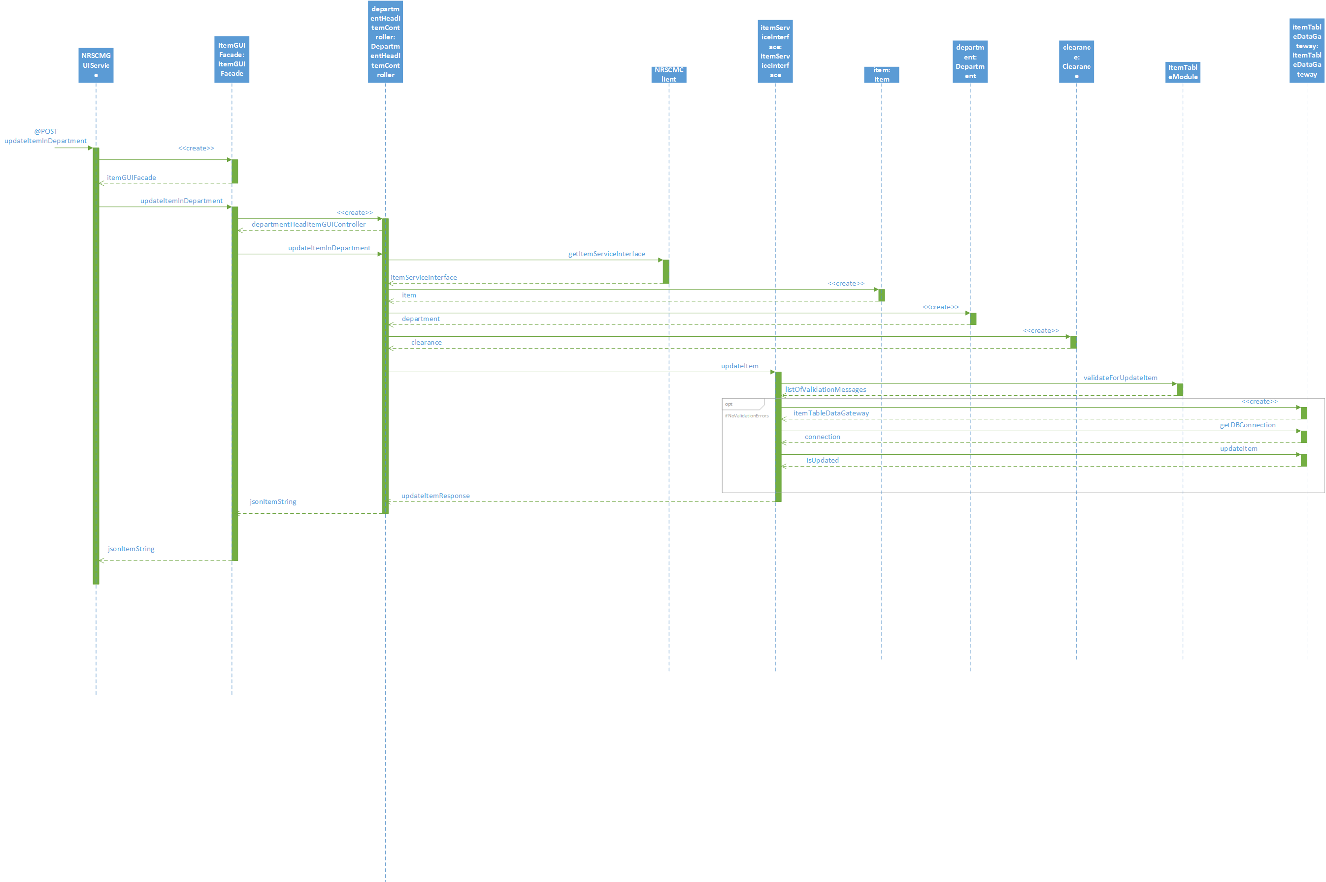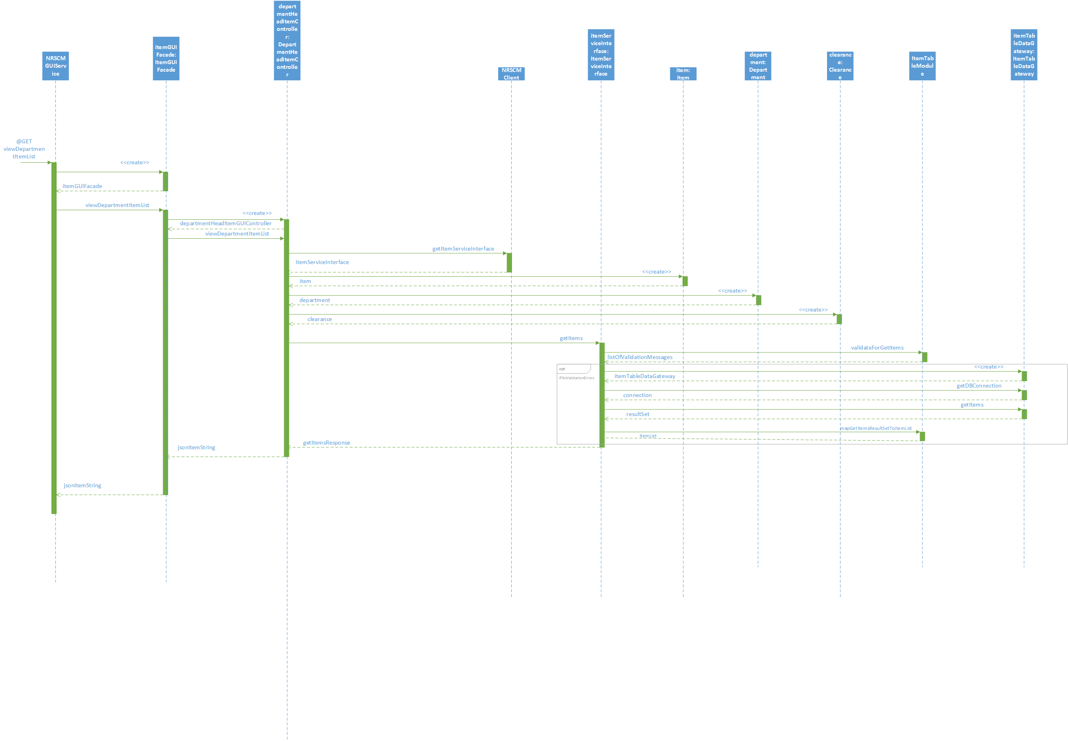

**5.3 PROMOTIONS AND CLEARANCES**

**5.3.1 Class diagram**

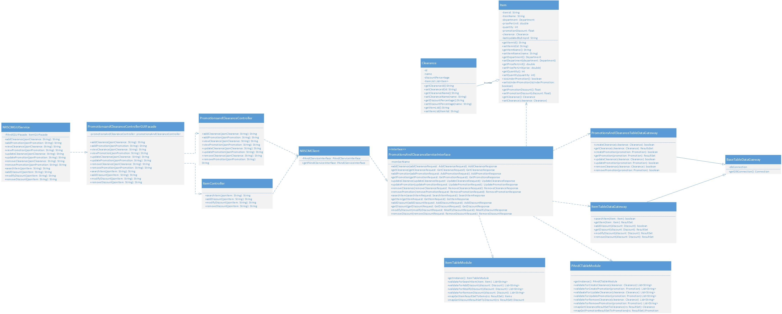

**5.3.2 Sequence diagram**

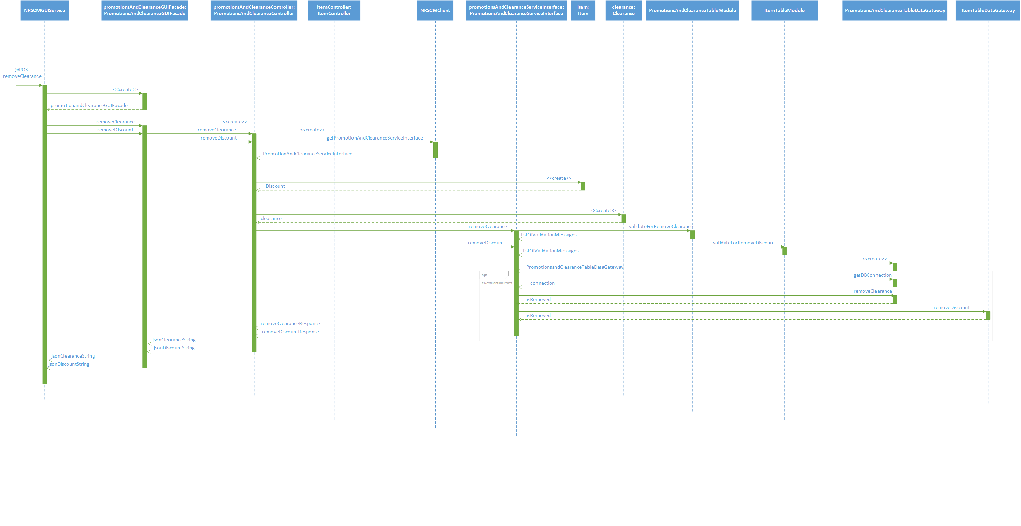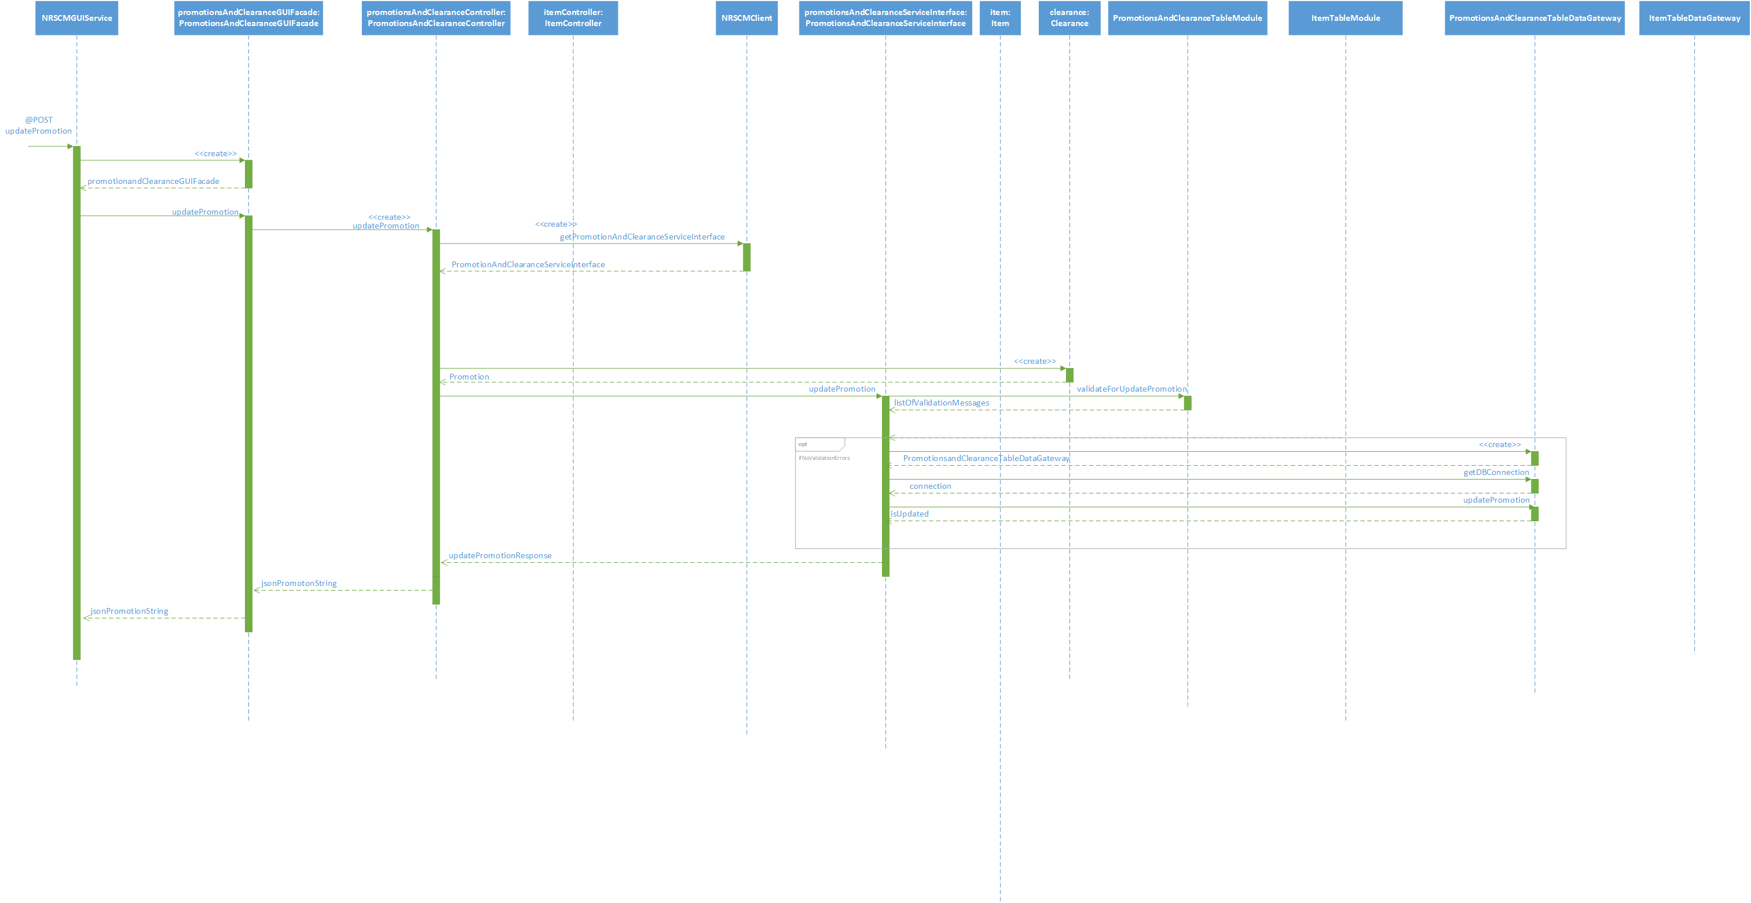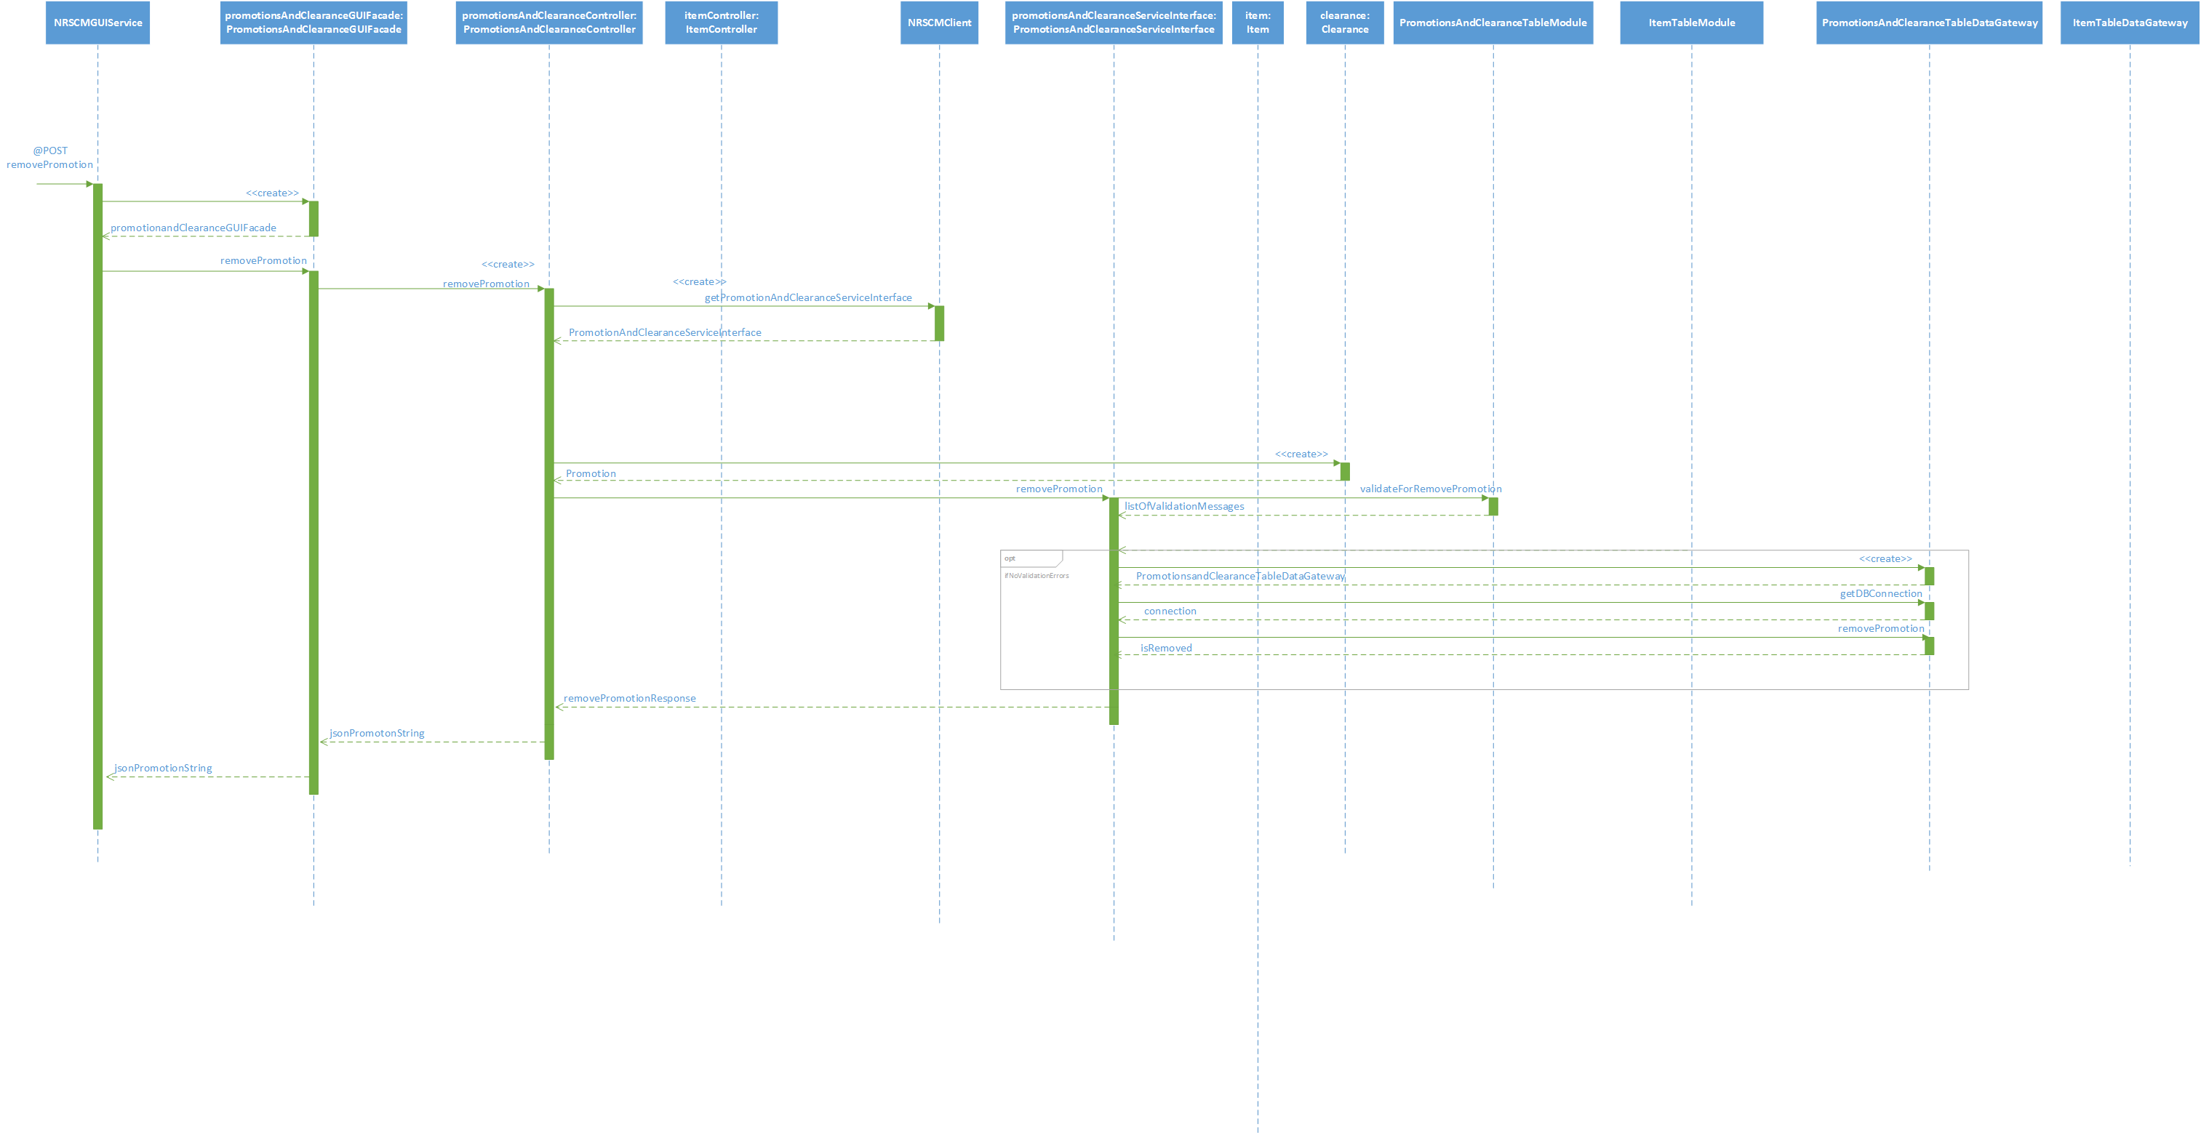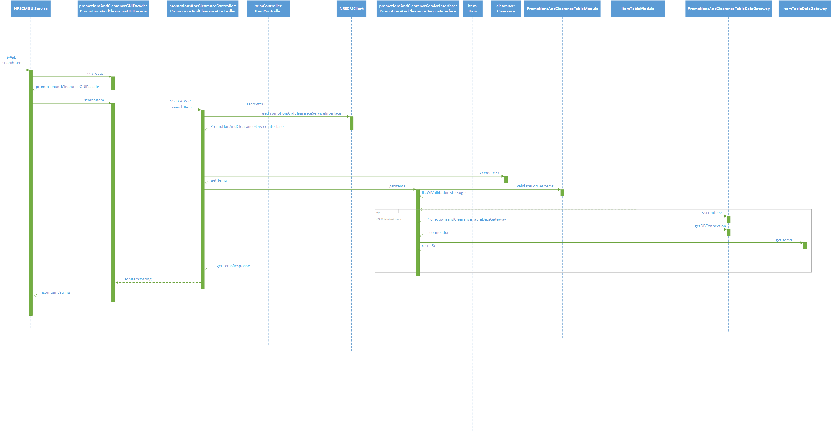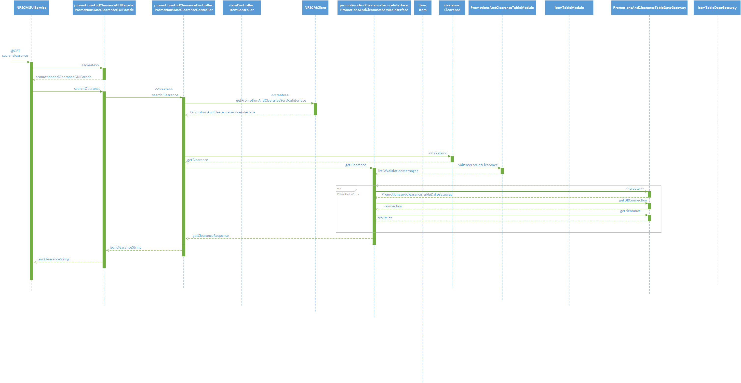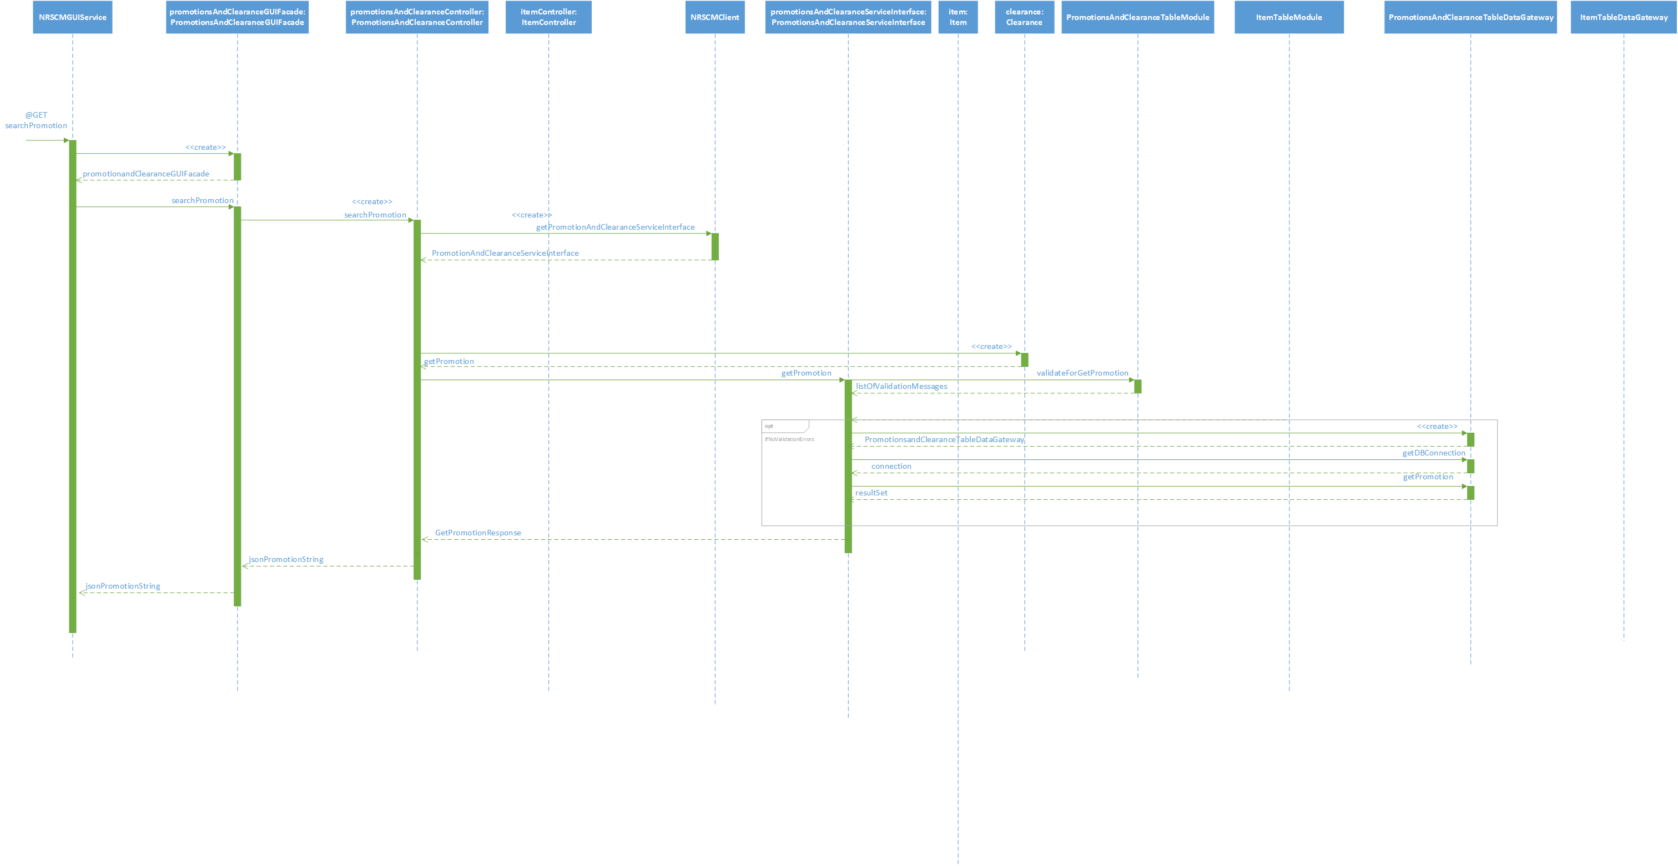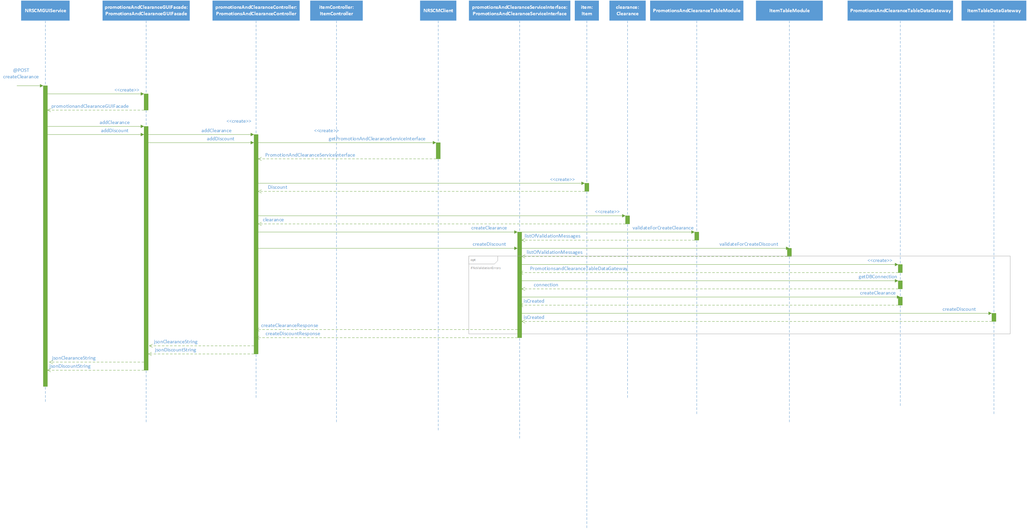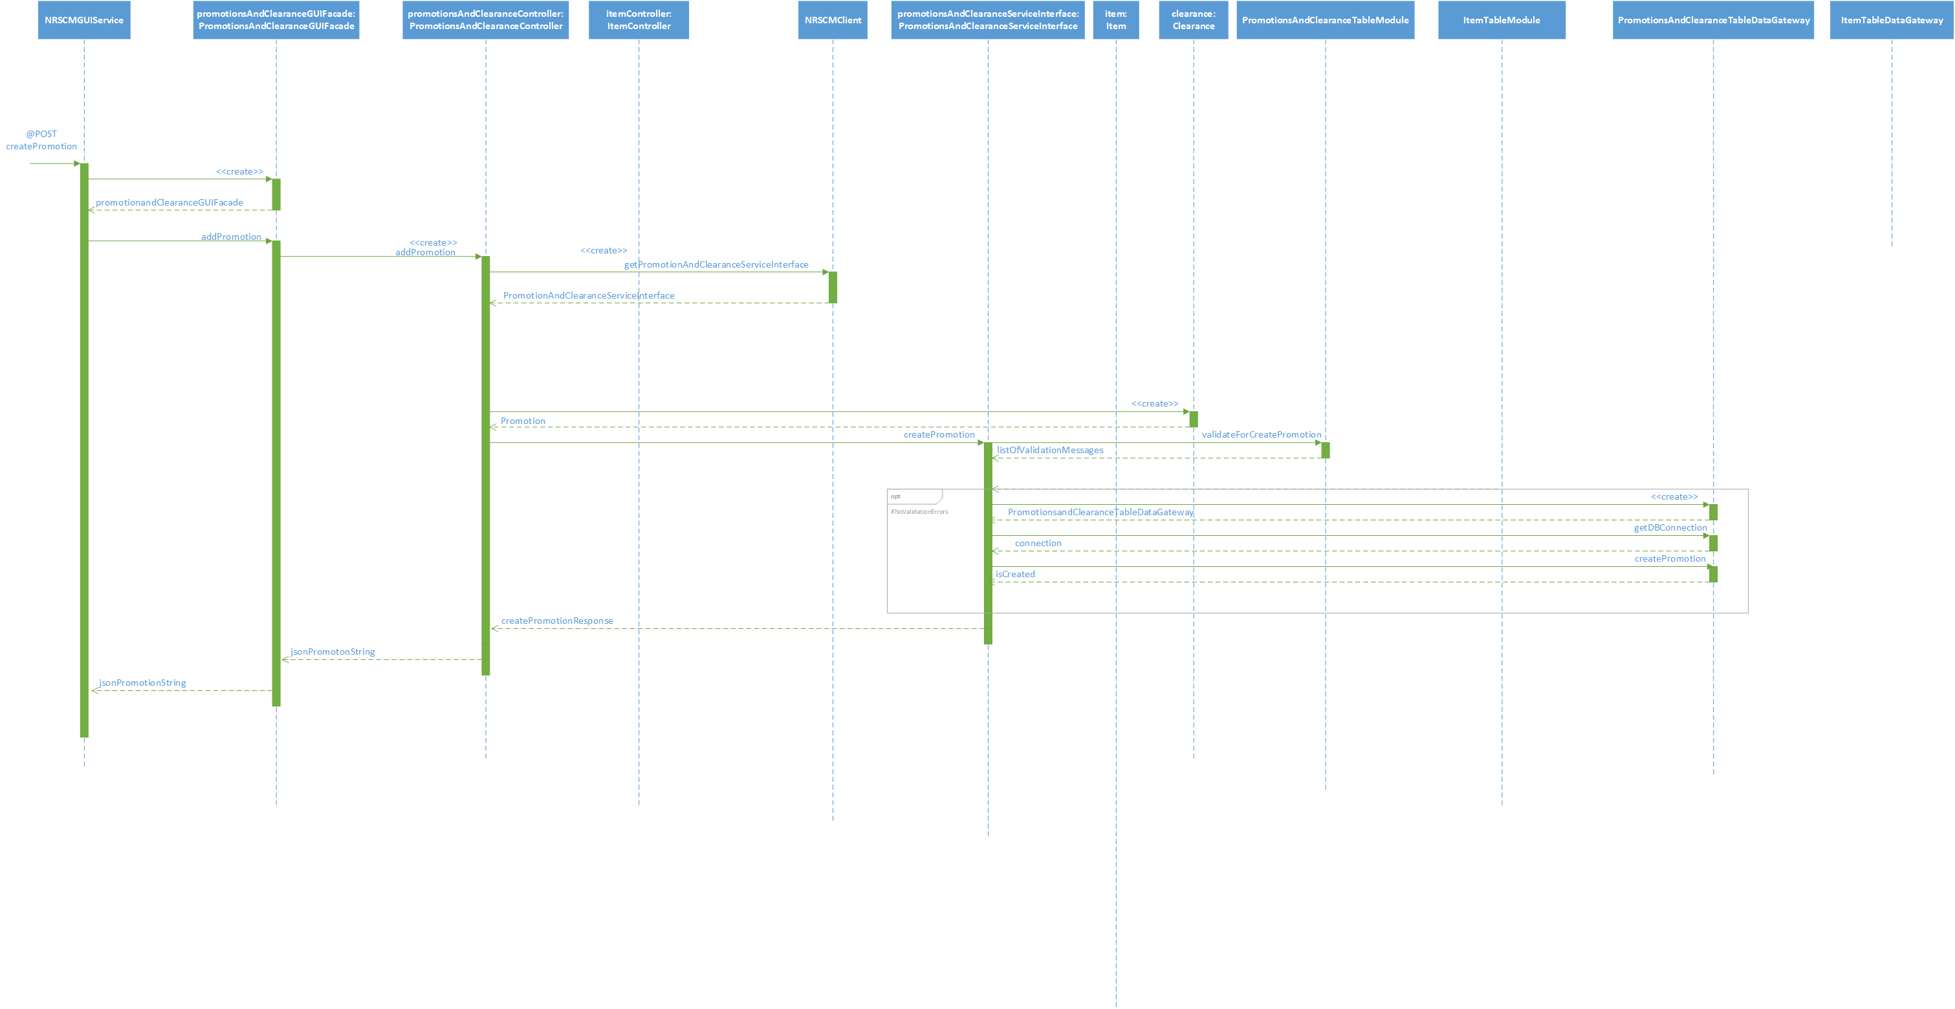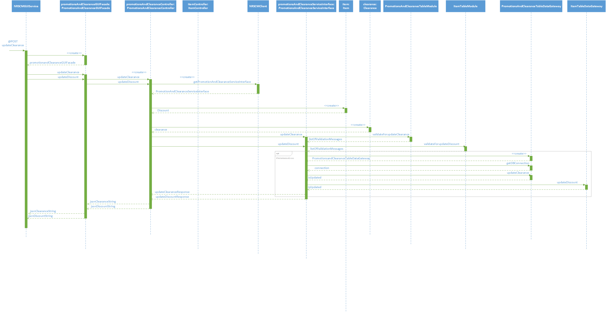

**5.4 CUSTOMER POINT SYSTEM**

**5.4.1 Class diagram**

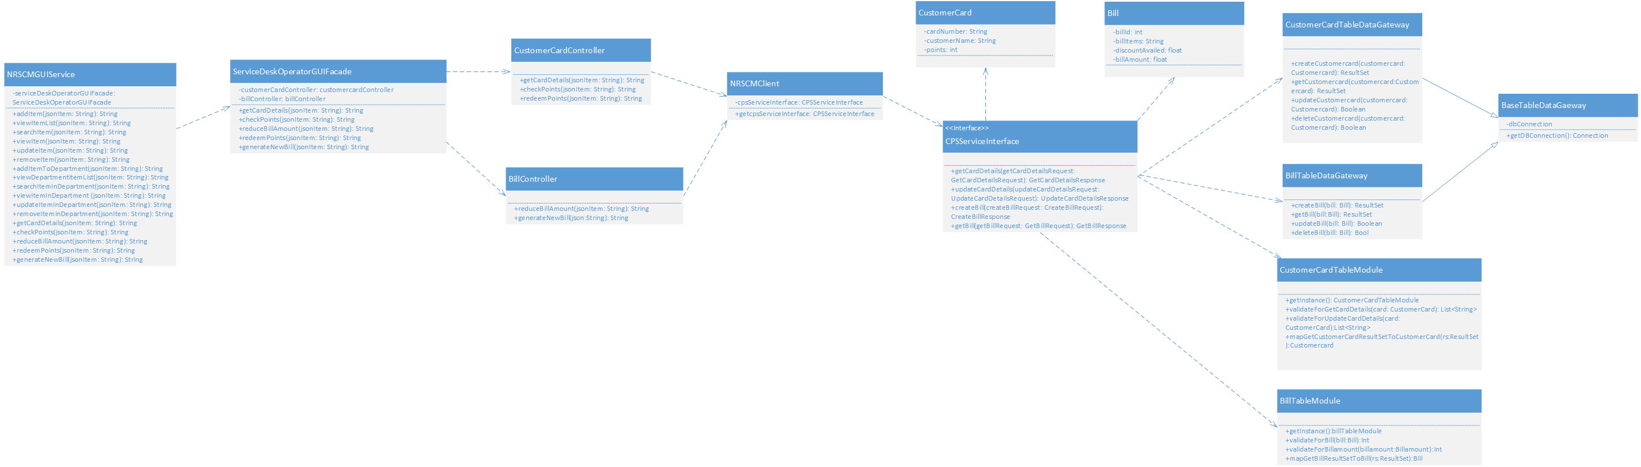

**5.4.2 SEQUENCE DIAGRAM:**

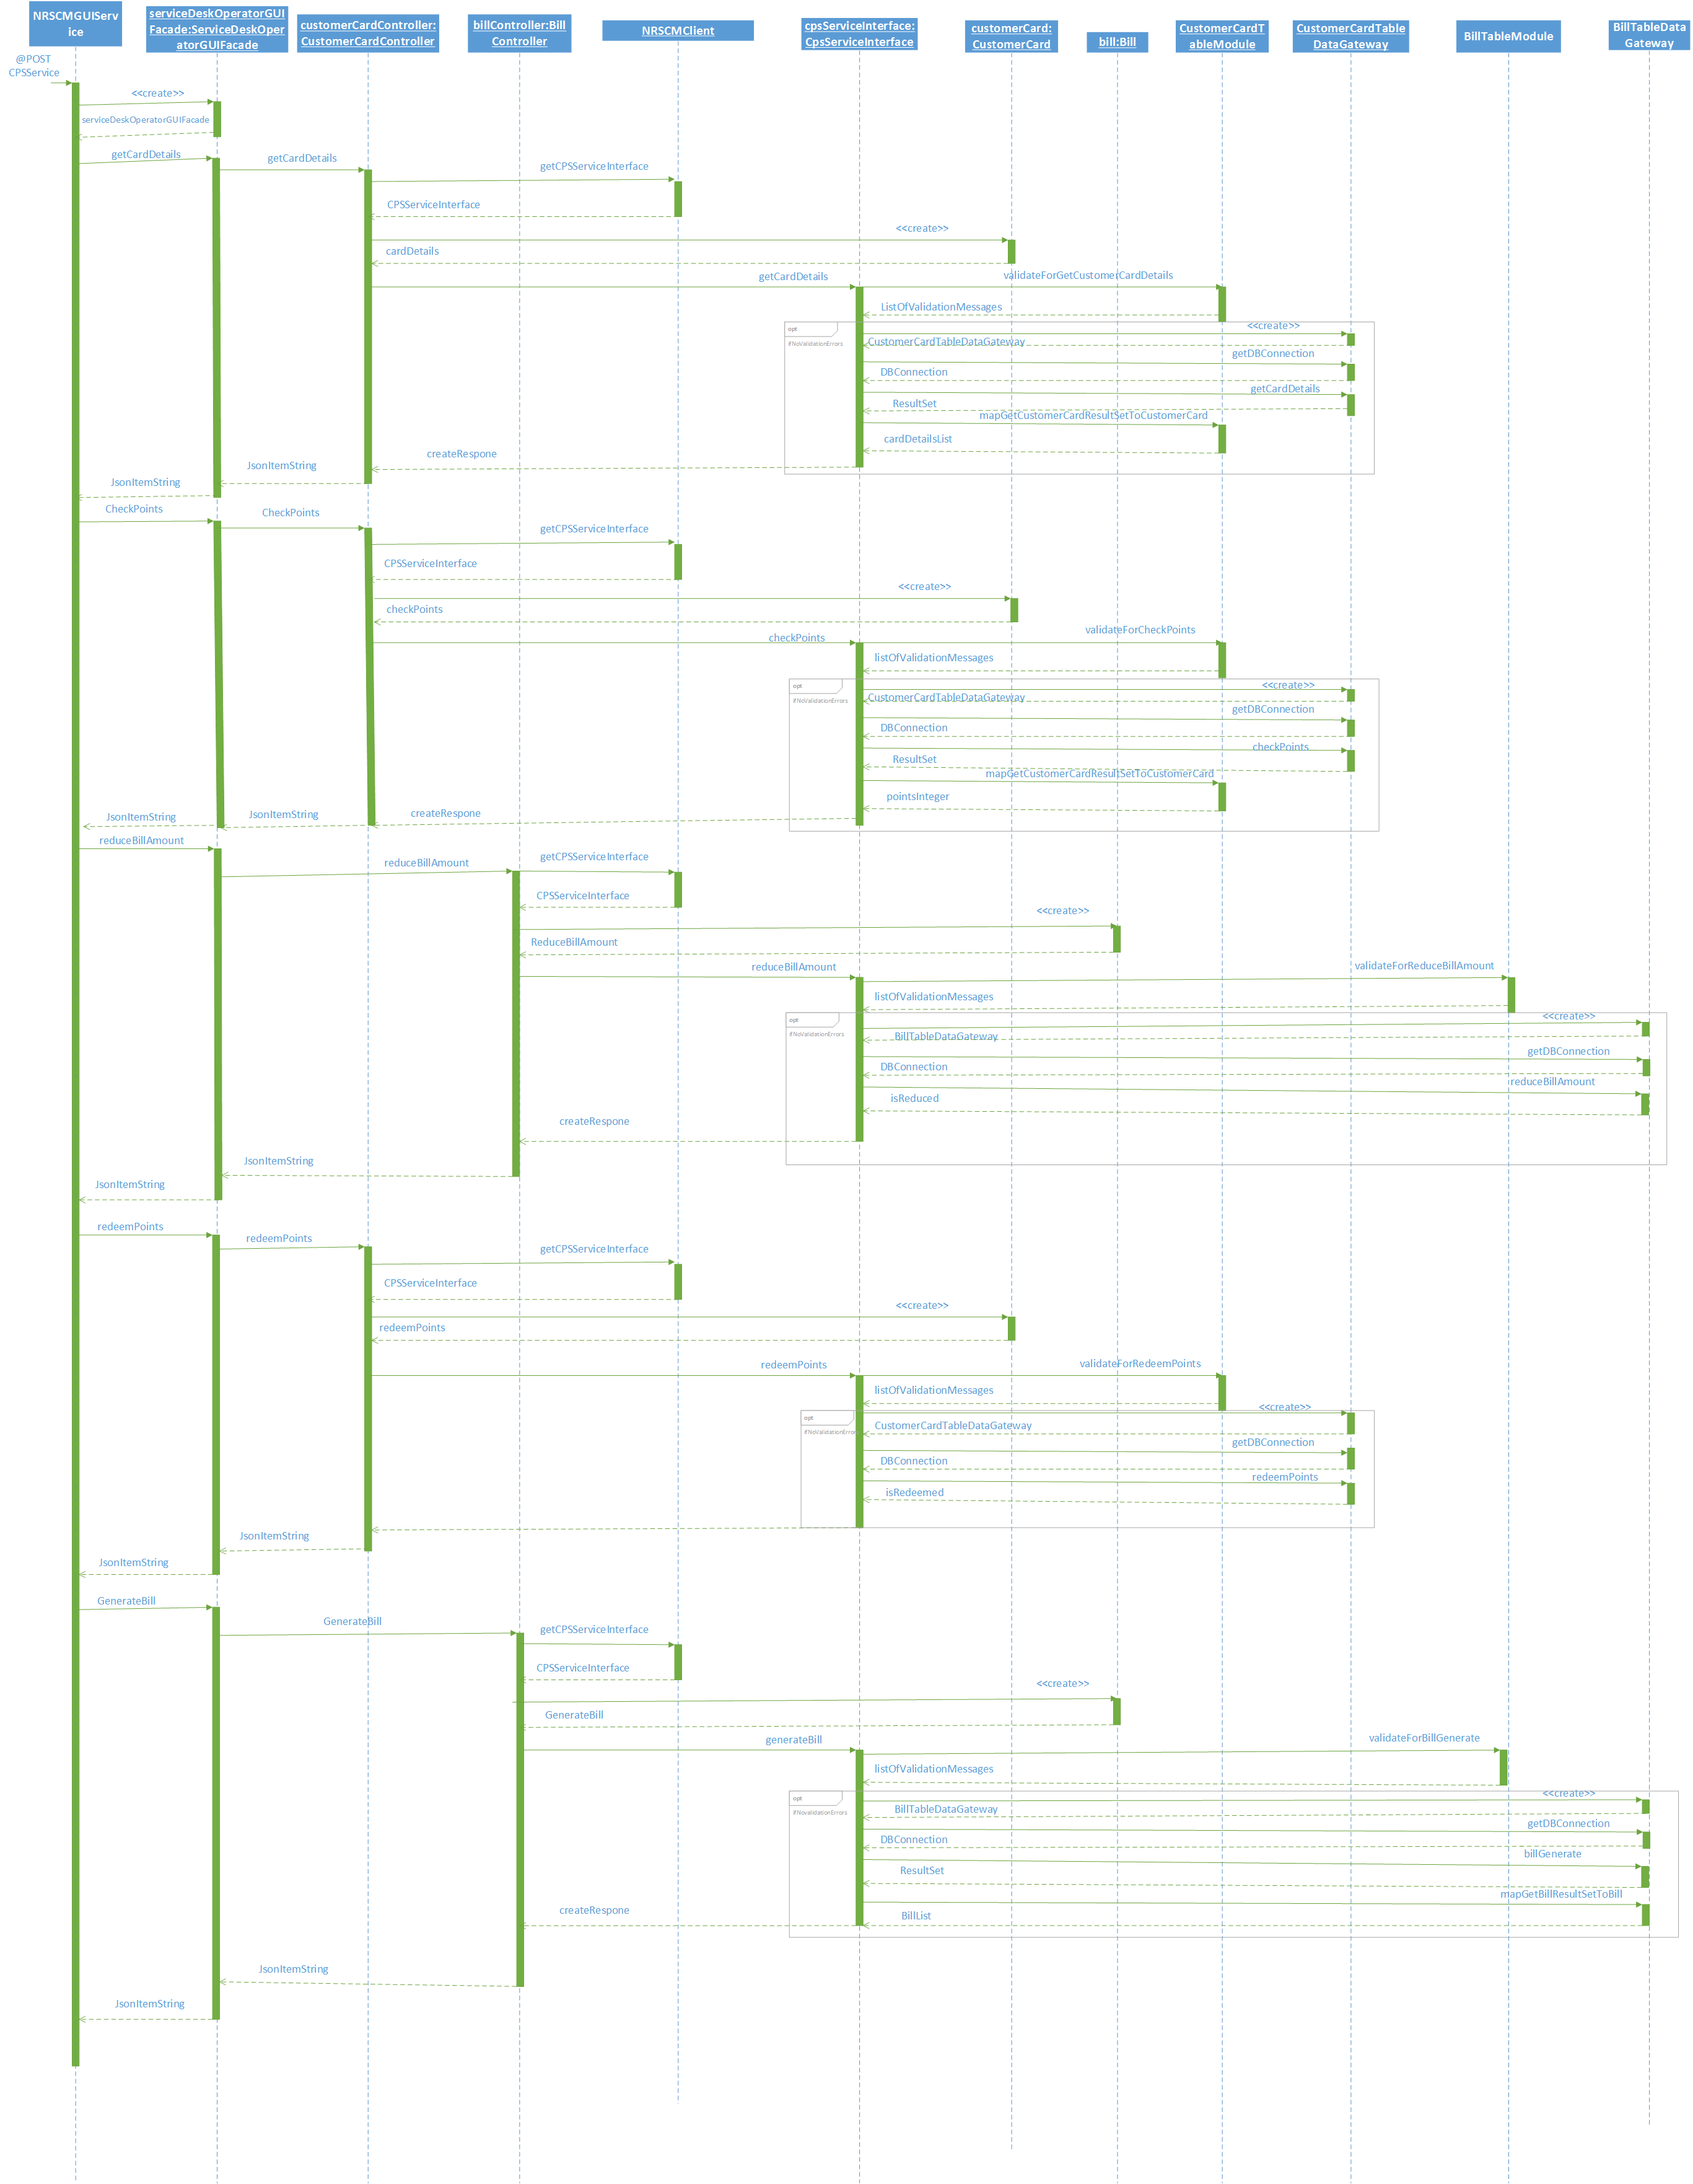

**5.5 POINT OF SALES**

**5.5.1 CLASS DIAGRAM**

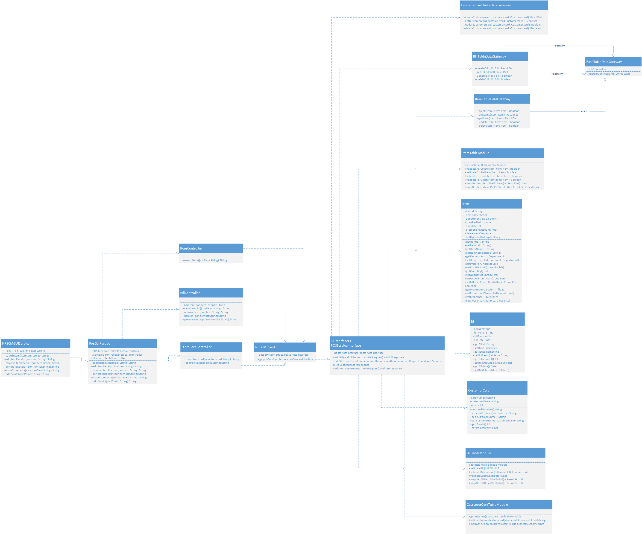

**5.5.2 sequence diagram:**

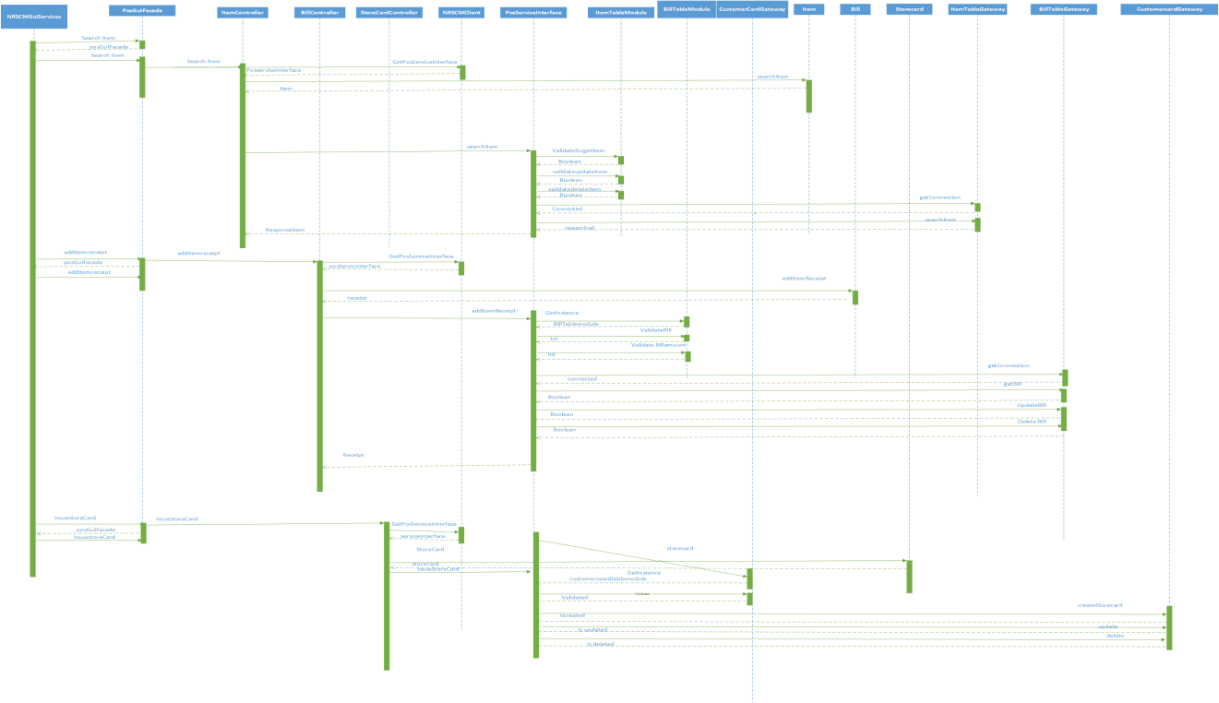

# 6. Subsystem Design

**6.1 NRSCMGUIService - Implementation of REST Web Service :**

**6.1.1 Subsystem for Creation of new store:**

In the creation of new store subsystem, We have used the Facade Design pattern, Table Module and Table Data gateway design patterns in order to have the interaction between the Storehead GUI and the controller classes. We have created three Table data gateways viz., StoreGateway, DepartmentGateway and Employee Gateway. Also We have created StoreTableModule, EmployeeTableModule and DepartmentTableModule for validating the details enetered by the user before implementing the CRUD operations on the Tables in the Database.

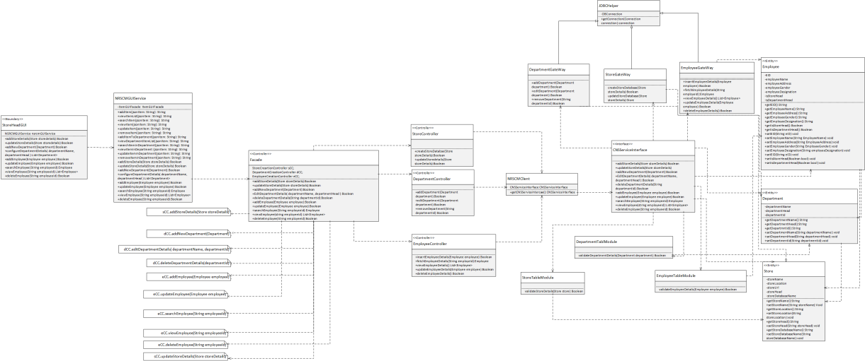

**6.1.2 Sequence Diagram :**

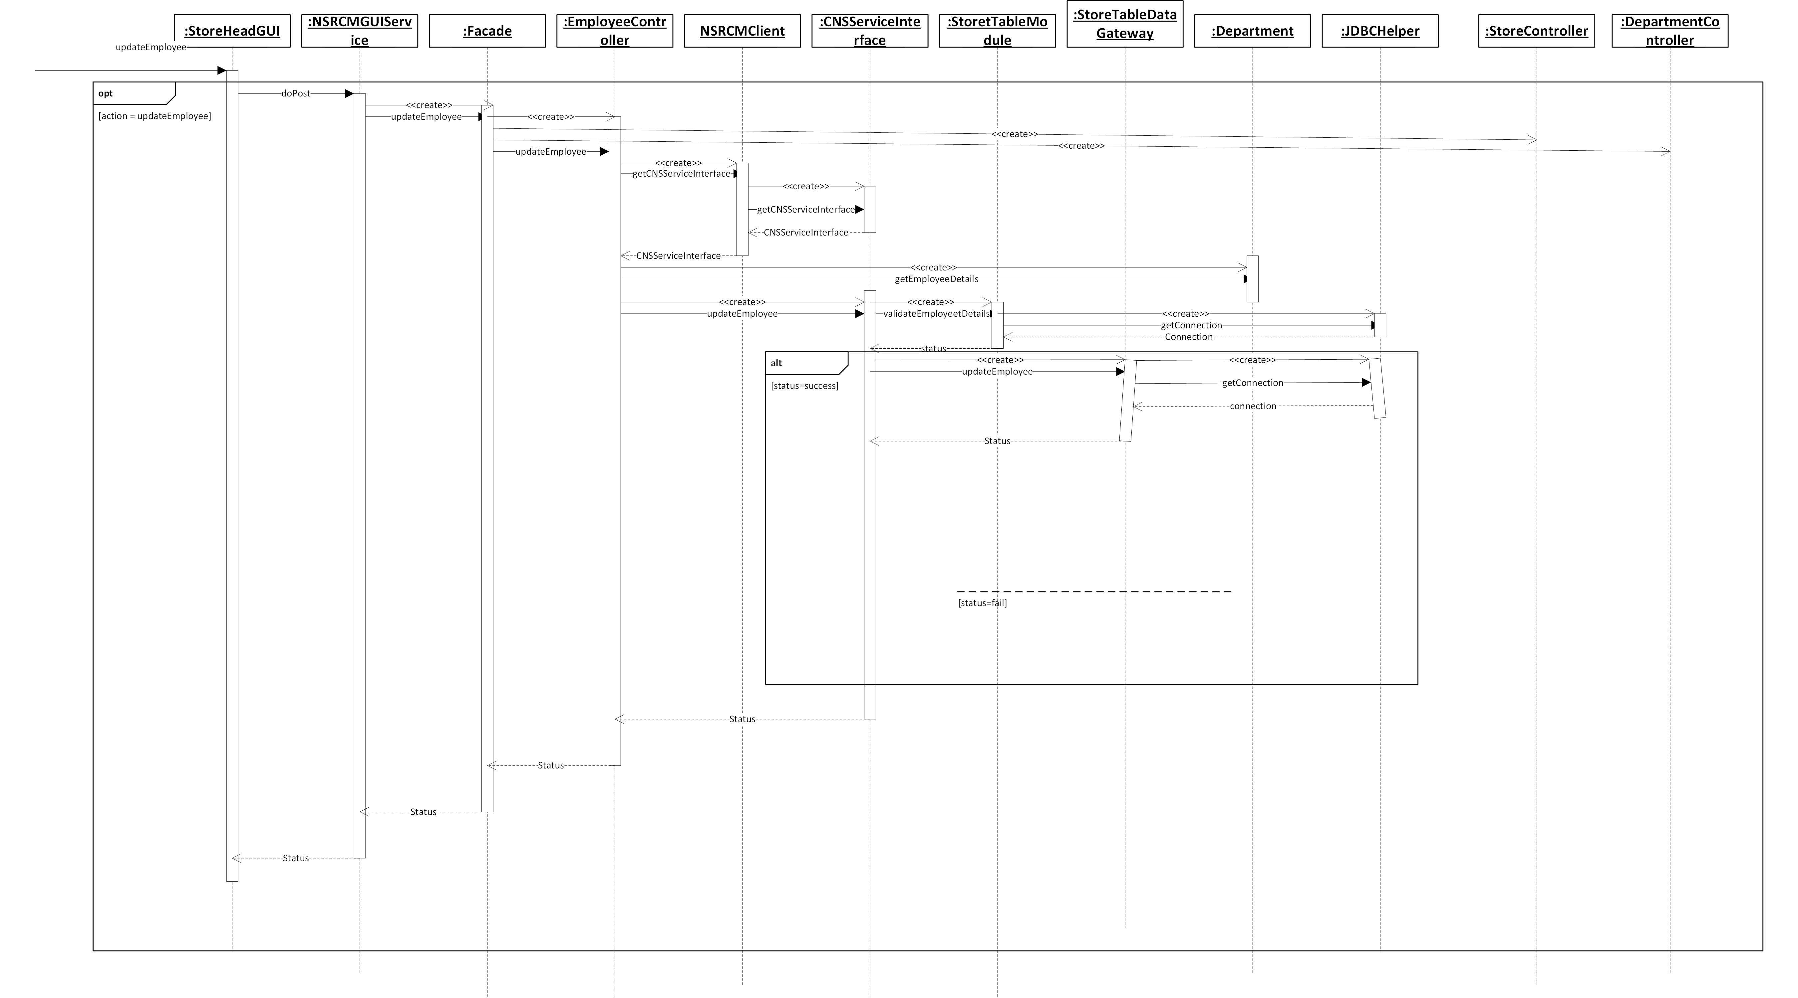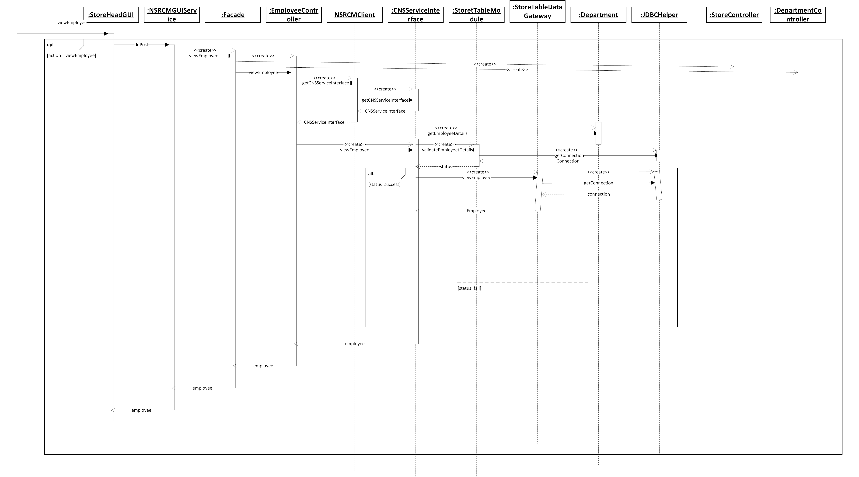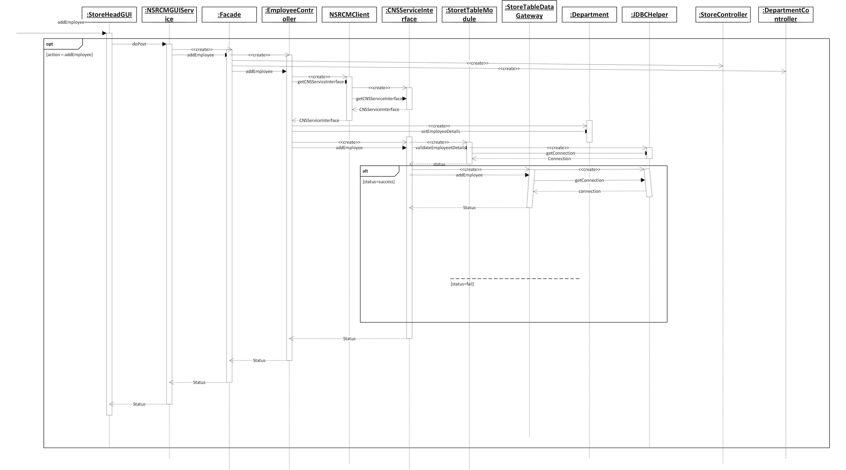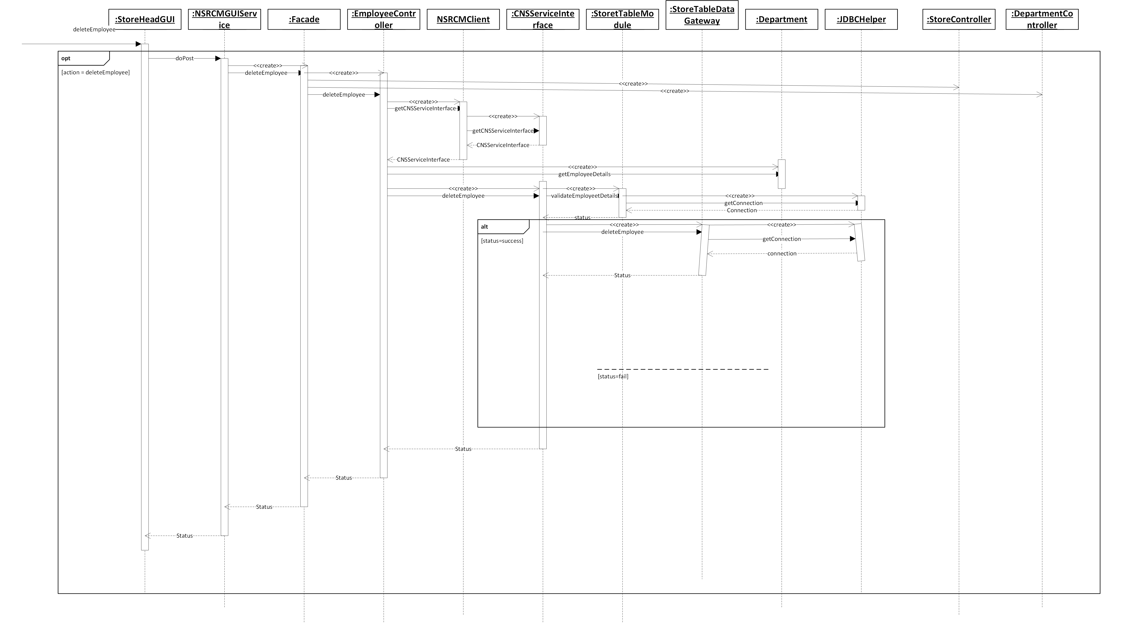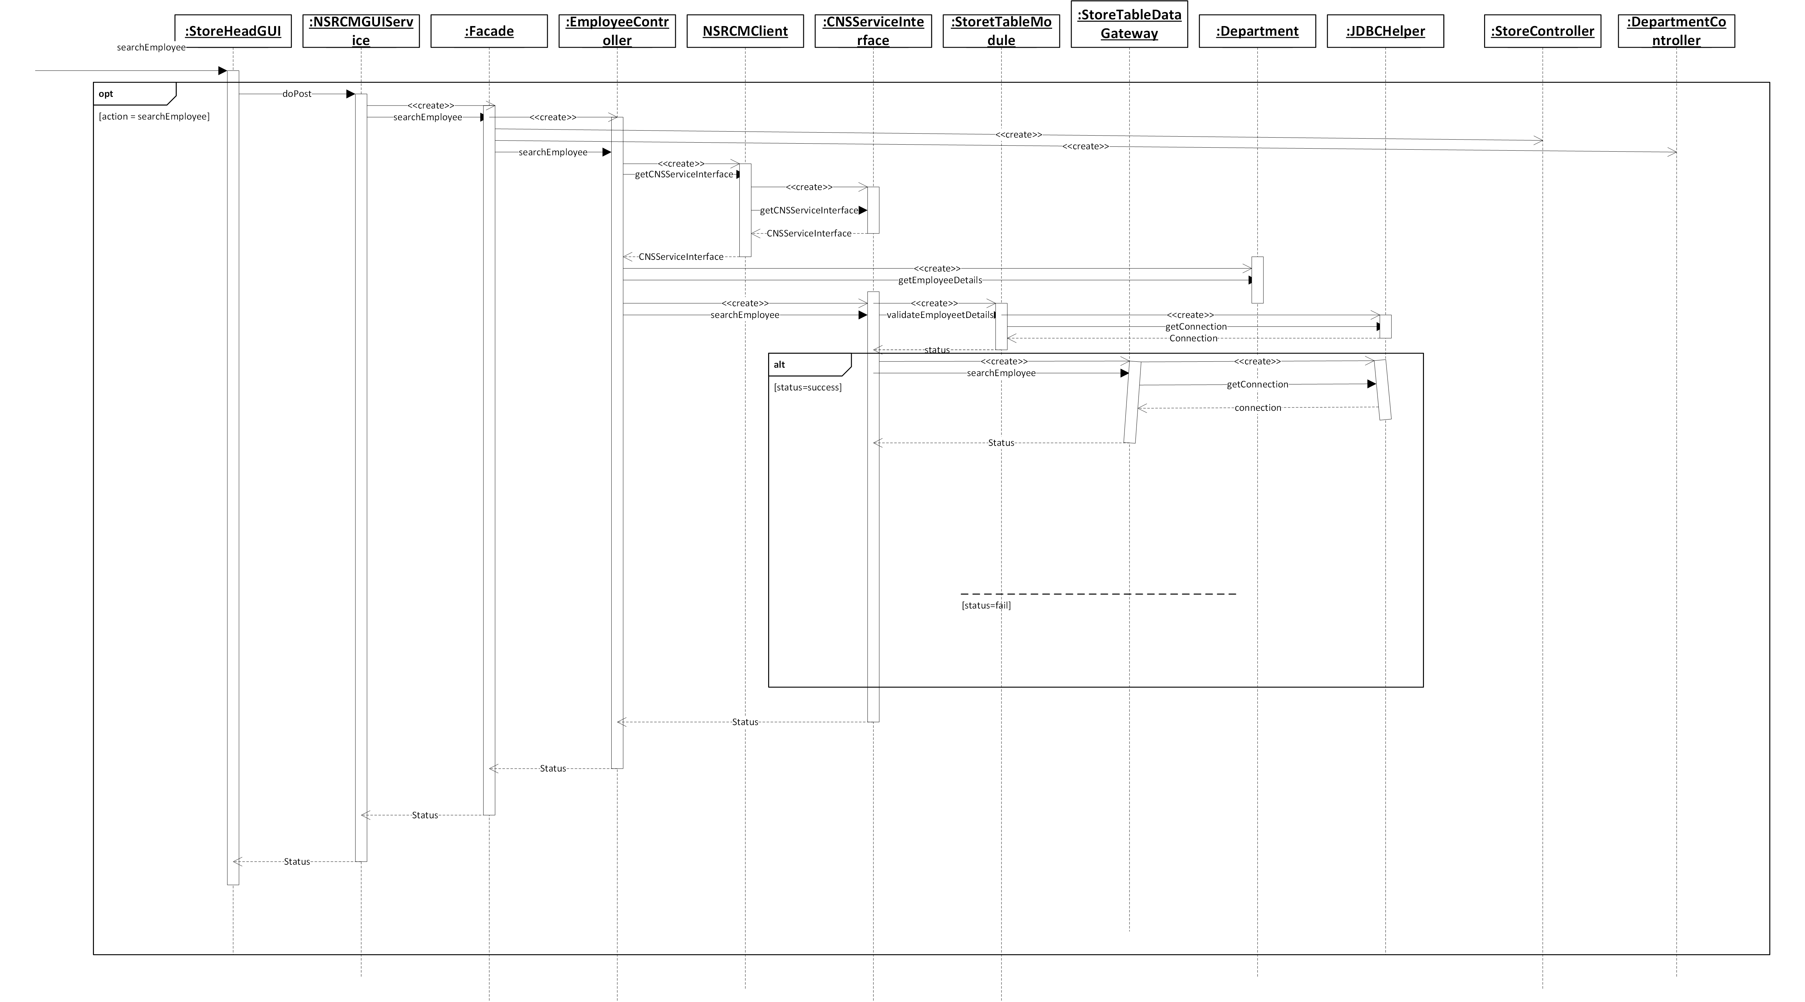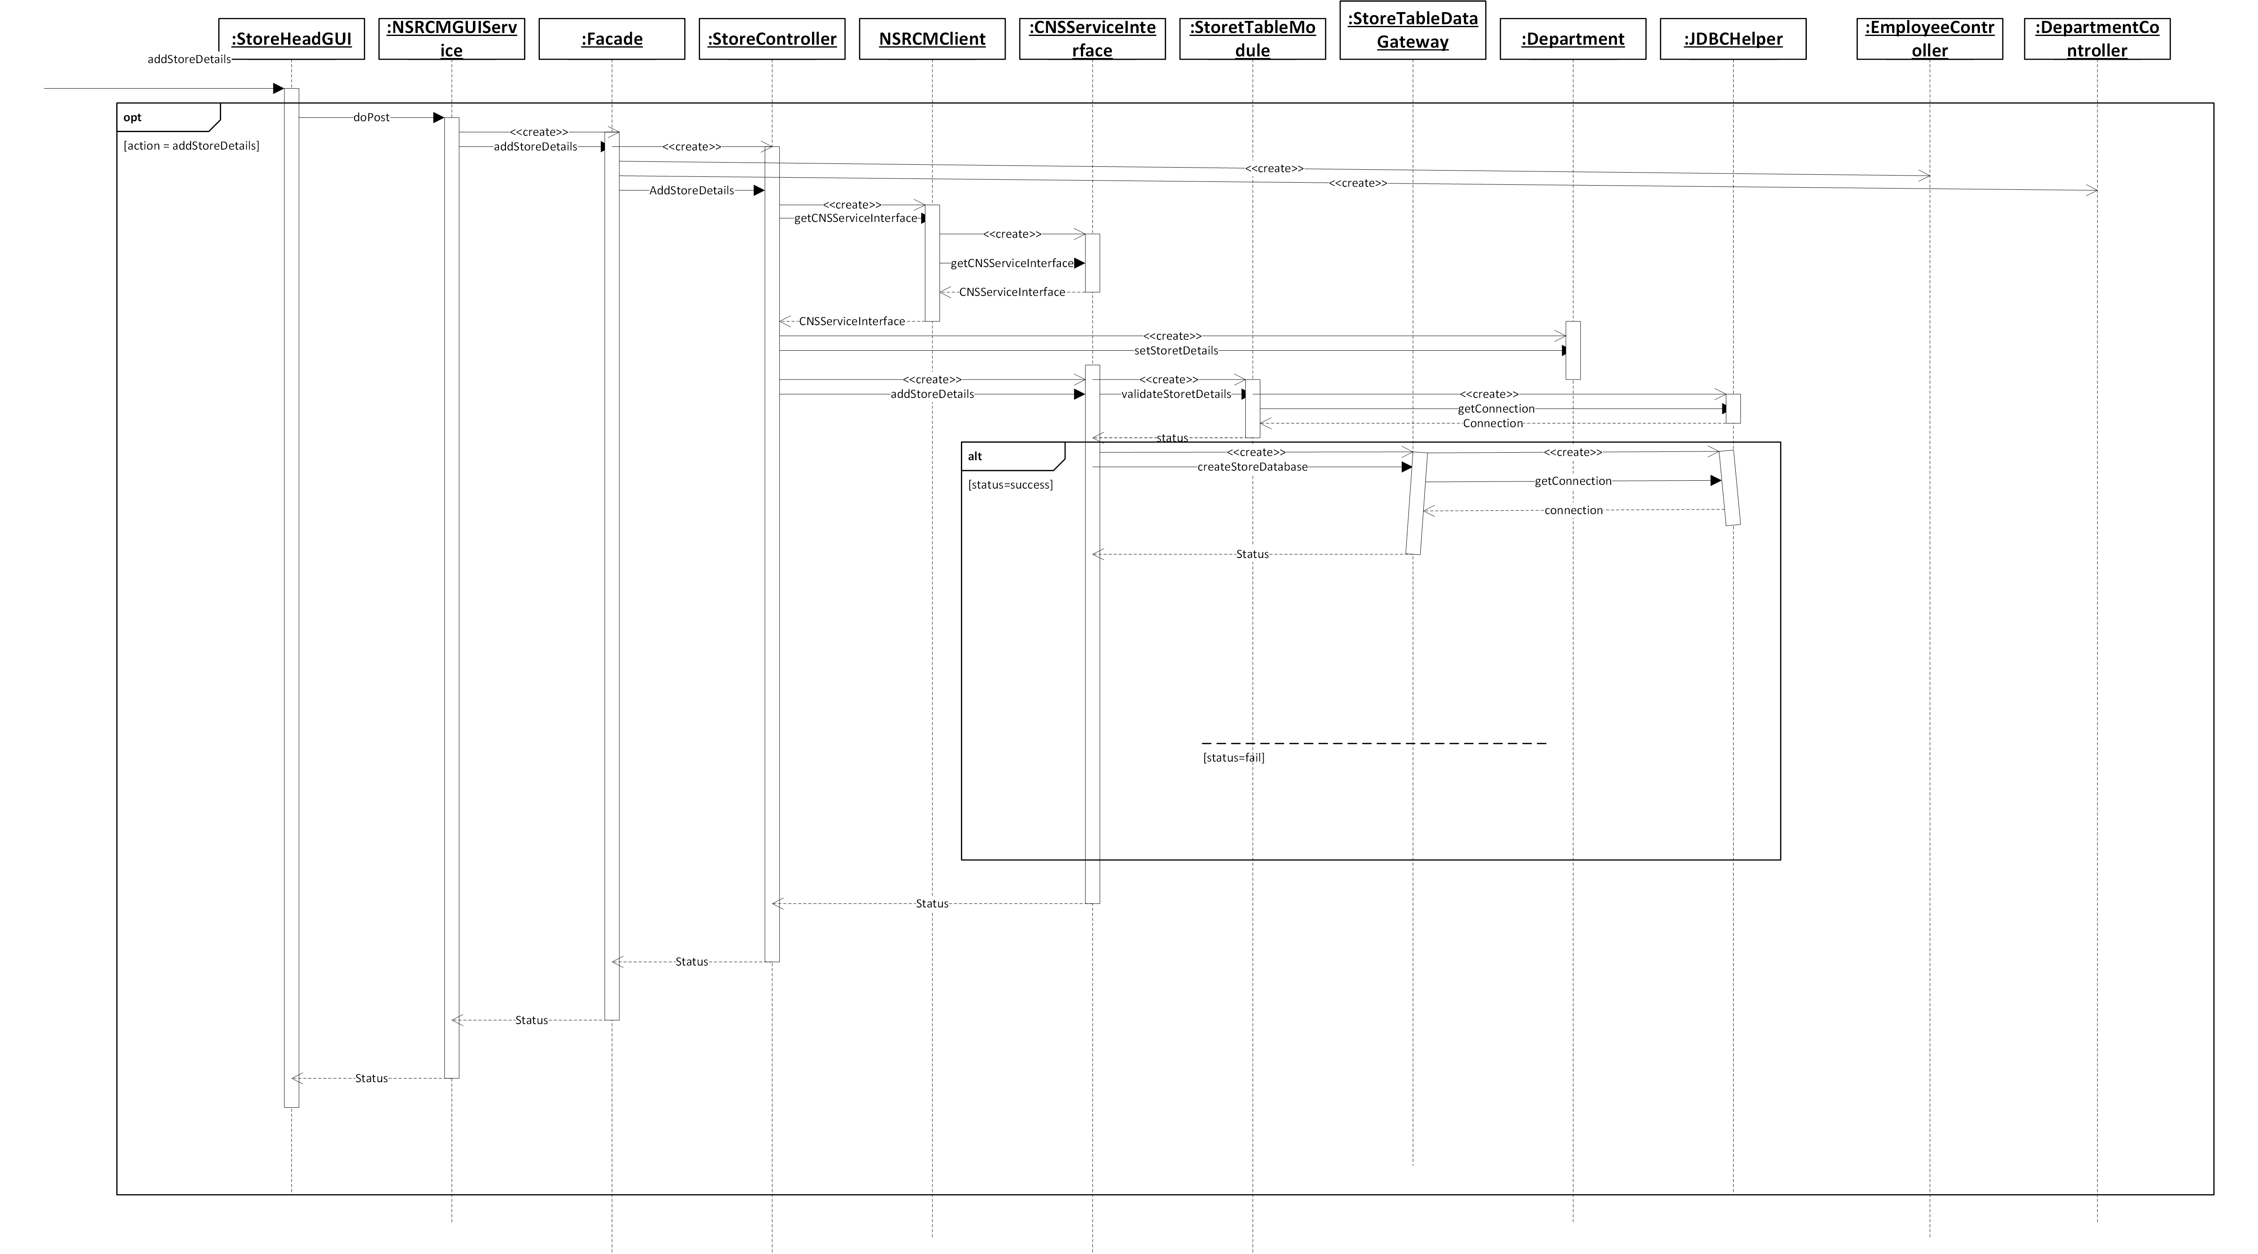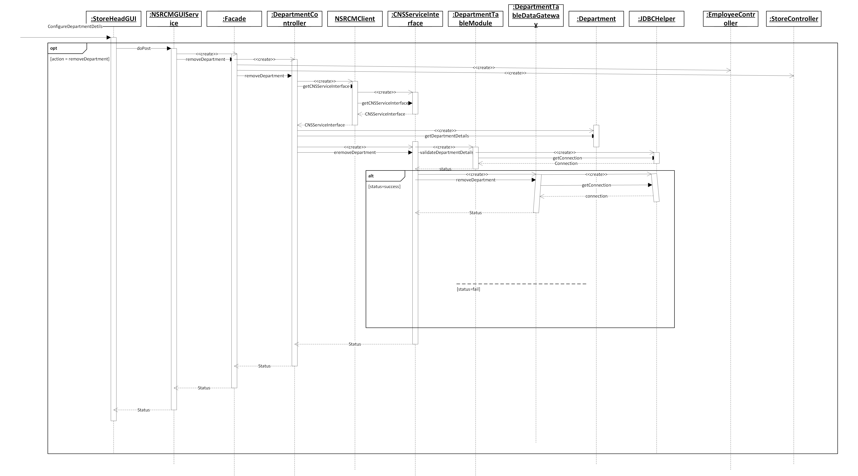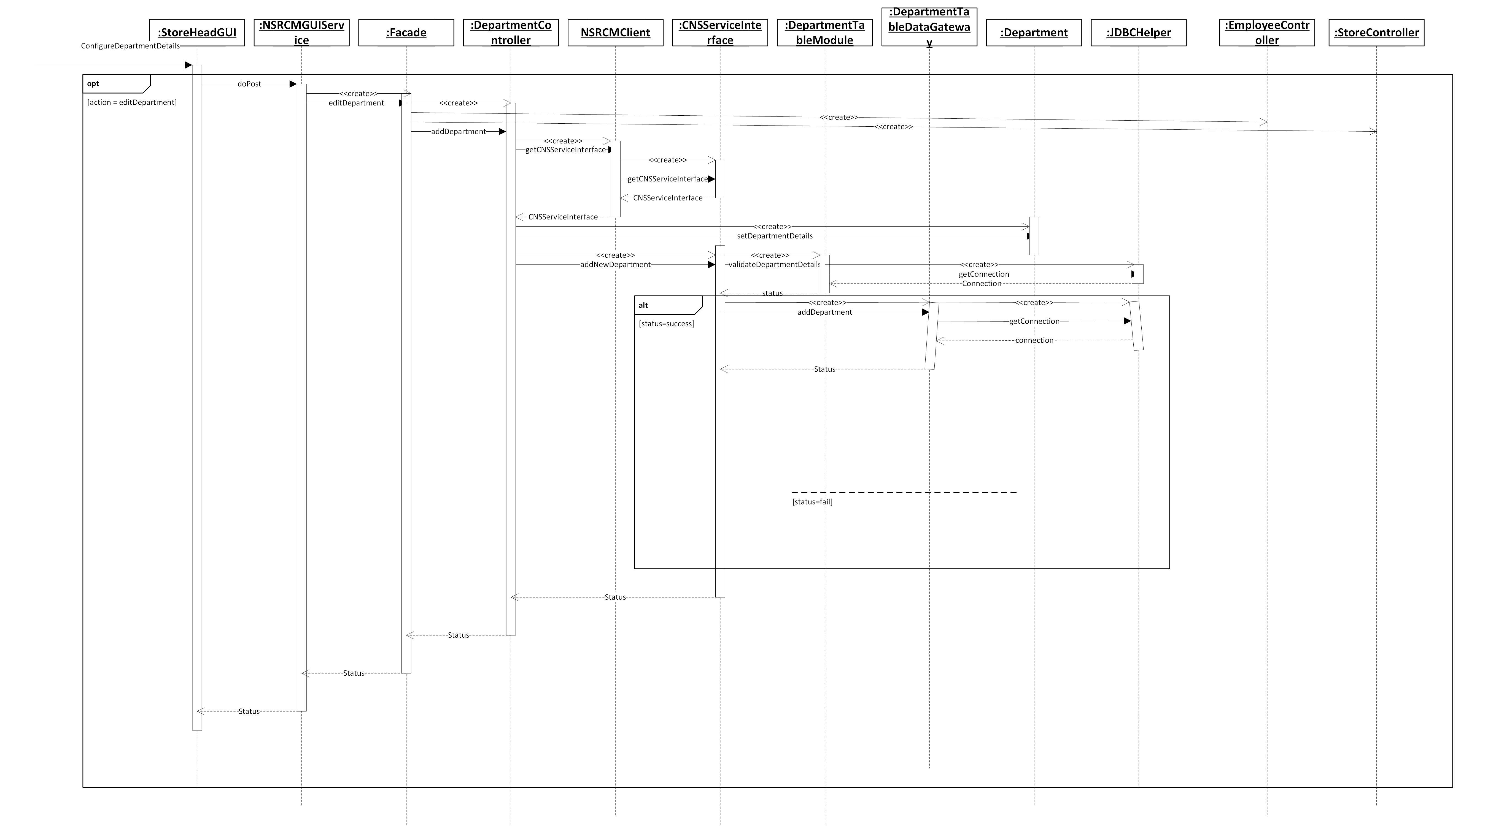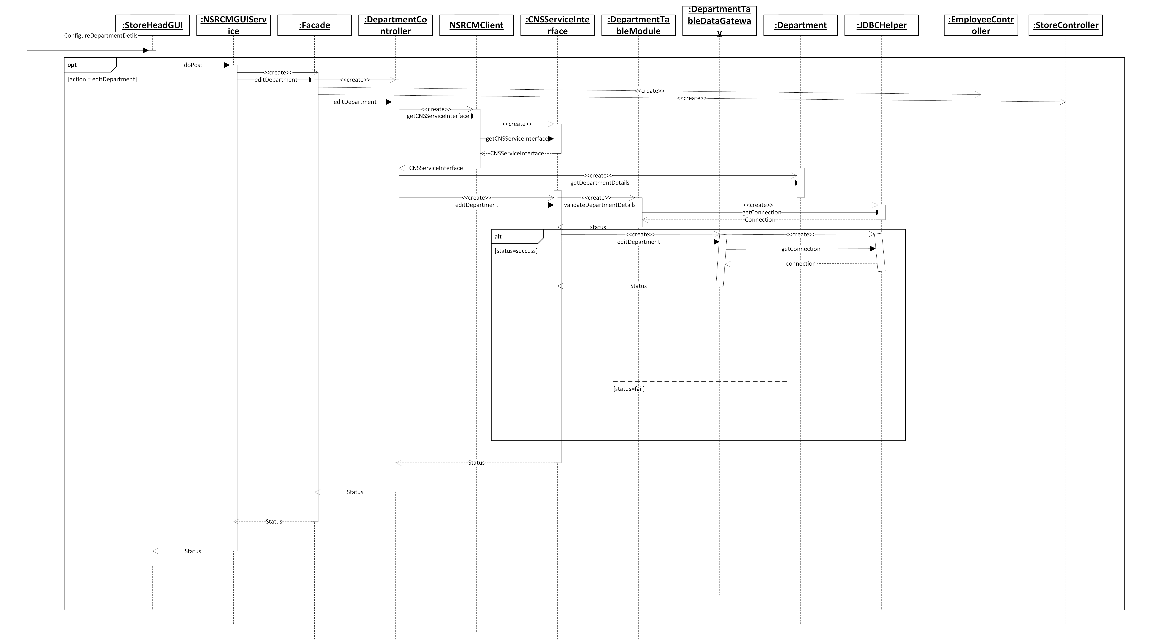

**6.1.2 Subsystem for Inventory management**

**6.1.2.1 Design Class Diagram**

In the Inventory Management subsystem, We have implemented AddItemand viewItemListPageController, SearchItemPageController, ViewItemPageController and updateandDeleteItemPageController are the Different page controllers so that each and every request from the Interface classes will be sent to a different controller class. Further to establish a connection with the database, we have implemented Table Data Gateway design pattern so that all the CRUD operations on the tables are performed using this Design Pattern. Also, We have implemented the Table model Design pattern ie., ItemTableModule in order to perform the business logic on the Item table.

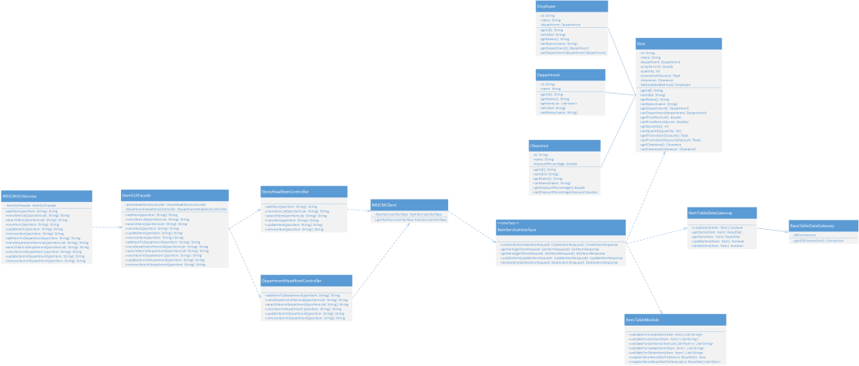

**6.1.2.2 Sequence Diagram**

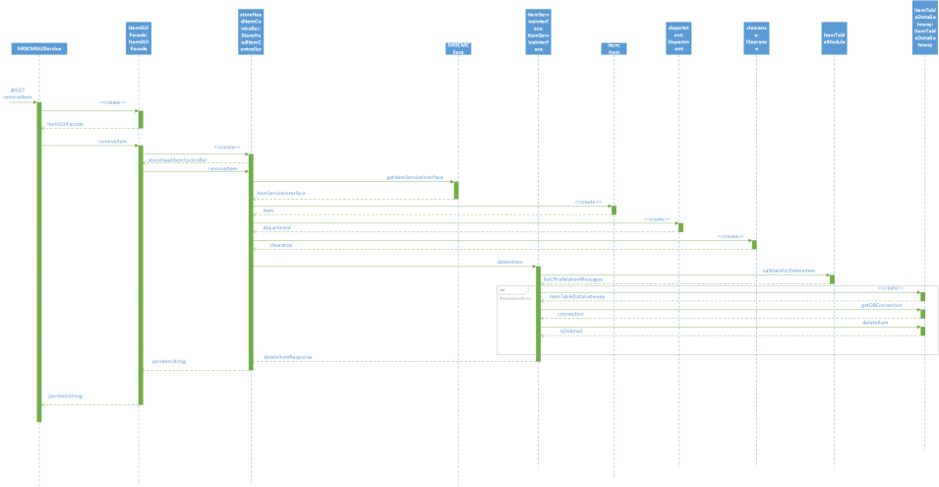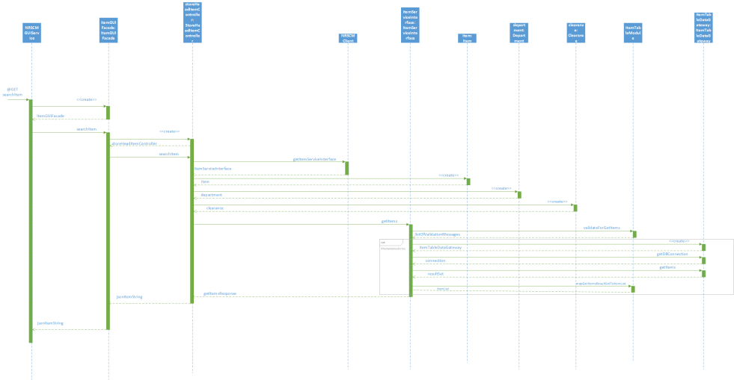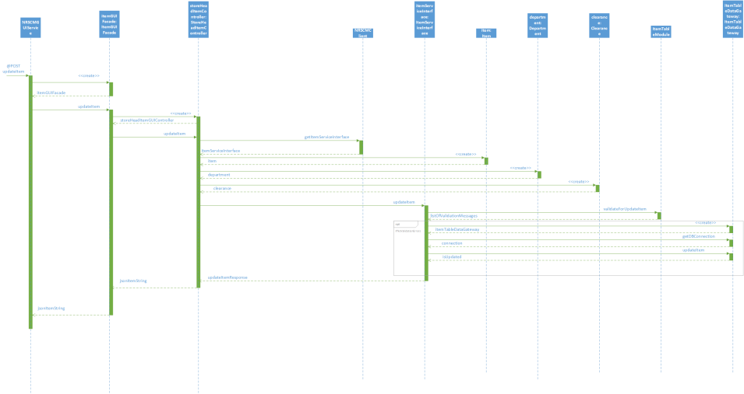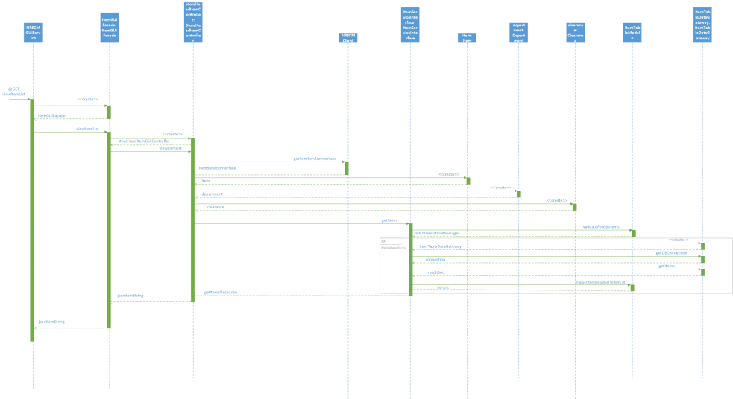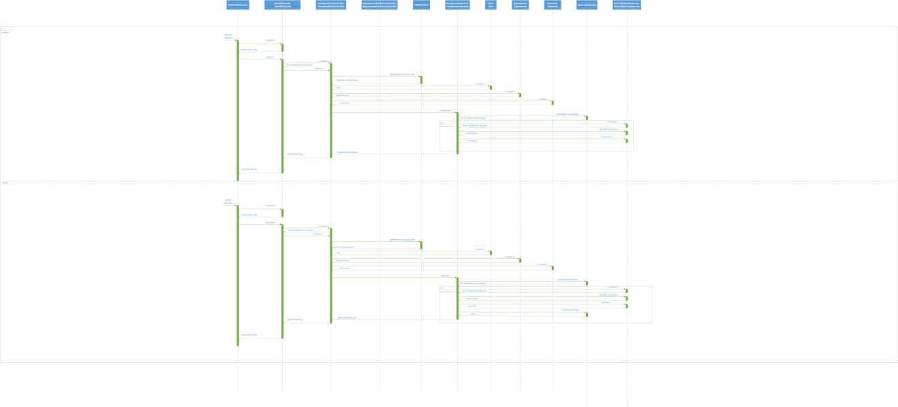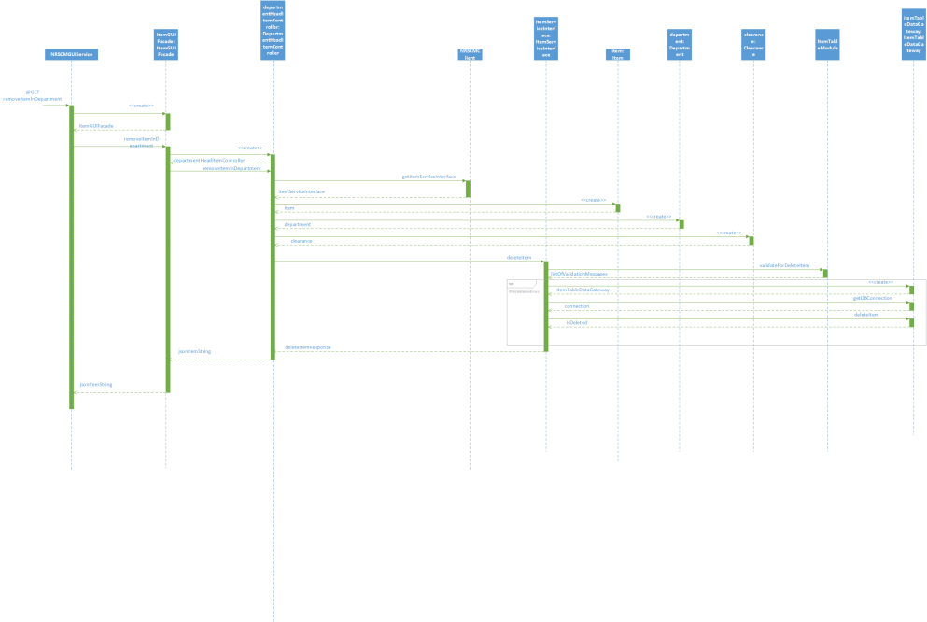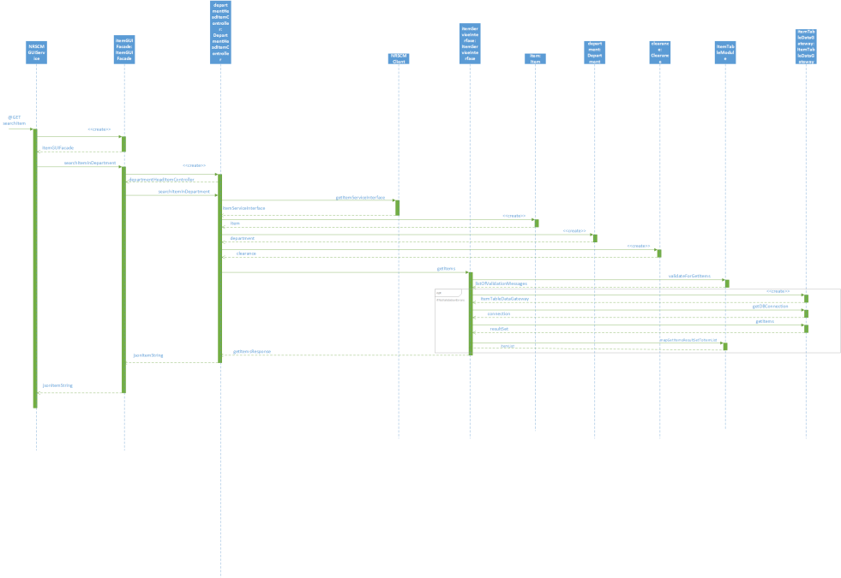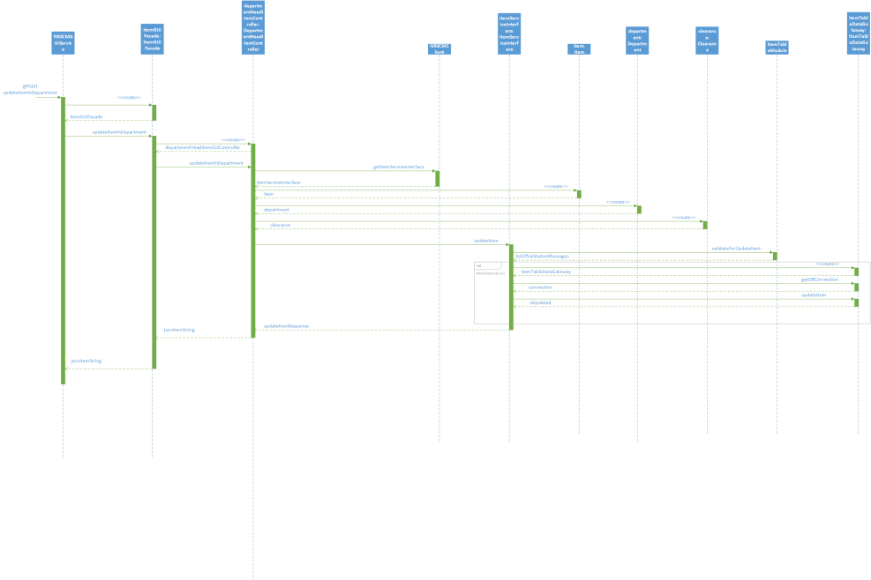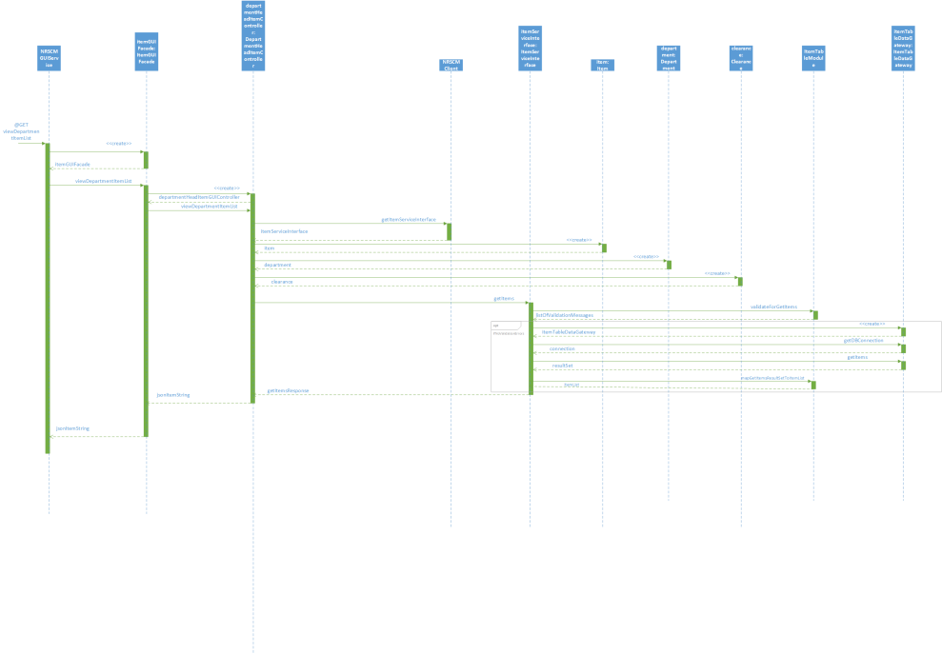

**6.1.3 Subsystem for PROMOTIONS AND CLEARANCES**

**6.1.3.1 Design Class diagram**

In the Promotions and Clearances subsystem, We have implemented AddPromotionalItem and AddClearanceItem Page Controllers so that each and every request from the Interface classes will be sent to a different controller class. Further to establish a connection with the database, we have implemented Table Data Gateway design pattern so that all the CRUD operations on the tables are performed using this Design Pattern. Also, We have implemented the Table model Design pattern ie., PromotionsandClearancesItem TableModule in order to perform the business logic on the Item table.

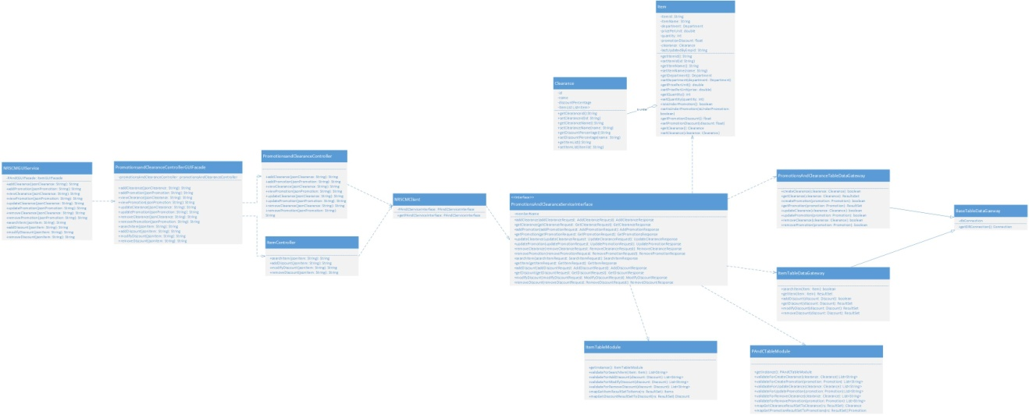

**6.1.3.2 Sequence diagram**

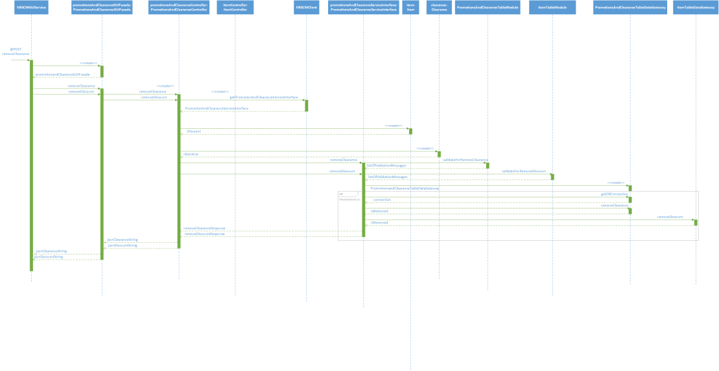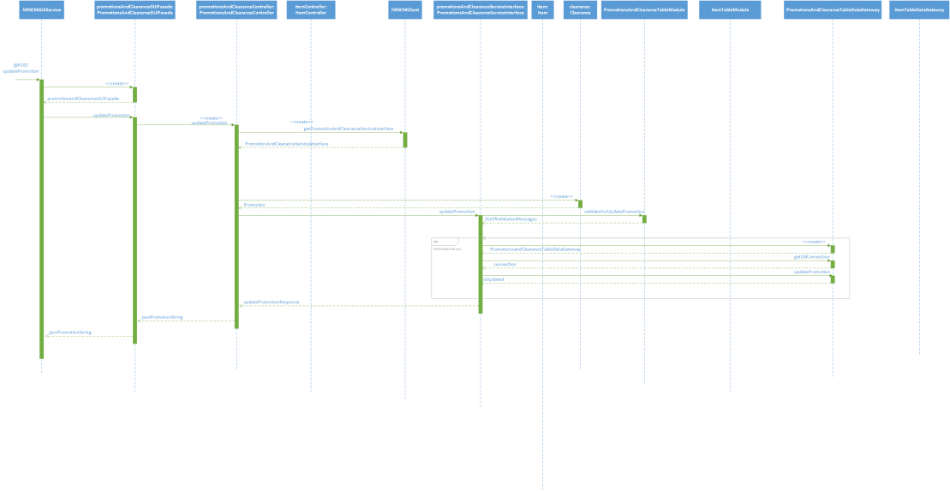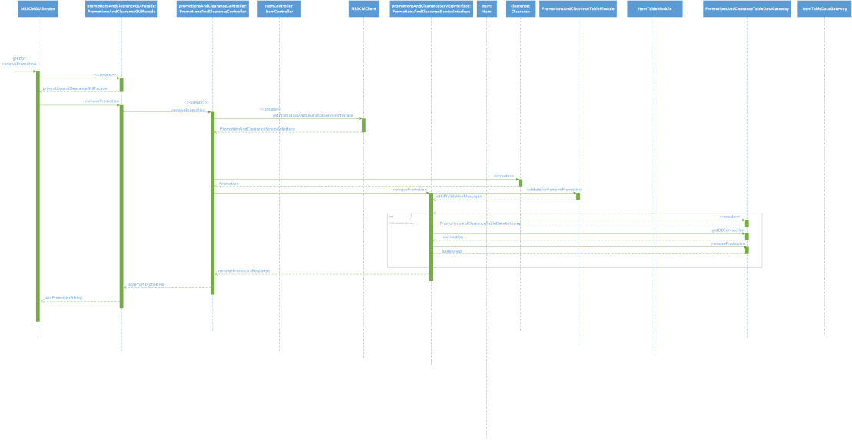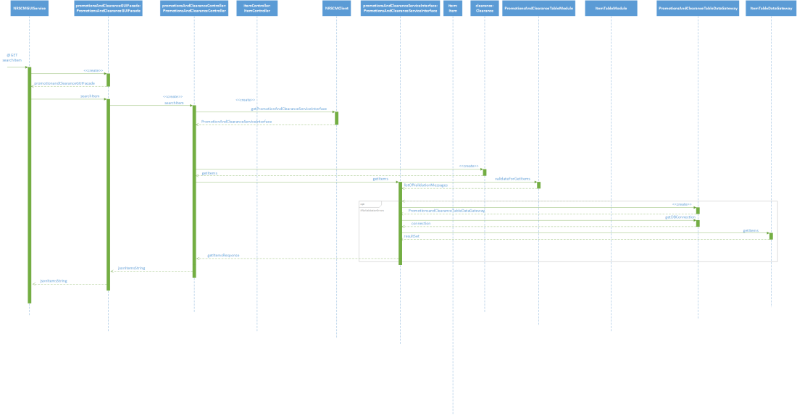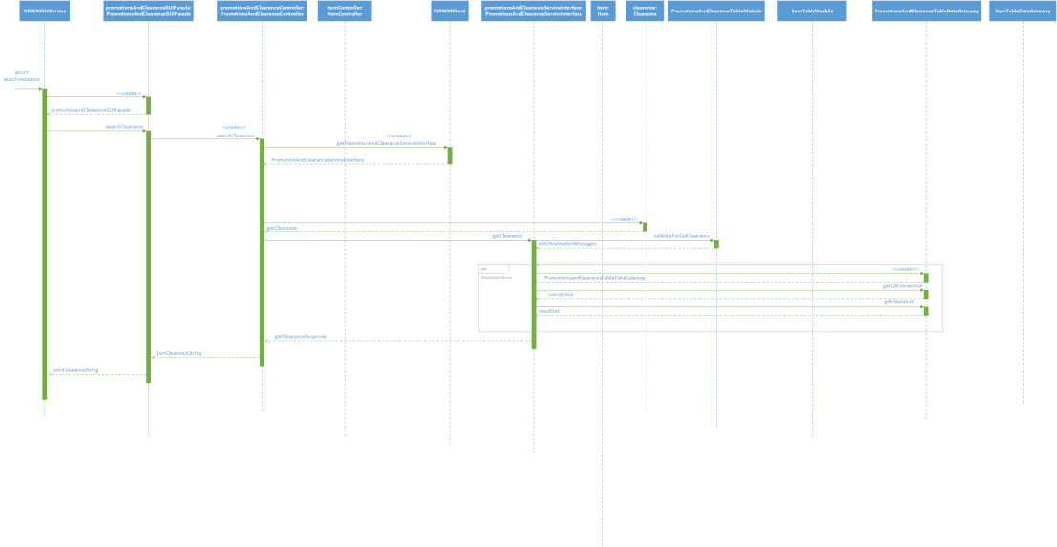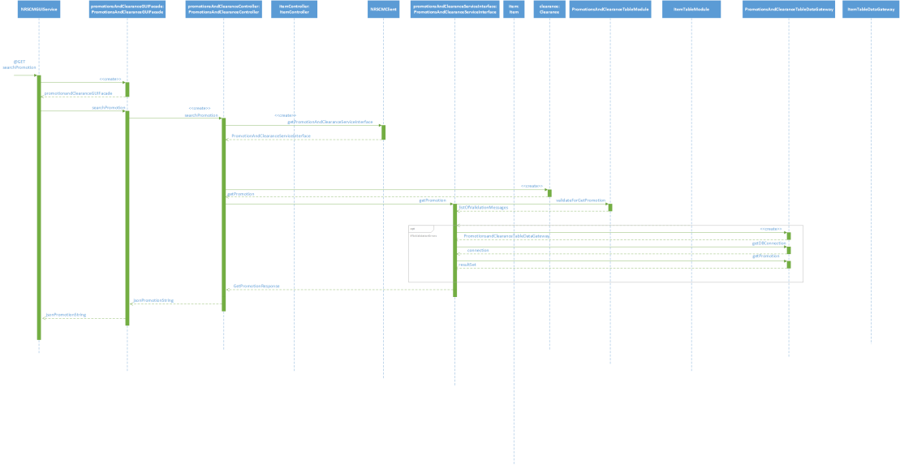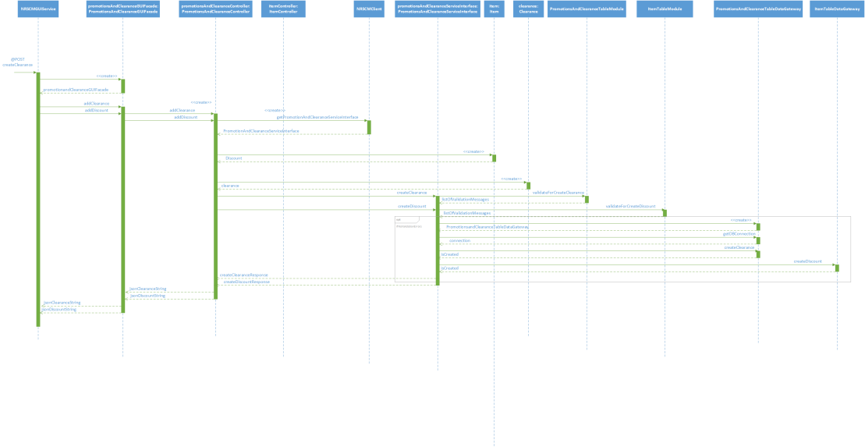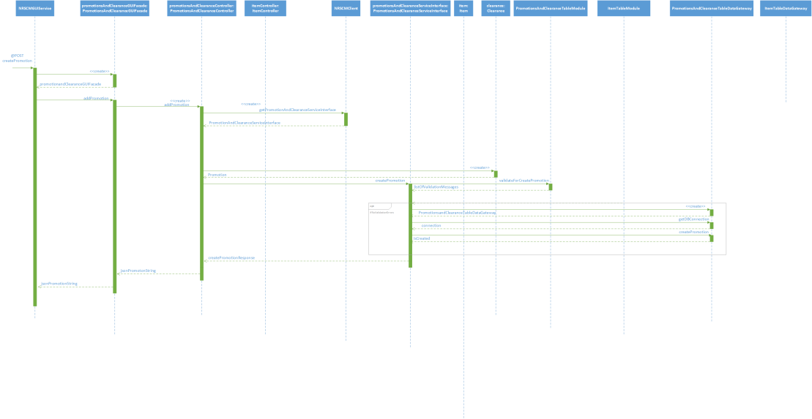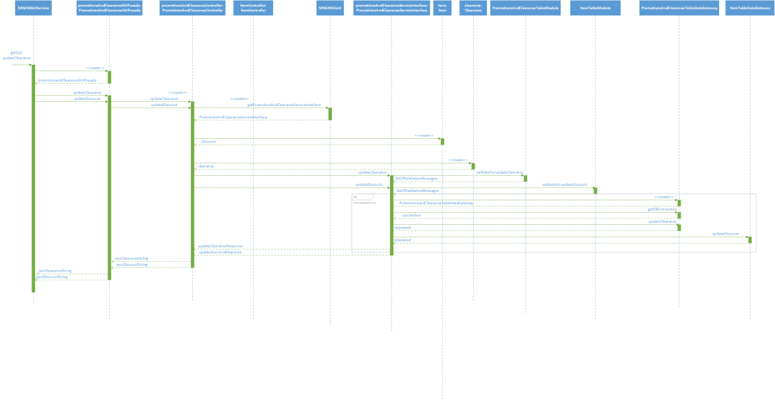

**6.1.4 Subsystem for CUSTOMER POINT SYSTEM**

**6.1.4.1 Design Class diagram:**

In the Customer points subsystem, We have implemented viewcardDetailsPageController, checkpointsPageController, reducebillAmountPageController, redeemPointspageController and generateNewBillPageController. These are the Different page controllers so that each and every request from the Interface classes will be sent to a different controller class. Further to establish a connection with the database, we have implemented Table Data Gateway design pattern so that all the CRUD operations on the tables are performed using this Design Pattern. Also, We have implemented the Table model Design pattern ie., customerCardTableModule and billTableModule in order to perform the business logic on the customerCard and bill tables respectively.

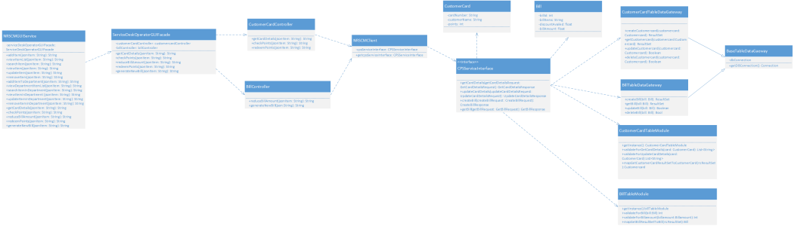

**6.1.4.2 SEQUENCE DIAGRAM:**

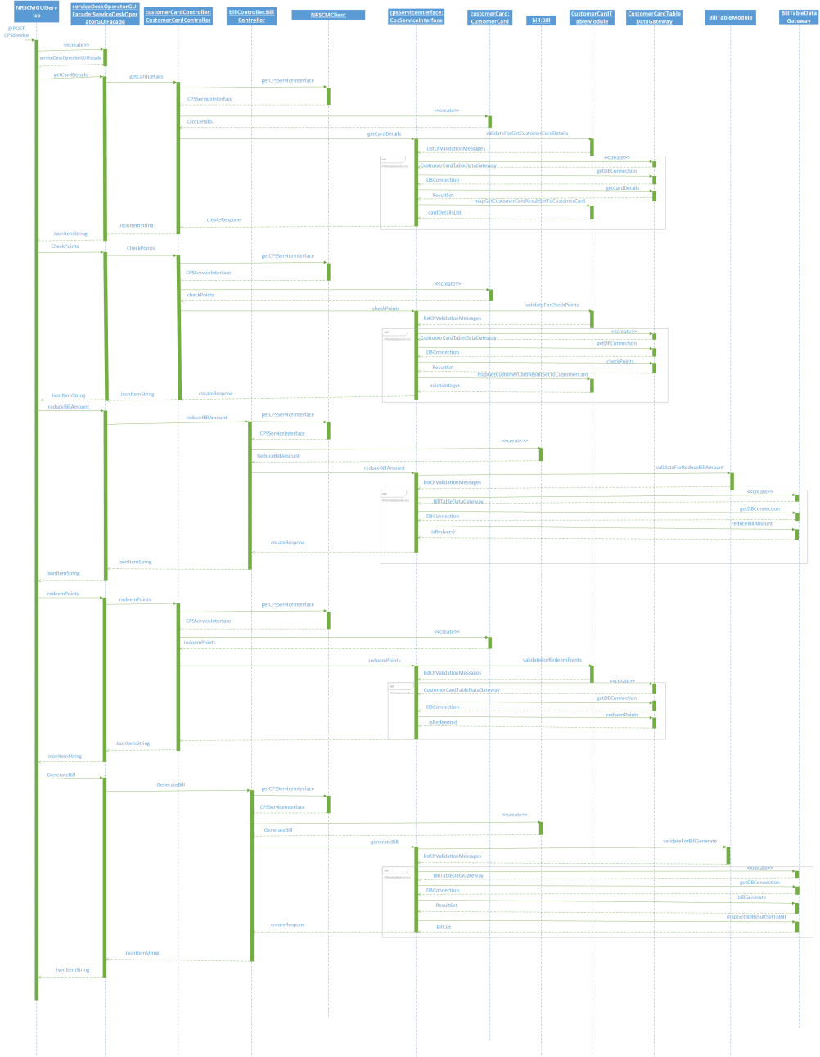

**6.1.5 POINT OF SALES**

**6.1.5.1 CLASS DIAGRAM**

In the Point of Sales Subsystem, We have implemented AddItemPageController, RemoveItemPageController, GenerationReceiptPageController page controllers so that each and every request from the Interface classes will be sent to a different controller class. Further to establish a connection with the database, we have implemented Table Data Gateway design pattern so that all the CRUD operations on the tables are performed using this Design Pattern. Also, We have implemented the Table model Design pattern ie., CustomerCardTableModule, BillTableModule, ItemTableModule in order to perform the business logic on the Bill table, receipt table and Item table.



**6.1.5.2 sequence diagram:**



**6.2 NRSCM Service - implementation of SOAP Web Service**

**6.2.1 Subsystem for Creation of new store:**

In the creation of new store subsystem, We have used the Facade Design pattern, Table Module and Table Data gateway design patterns in order to have the interaction between the Storehead GUI and the controller classes. We have created three Table data gateways viz., StoreGateway, DepartmentGateway and Employee Gateway. Also We have created StoreTableModule, EmployeeTableModule and DepartmentTableModule for validating the details enetered by the user before implementing the CRUD operations on the Tables in the Database.



**6.2.2SequenceDiagram :**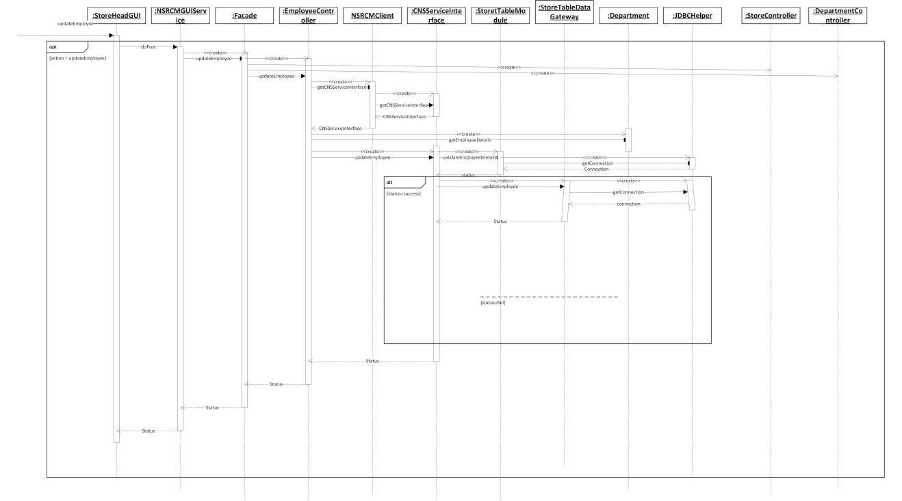



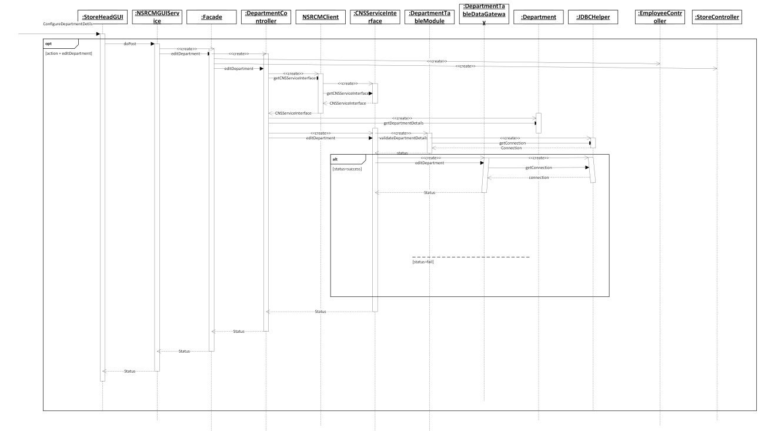

**6.2.2 Subsystem for Inventory management**

**6.2.2.1 Design Class Diagram**

In the Inventory Management subsystem, We have implemented AddItemand viewItemListPageController, SearchItemPageController, ViewItemPageController and updateandDeleteItemPageController are the Different page controllers so that each and every request from the Interface classes will be sent to a different controller class. Further to establish a connection with the database, we have implemented Table Data Gateway design pattern so that all the CRUD operations on the tables are performed using this Design Pattern. Also, We have implemented the Table model Design pattern ie., ItemTableModule in order to perform the business logic on the Item table.



**6.2.2.2 Sequence Diagram**



**6.2.3 Subsystem for PROMOTIONS AND CLEARANCES**

**6.2.3.1 Design Class diagram**

In the Promotions and Clearances subsystem, We have implemented AddPromotionalItem and AddClearanceItem Page Controllers so that each and every request from the Interface classes will be sent to a different controller class. Further to establish a connection with the database, we have implemented Table Data Gateway design pattern so that all the CRUD operations on the tables are performed using this Design Pattern. Also, We have implemented the Table model Design pattern ie., PromotionsandClearancesItem TableModule in order to perform the business logic on the Item table.



**6.2.3.2 Sequence diagram**



**6.2.4 Subsystem for CUSTOMER POINT SYSTEM**

**6.2.4.1 Design Class diagram:**

In the Customer points subsystem, We have implemented viewcardDetailsPageController, checkpointsPageController, reducebillAmountPageController, redeemPointspageController and generateNewBillPageController. These are the Different page controllers so that each and every request from the Interface classes will be sent to a different controller class. Further to establish a connection with the database, we have implemented Table Data Gateway design pattern so that all the CRUD operations on the tables are performed using this Design Pattern. Also, We have implemented the Table model Design pattern ie., customerCardTableModule and billTableModule in order to perform the business logic on the customerCard and bill tables respectively.



**6.2.4.2 SEQUENCE DIAGRAM:**



**6.2.5 POINT OF SALES**

**6.2.5.1 CLASS DIAGRAM**

In the Point of Sales Subsystem, We have implemented AddItemPageController, RemoveItemPageController, GenerationReceiptPageController page controllers so that each and every request from the Interface classes will be sent to a different controller class. Further to establish a connection with the database, we have implemented Table Data Gateway design pattern so that all the CRUD operations on the tables are performed using this Design Pattern. Also, We have implemented the Table model Design pattern ie., CustomerCardTableModule, BillTableModule, ItemTableModule in order to perform the business logic on the Bill table, receipt table and Item table.



**6.2.5.2 sequence diagram:**



**6.3 DB Tables Subsystem:**

This is an application Generic subsystem for which all the application has to use this subsystem to store the data. We are using the MySQL 6.0 Database to create the tables and establish the Database connection with the Java application.

**6.4 Database Subsystem:**

Database subsystem is also an application generic subsystem, wherein we are using MySQL 6.0 Server that supports maintaining Database Cache and is useful to declare columns with all the primitive data types and advanced data types.

**6.5 HTML Subsystem:**

Our application can be run in all the browsers that supports HTML 4 and above versions. We have developed the templates using HTML 4 Doctype version.

**6.6 JSP subsystem:**

The JSP subsystem we are using follows JSP 2.2 specification and the tag library we have used also follows the JSP 2.2 Subsystem.

**6.7 REST Subsystem:**

We are exposing GUI as a REST service. Also we are using the REST Easy implementation provided by wildfly server.

**6.8 JAVA API subsystem:**

we have designed all the designed patterns and the classes using the Java API specification for the Java™ Platform, Standard Edition 7

**6.9 JDBC subsytem:**

we are using JDBC helper classes that establishes connection to the MySQL 6.0 Database server using the Jars that are defined in the J2SE 7 API. The same class can be used in order to migrate the database server. But the connection can be established with the Database servers that supports Relational Database schema.

**6.10 MySQL subsystem:**

We are using MySQL 6.0 version to establish the connection with the application.

**6.11 Web Browser subsystem:**

Our application can be run Google Chrome 11.0 and above versions, Mozilla Firefox 23 and above versions, IE 9.0 and above versions. Javascript should be enabled to work with our application. The browsers should accept cookies and should be able to store sessions.

**6.12 HTTP subsystem:**

Browser and Server communicate with HTTP 1.1 requests and responses

**6.13 JVM:**

The applications uses JVM for Java SE 7

**6.14 TCP/IP:**

The application uses TCP/ IP internet protocol suite.

**6.15 SOAP Sub system:**

Business service is exposed as a SOAP web Service. GUIService will become the Client for this webservice. Communication between GUIService and SOAP Service is established using SOAP XML Requests and Responses.

**6.16 JavaScript/JQuery Sub System:**

We are using JQuery.min.js.1.11.1 file for client side validations.

**6.18 WildFly Server Subsystem :**

# We are using Wildfly 8.1.0 Server to deploy and run this application.

# 7. Use-Case Storyboards

## 7.1 Use case story board for Store Head:

**Interface flow Diagram For Creation of new store:**

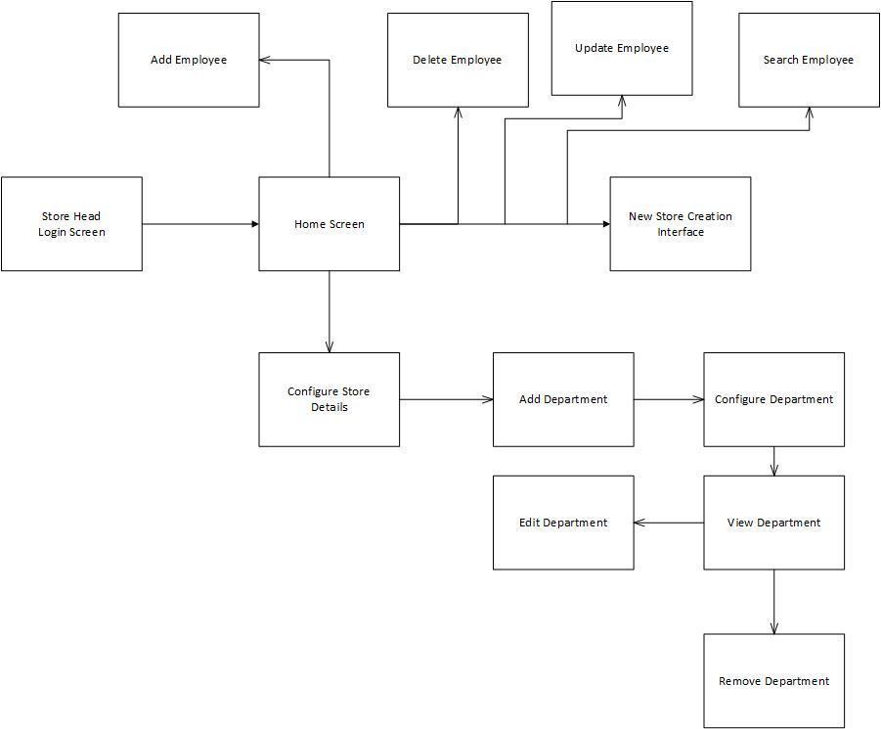

Store head will open the main interfaces and logins and he creates the store using the create a new store interface. As a sequence of steps, he adds the department’s details using the Add department Interface. He configures the department details using the Configure Department Interface and assigns department heads to departments. The store head uses search Employee Interface to search and view the employee information. He uses update Employee interface to update the employee information. He uses the delete employee interface to delete the employee.

## 7.2 Interface flow diagram for Inventory Management:

**Inventory Management Store Head Interface Diagram**

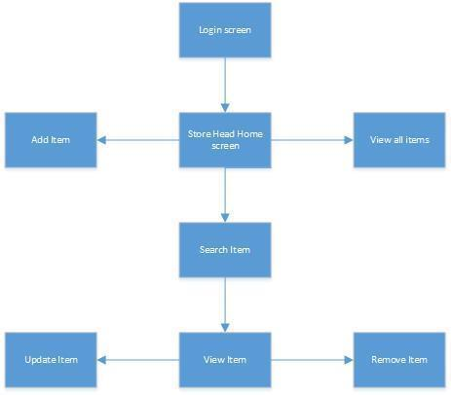

Store Head will login from the login screen which is a prerequisite for the Inventory Management use case model. The Store Head can then view his Home screen. From the Home screen the Store Head can navigate either to Add Item screen to add item to store inventory or View all items screen to view all items in store inventory. The Store Head can also navigate to Search Item screen to search for an item in store inventory. After searching for an item, the user can navigate to View Item screen. From View Item screen Store Head can update or remove item.

**Inventory Management Department Head Interface Diagram**

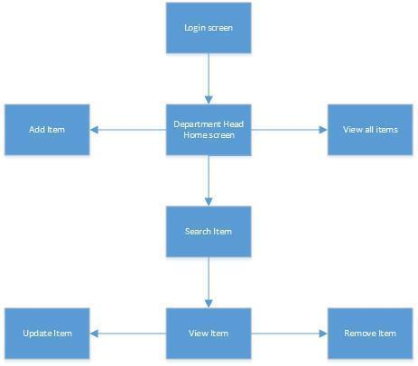

Department Head will login from the login screen which is a prerequisite for the Inventory Management use case model. The Department Head can then view his Home screen. From the Home screen the Department Head can navigate either to Add Item screen to add item to department inventory or View all items screen to view all items in store inventory. The Store Head can also navigate to Search Item screen to search for an item in store inventory. After searching for an item, the user can navigate to View Item screen. From View Item screen Store Head can update or remove item.

## 7.3 Use case story board for POS Executive

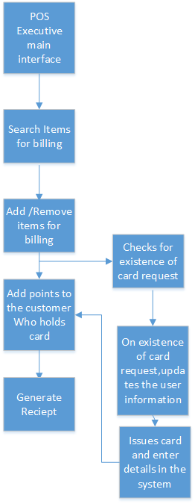

POS executive logins to his main interface and he then adds /removes items for billing .once the items are billed,points are added to the customer credit card based on the bill amount.He also checks for the existence of card request,If the request exist in the system,he adds customer details to the card and issues the card ,post which points could be added to the card and he finally generates the receipt

## 7.4 Use case story board for Service desk operator

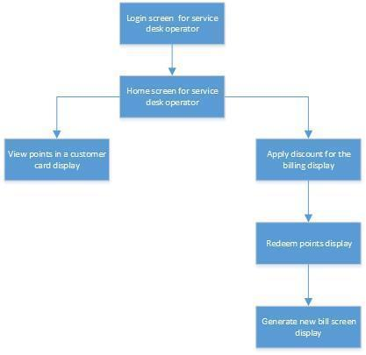

Service desk operator logins into his account and views the customer credit card details and the points present. He can apply discounts to the customer by checking the points available and redeeming them. He then generates a new receipt with the bill amount and points updated.’

# 8. Prototype User Interfaces

**Creation of new store:**

**Login Screen:**

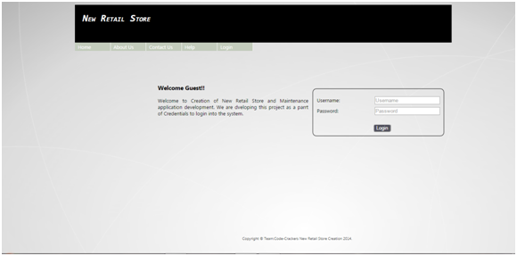

**Home Screen:**

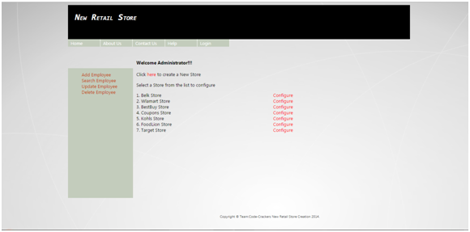

**Adding Store Details screen:**

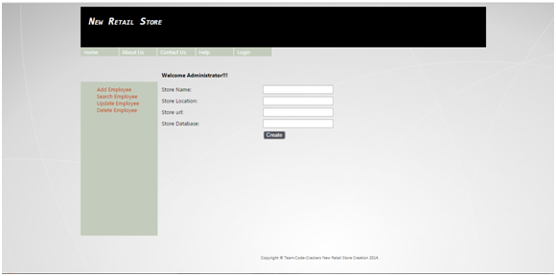

**Home Screen:**

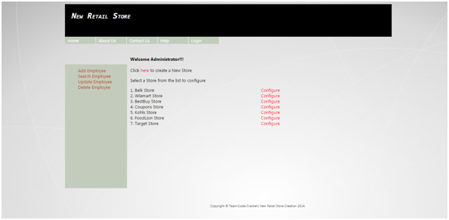

**Configure New Store Screen:**

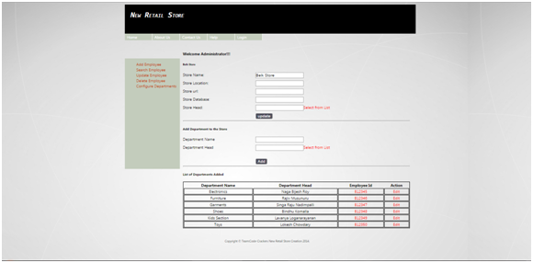

**Configure Department Screen:**

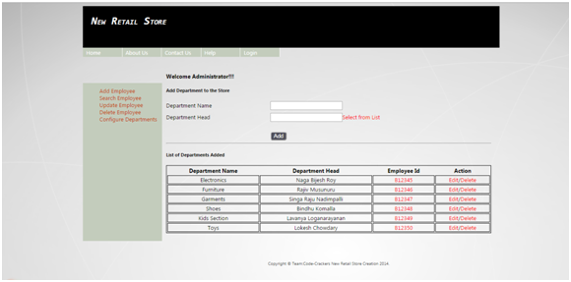

**Add Employee Screen:**

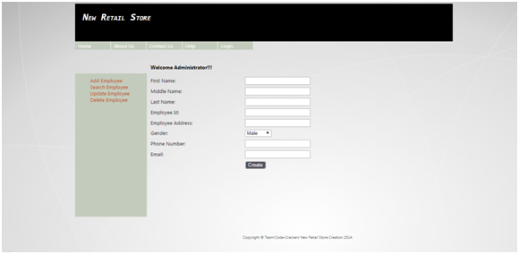

**Search Employee Screen:**

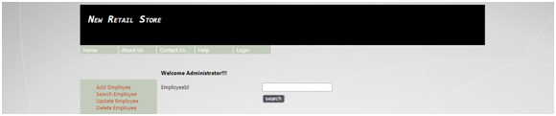

**Update Employee Screen:**

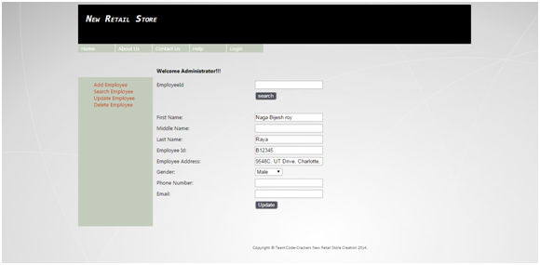

**Delete Employee Scren:**

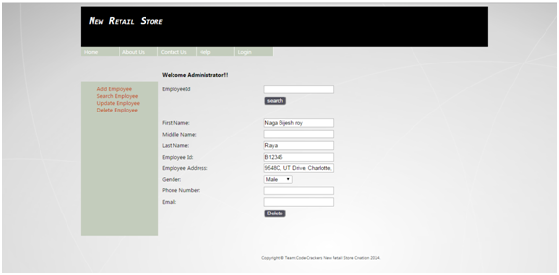

**Inventory Management:**

**Home screen:**

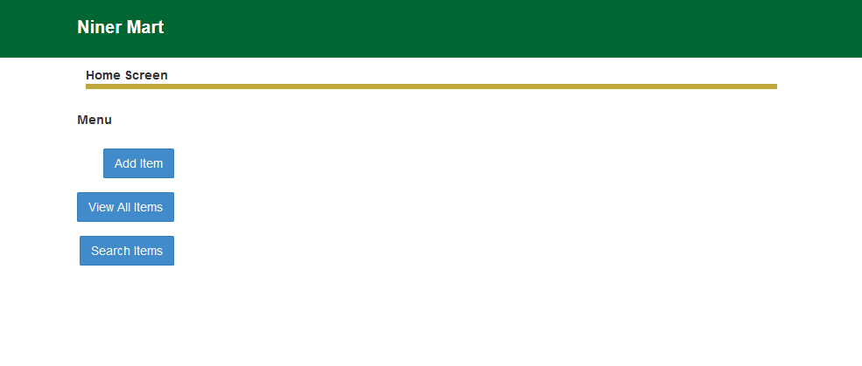

**Add Item prototype:**

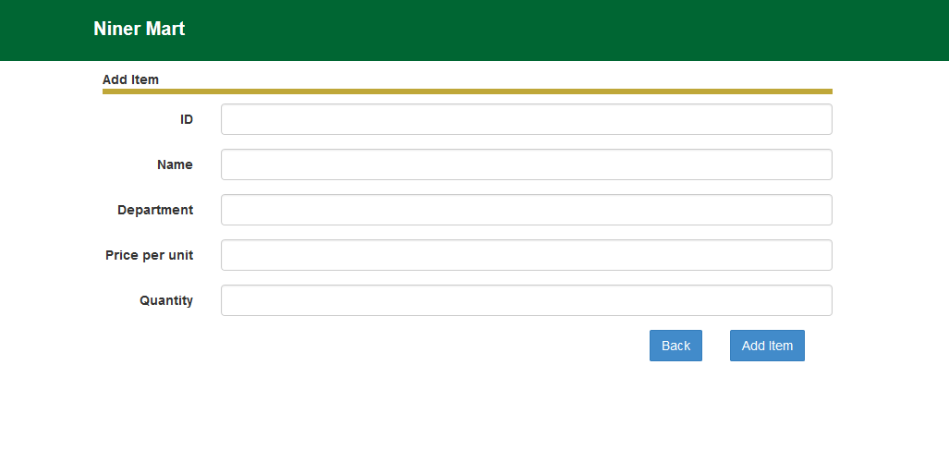

**View - Update - Delete item prototype**

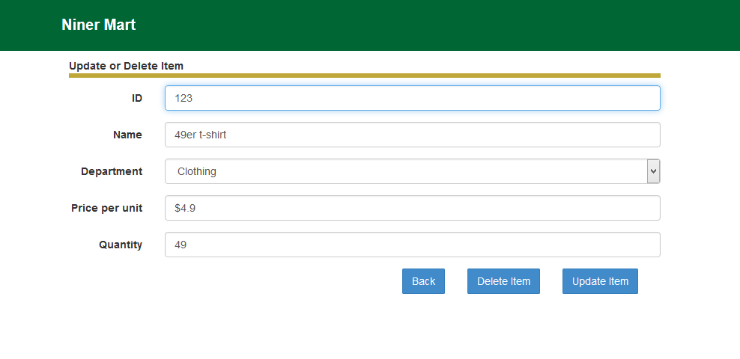

**Search item prototype:**

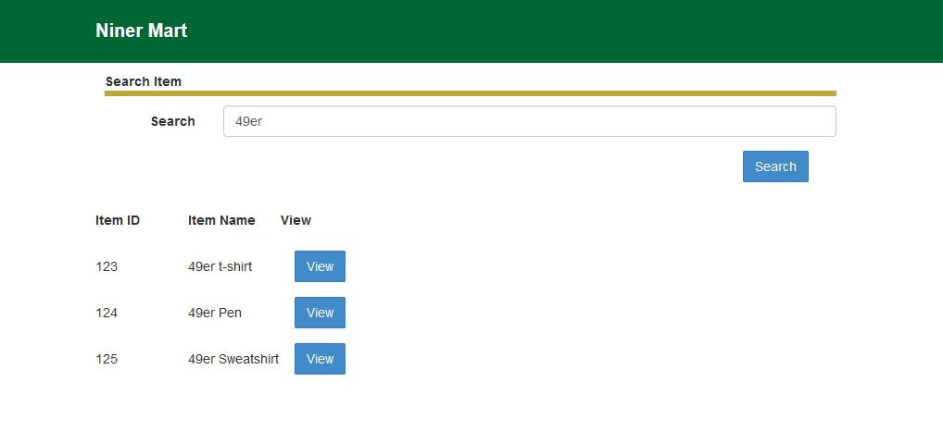

**View all items prototype:**

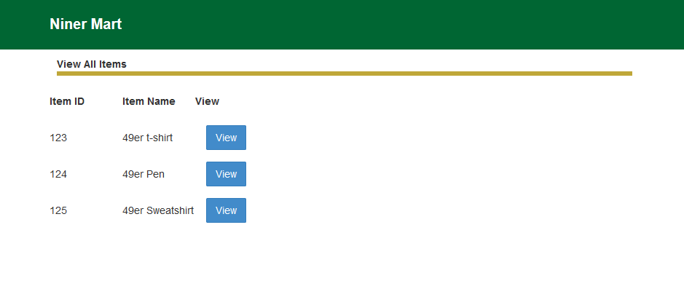

**Promotions and Clearances:**

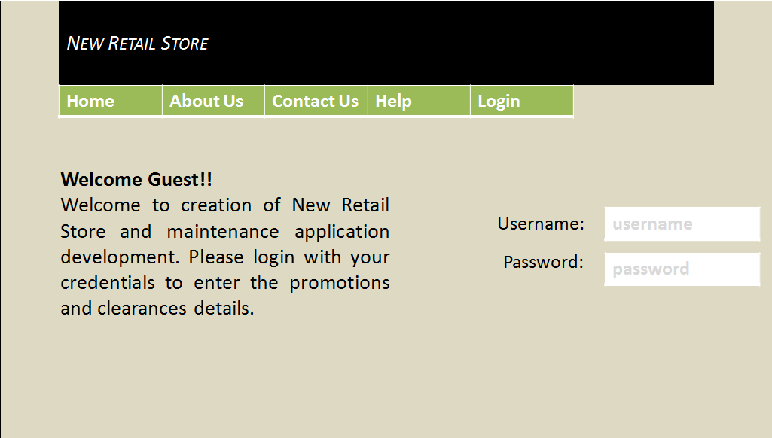

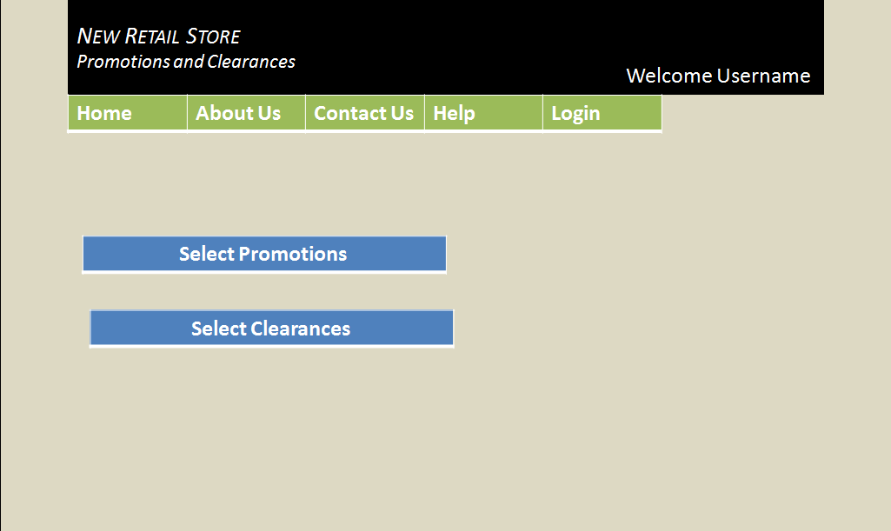

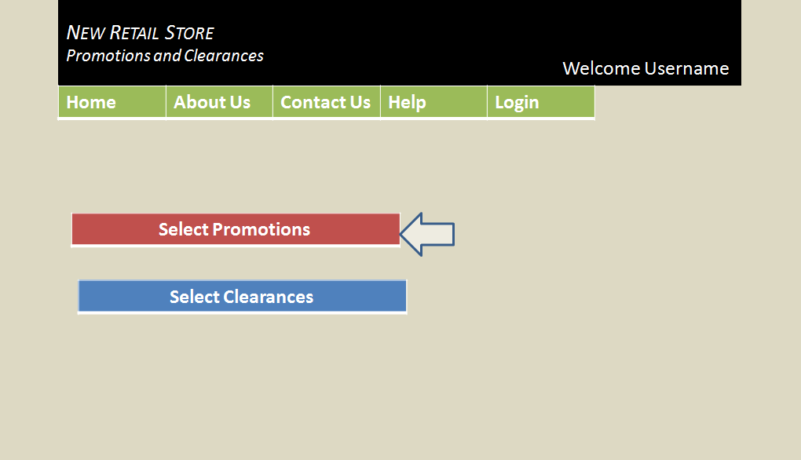

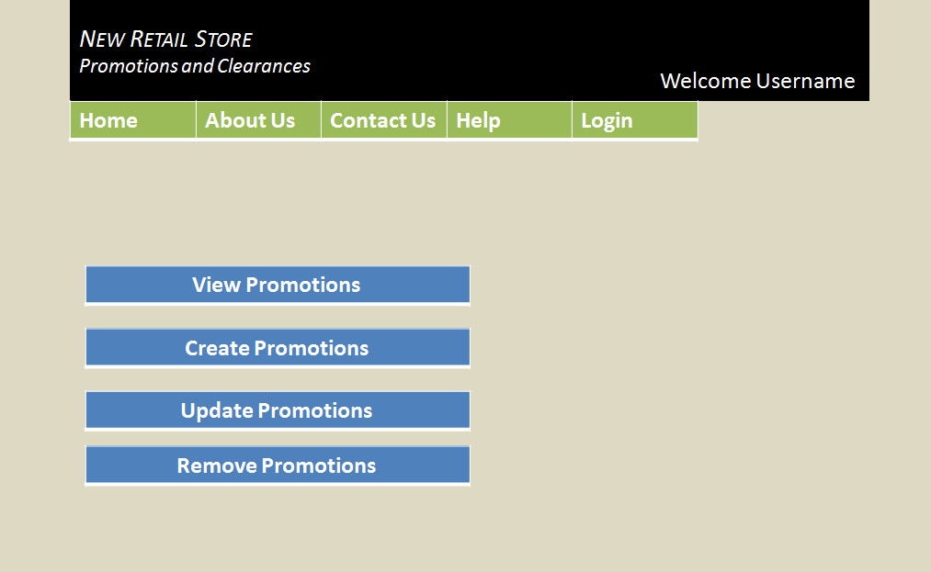

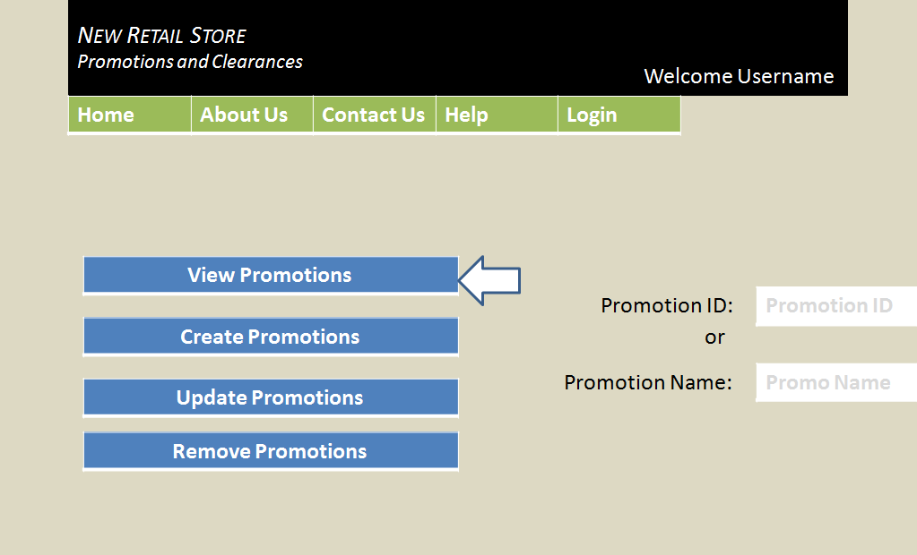

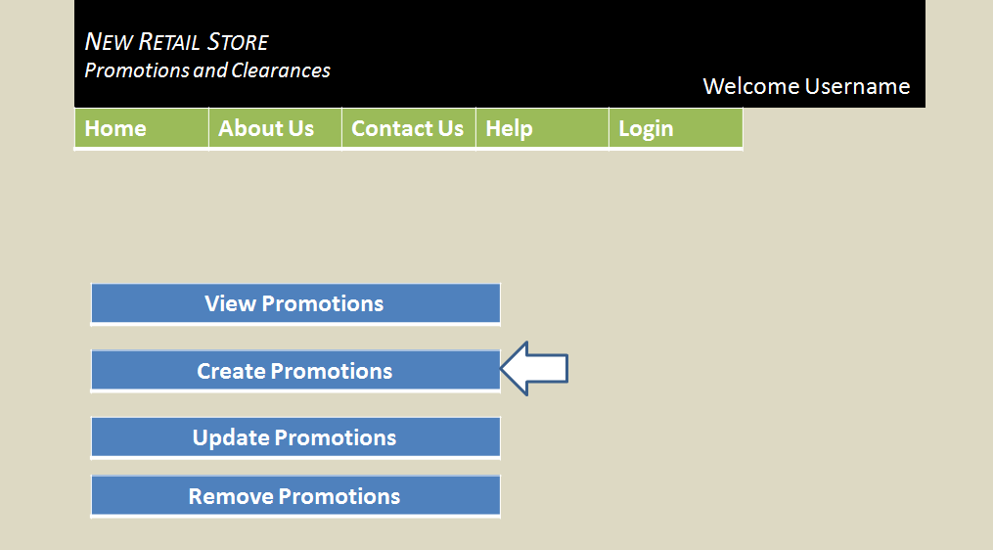

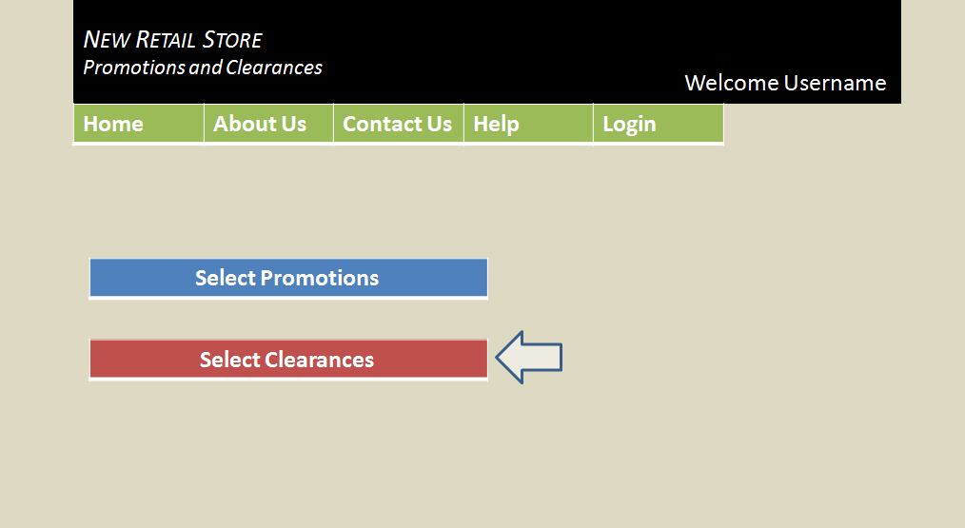

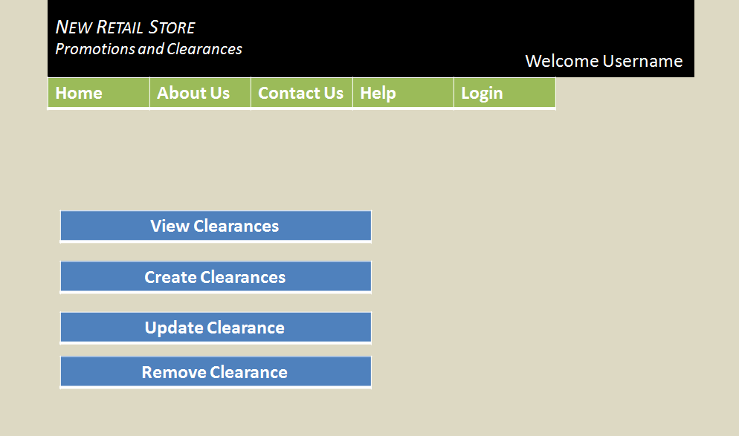

**Customer Point System:**

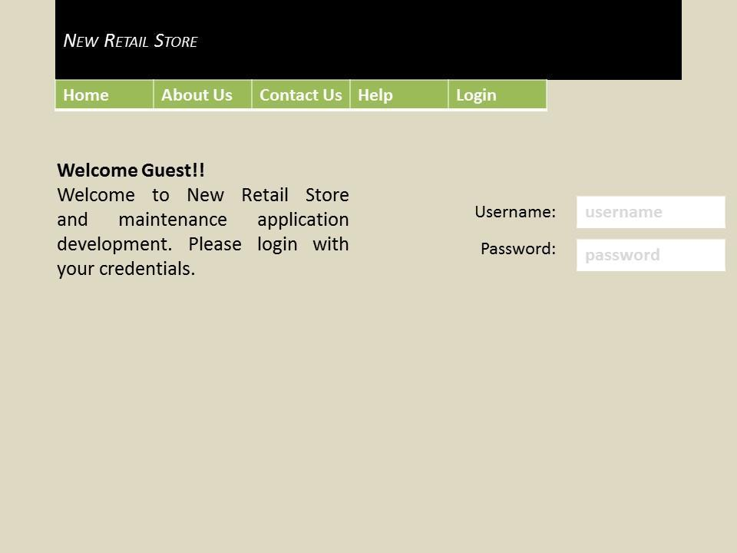

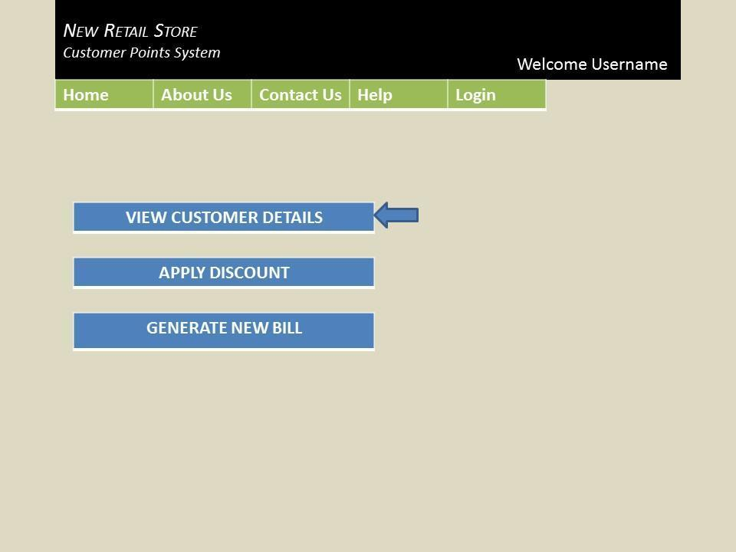

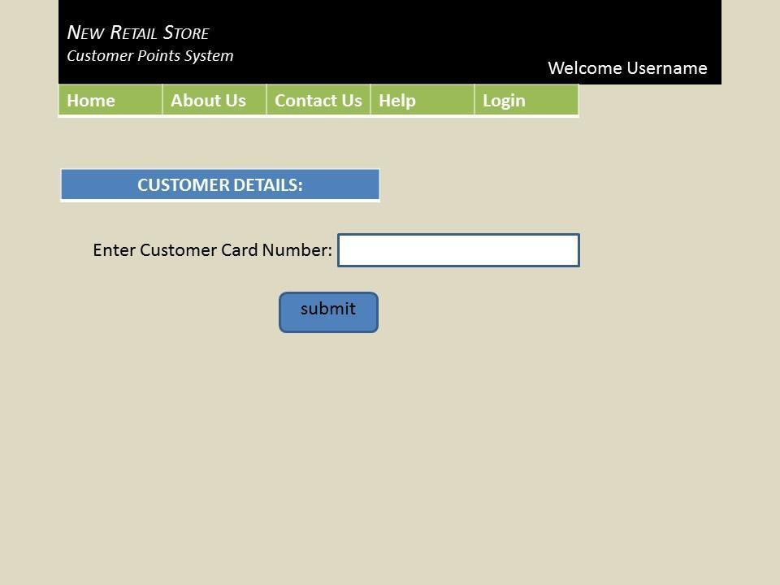

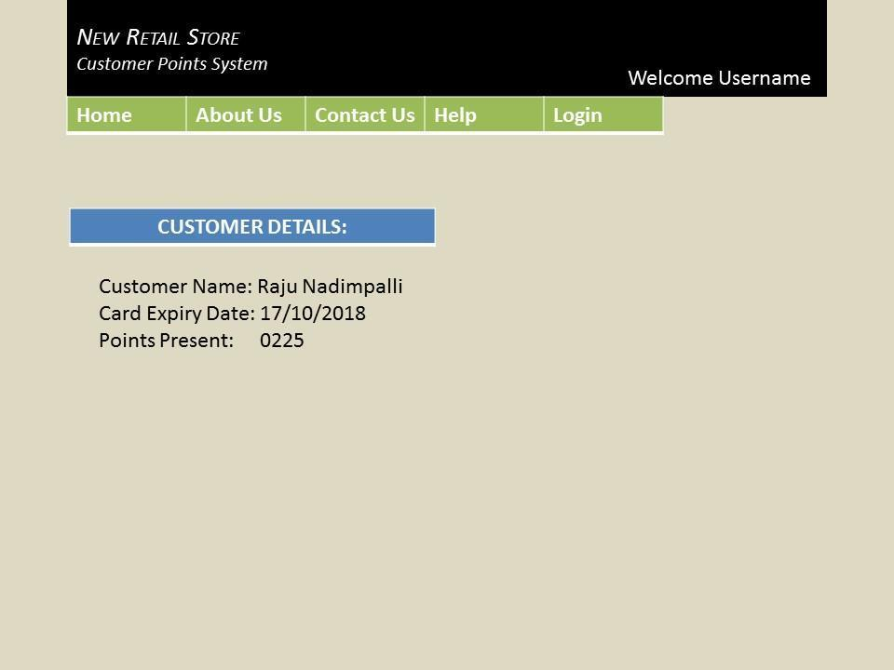

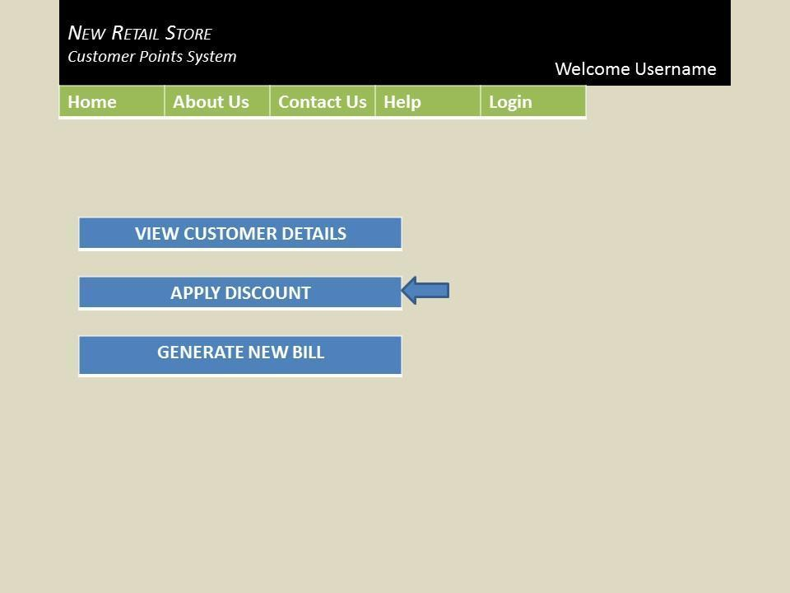

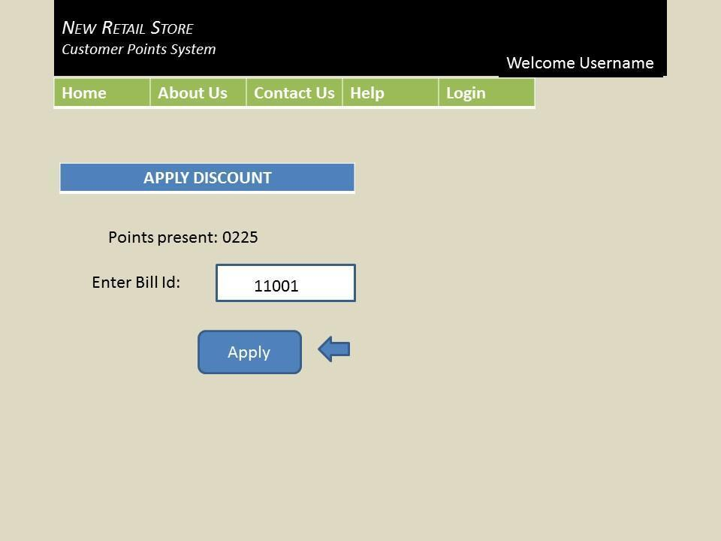

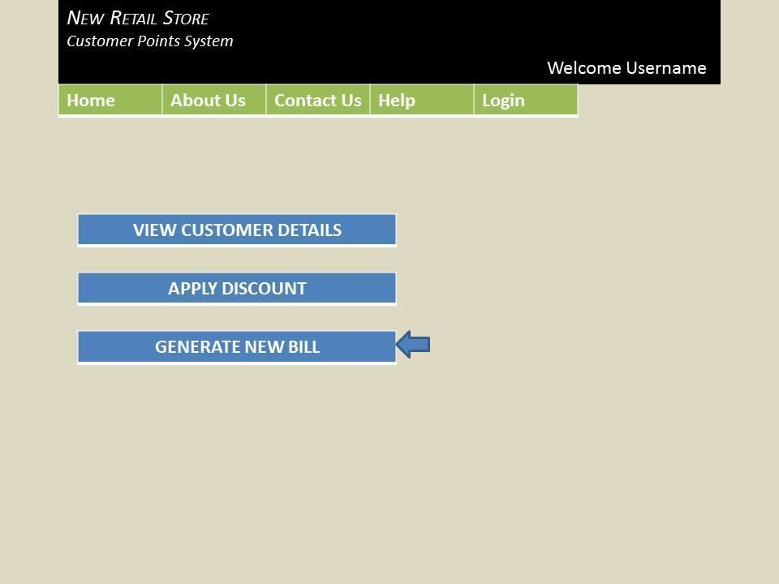

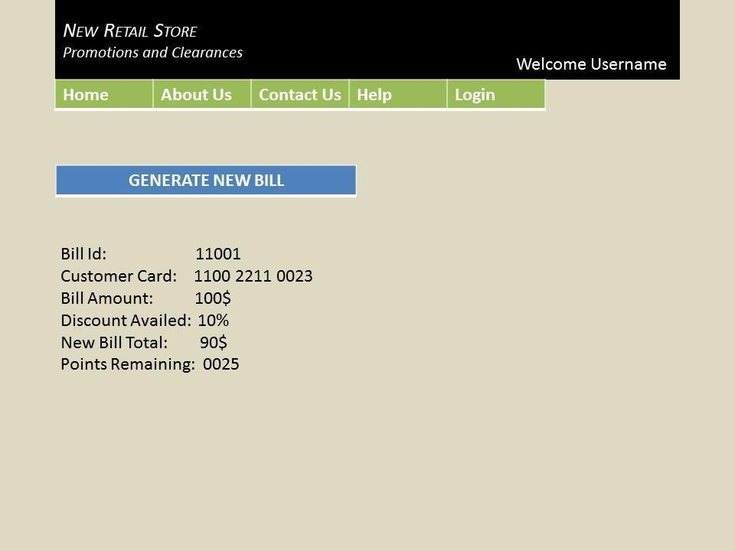

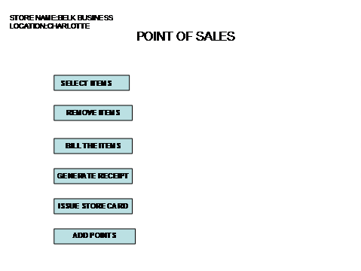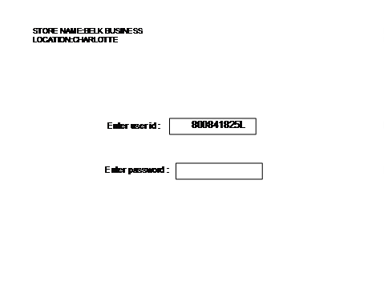

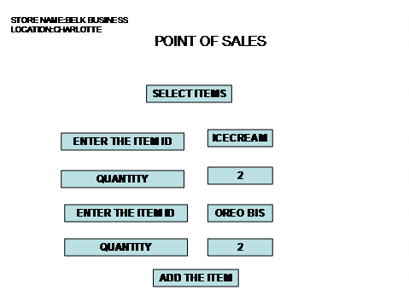

# 

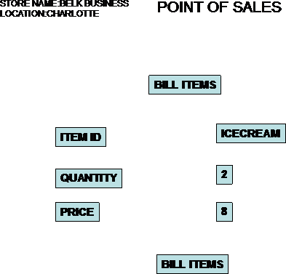

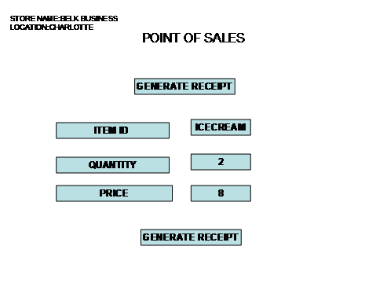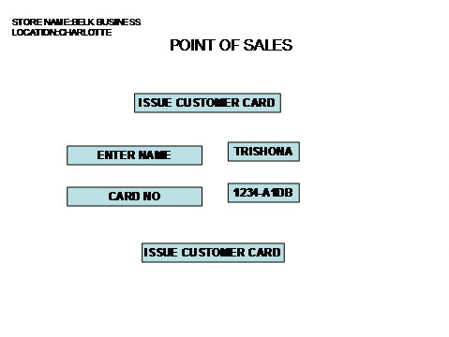

|  |  |  |  |  |  |  |  |  |  |  |  |  |  |
| --- | --- | --- | --- | --- | --- | --- | --- | --- | --- | --- | --- | --- | --- |
|  |  |  |  |  |  |  |  |  |  |  |  |  |  |
|  |  |  |  |  |  |  |  |  |  |  |  |  |  |

**9. System/Data Dependencies**

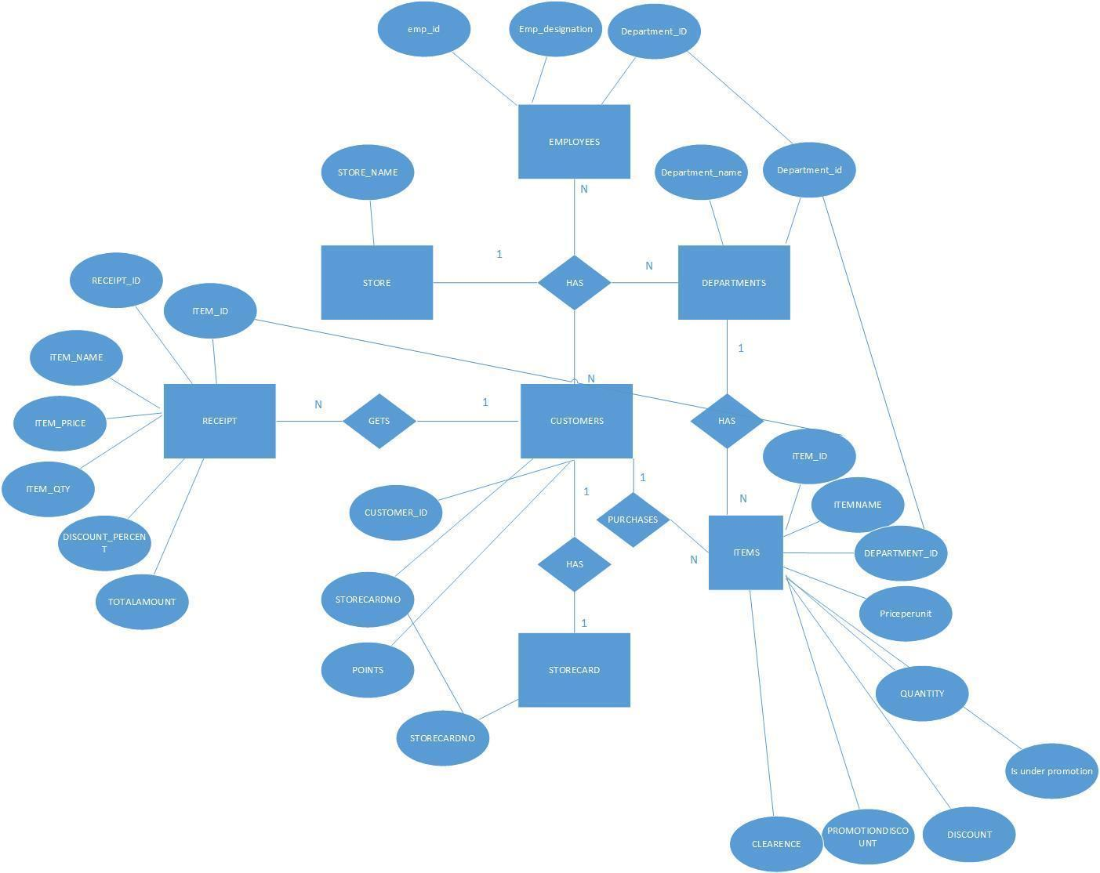

# 10. Appendices

1. We have implemented REST Easy Web Service and SOAP web service in our Sub System Architecture.

2. Also we have implemented Facade, Table Module and Table Data Gateway in all the Design Classes of our application.

3. Sequence Diagrams are corrected as per the feedback provided in the previous submission.

**11. Status:**

We have started developing the basic structure of all the classes using WSDL files. We have split our work to develop the individual modules implementing the business logic. Also we have designed the Database required for the connection to the JDBC Helper classes and Table Data Gateway Design Pattern.